
Interim Head of Policy
Reigate and Banstead Borough Council
Town Hall
Castlefield Road
Reigate
RH2 0SH 6 June 2008
BY EMAIL ONLY

Dear Sir/Madam
REIGATE AND BANSTEAD: PLANNING OBLIGATIONS AND INFRASTRUCTURE SPD

Thank you for the opportunity to comment on Reigate and Banstead’s Planning Obligations SPD. We would like to make the following comments:

Introduction

We note that it is the council’s intention to negotiate the infrastructure contribution from large development on a site-by-site basis. We would draw the council’s attention to the new PPS12, paragraphs 4.8 to 4.12 which explains how infrastructure needs will need to be assessed and planned in advance to a much greater extent than before, and the council will need to support its demands with evidence. As paragraph 4.8 states, the evidence will need to cover “who will provide the infrastructure and when it will be provided.” Not all infrastructure can be subsidised by housebuilders without risking jeopardising housing delivery.

Section 8: Reigate and Banstead’s approach

The statements contained in this section seem to be at odds with the council’s intention to operate a tariff based approach. In paragraph 8.1 the council states that it will provide the developer with early guidance on the services, facilities and priorities for development, but later on outlines a fixed, pre-determined standard tariff approach.

We are concerned that the tariff approach outlined takes little account of all the tests set out in Circular 5/2005. In particular, any obligation demanded from a developer should be (iii) directly related to the proposed development; and (iv) be fairly and reasonably related in scale and kind to the proposed development.

Until the Community Infrastructure Levy is introduced it is necessary to remind the council that according to paragraph B7 of Circular 5/2005 planning obligations should “never be used purely as a means of securing for the local community a share in the profits of development”. Because this tariff levies a sum from all new housing developments in all locations (except large schemes which will be subject to separate negotiations) no account has been made of the extent of existing provision and capacity. This amounts to “betterment levy”.

This document is also contrary to paragraph B9 on Circular 5/2005 which states that: “Planning obligations should not be used solely to resolve existing deficiencies in infrastructure provision”. In many places in this document it is unclear where other funds will be provided to match developer contributions.

It is also necessary to ask the council why new housing and new residents should be penalised in this way (for it is effectively they who will carry the cost through higher housing prices) while residents of existing housing are exempted? The changing make-up of households within the existing stock could have as much an impact on altering the demand for council services? The most equitable way to ensure that council services are adequately supported without punishing new and increasingly financially strained first-time buyers and the residents of social housing, would be to ensure that council services are paid for through local and national taxation.

Tests of reasonableness

Of particular concern to the HBF is the way the council on the one hand seems to acknowledge the provisions of Circular 5/2005 then disregards them when it comes to satisfying the five tests of reasonableness. The HBF does not object to the principle of developer obligations nor their application to secure appropriate and necessary additional infrastructure in association with new residential development. However, as Circular 5/2005 makes clear, developers can only be expected to provide for those facilities which are made necessary by the development and obligations should not be levied to make good any existing deficiencies in provision or to provide benefits for the community at large which this document is clearly attempting to do by pooling contributions at district level (as distinct from pooling contributions at a local level which is allowed by Circular 5/2005) by the adoption of a tariff mechanism.

Any planning obligation levied needs to satisfy Circular 5/2005’s five tests of reasonableness. Thus, while obligations can be levied to make a development acceptable, they must also be:

- Necessary
- Relevant to planning
- Directly related to the proposed development
- Fairly and reasonably related in scale and kind to the proposed development; and
- Reasonable in all other respects.

Circular 5/2005 (paragraph B5) goes onto clarify that in order to be lawfully sought planning obligations must satisfy all five of these tests.

While the forthcoming Community Infrastructure Levy may well change the way financial contributions from developments are levied, under the existing regime, we are concerned that many of the proposals contained in this SPD would not satisfy these five tests because the obligations are collected via the tariff would appear to be for district-wide disbursement to subsidise council core responsibilities.

Viability?

It is unclear whether any financial appraisal has been carried out to test the tariff’s viability in sample locations (not just town centre vs outer area locations which seems to be the only locational variation applied)? How will the council approach the problem of housing supply if the tariff renders development unviable? Will it reduce the total package of its demands and which elements of the tariff will it drop? We would welcome some consideration of these issues. In a falling residential market where land for residential development will carry less value than other uses, the development margins will be narrower and the capacity for the local authority to extract a larger share of the planning gain will be reduced accordingly.

Education (paragraph 9.8)

The renewal of existing infrastructural capacity should certainly be supported, and in the case of schools, the costs associated with bringing existing facilities back into use are likely to be less than the capital costs associated with new construction. We would therefore expect to see an assessment of the likely repair and renewal costs and for these calculations to be available to developers and reflected in any local planning obligations negotiation.

Formulae & standard charges (pages 20-21)

It is unclear from this section whether the council is seeking to use obligations to subsidise borough-wide core responsibilities. As stated above, if it is, then this is contrary to Circular 5/2005 which states that obligations must be directly related to the development in question and as paragraph B7 of the Circular states:

“planning obligations should never be used purely as a means of securing a local community share in the profits of development, i.e. as a means of securing a ‘betterment levy’.”

Obligations levied may be pooled, as paragraph 22.4 of your document discusses, but only to support new infrastructure needs generated as a result of a development or series of development in a specified locality of the borough. They cannot be pooled to support borough-wide or county-wide provision. The Surrey wide Planning Obligations tariff is therefore illegal.

Fees (Page 22)

At a time when planning application fees continue to rise and local authorities receive higher settlements from Government through the Planning (and Housing) Delivery Grant, the HBF objects to the levying of a 5% fee and charges to cover legal fees incurred in the preparation of s106 agreements, to discharge what are effectively core responsibilities that should be carried out as part of the statutory planning process and for which local authorities are more than adequately remunerated and for which developers and applicants for planning permission already pay. We are also concerned about the amount to be levied in respect of legal fees for preparing a s106 agreement which will be £500 per agreement.

We would be interested to learn how the council proposes to react if the total cost of the fees to be levied has the effect of rendering the housing development unviable? Will the council refuse planning permission for new housing if insufficient residual site value is generated to accommodate its total s106 demands and its fees? Or will it seek to reduce the amount of affordable housing required or the s106 package elsewhere in order to ensure that sufficient planning gain can be extracted to pay for the costs of council staff processing the application? Who here is acting more in the ‘public interest’? Is it the housing developer trying to build houses for people who need them or the council trying to cover its costs? We would be interested in the council’s view.

Otherwise these fees are unreasonable and this section should be deleted from the document.

We hope the council will take notice of these comments and we look forward to a response from the council in due course.

Yours faithfully
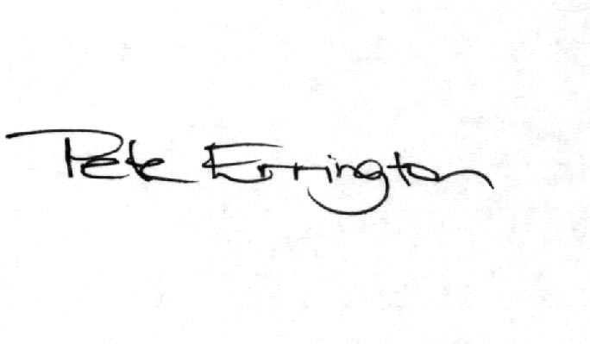
Pete Errington
Homes Builders Federation
Regional Policy Manager (South, East and London)

