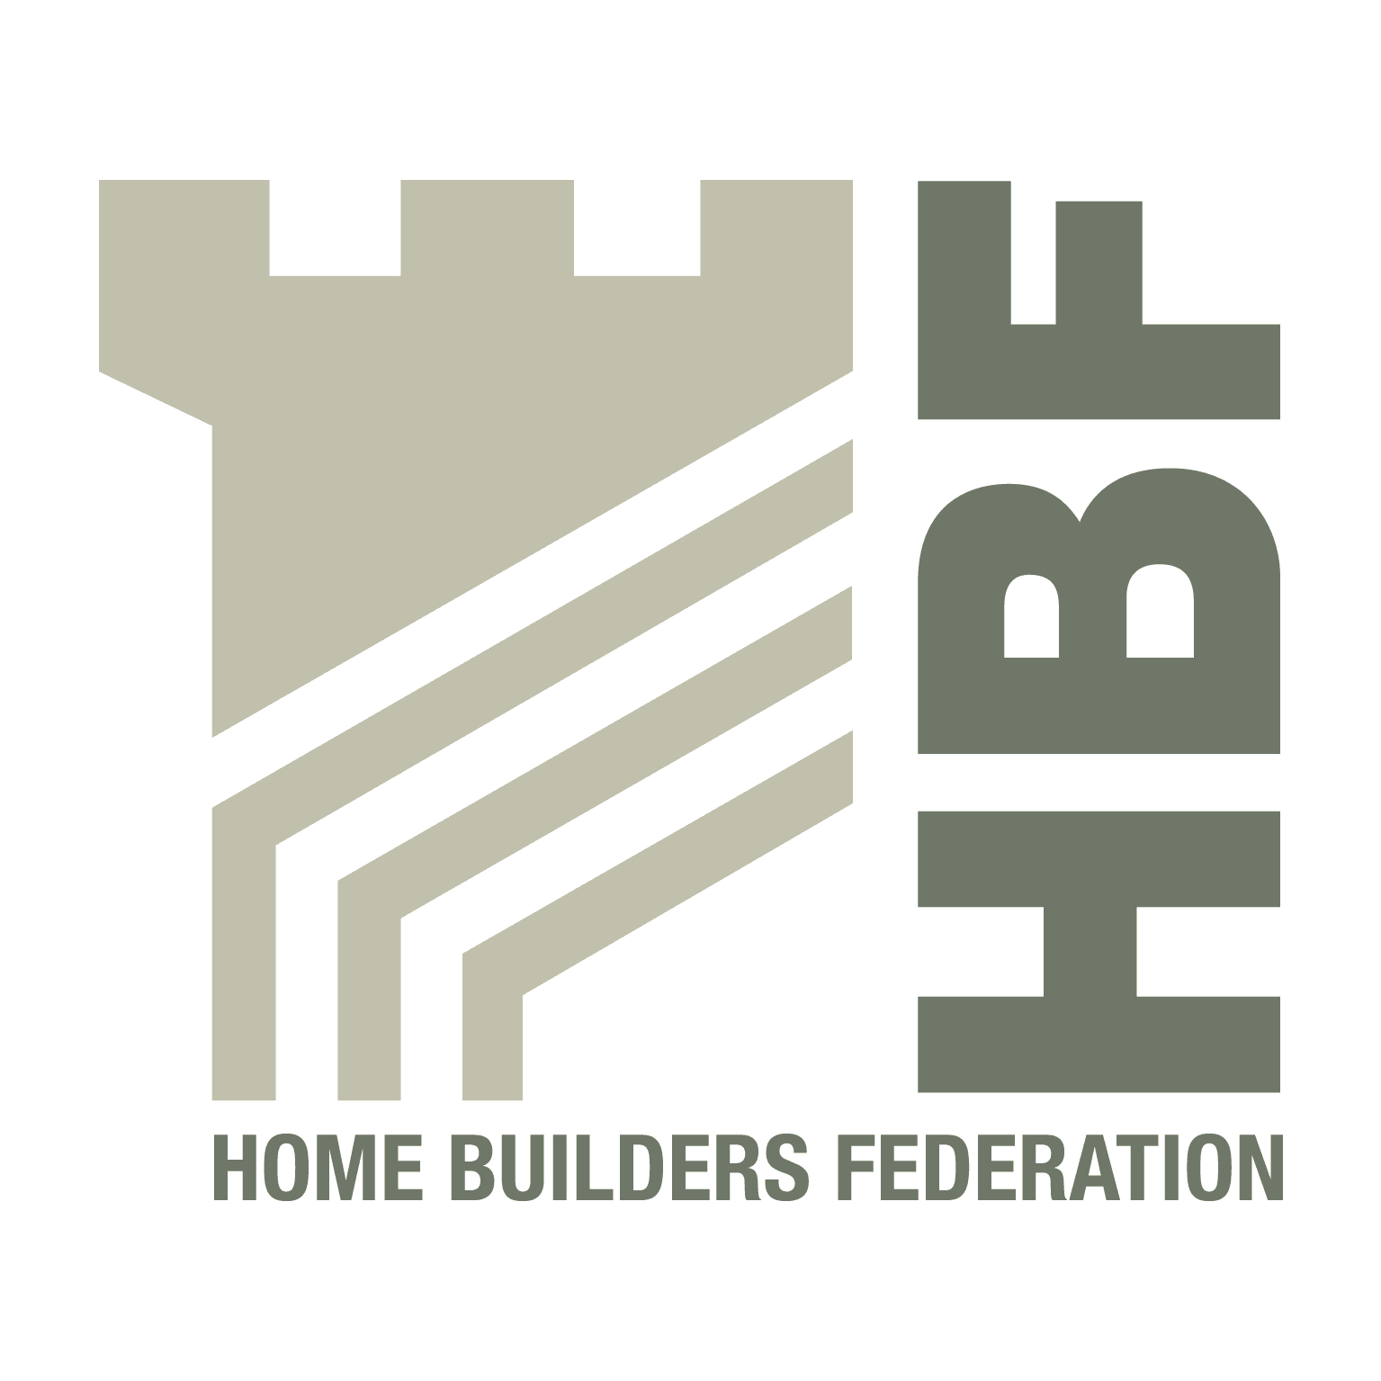
Crawley Borough Council
Forward Plannng
The Boulevard
Crawley
West Sussex
RH10 1UZ 30 May 2008
BY EMAIL ONLY

Dear Sir/Madam
CRAWLEY BOROUGH COUNCIL: STRATEGIC HOUSING LAND AVAILABILITY ASSESSMENT

Thank you for consulting the Home Builders Federation (HBF) on the above draft document. The HBF has a number of comments to make.

Paragraph 1.3

While it is true to state that identification of a site with potential does not necessarily translate into a formal housing allocation site and that the decision whether to progress a site will be made in the context of the policies set out in the Local Development Framework, equally it is important to remember that housing targets must be met and LDF policies should not so overly constrain land from coming forward for development that would prevent this target from being achieved. Some policy constraints may have to be scrutinised more closely as part of the assessment process to rigorously examine the potential of sites coming forward from within these designations (e.g. conservation areas, rural exception sites etc).

As a preliminary step it is essential for the council to carry out a rigorous SHLAA survey in accordance with the Government’s practice guidance. This will include revisiting the potential of sites within designated areas (stage 8) if a sufficient supply cannot be identified in the first round of the survey. Only then will the council be in a strong position to justify a more generous windfall allowance if it can demonstrate that it has assessed the suitability and deliverability of sites within some of these designated areas.

Stage one – planning the assessment

We welcome the consultation with housebuilders. We hope that the council can also find time to consult with land owners if it is not already planning to do so.

Stage two – sources of sites included and excluded from the assessment

Echoing our remarks above, we see no reason why, at the initial survey stage, the council should not consider the potential of new free standing settlements, rural settlements and rural exception sites to contribute to Crawley’s housing needs. The Government’s practice guidance encourages local authorities to explore these options even if these areas are discounted later on (at stage 7a: considering the policy restrictions).

We feel that some consideration should be given to such sites and that they are included for assessment in the initial phase of the survey.

Stage four and five – site surveys

We are slightly concerned that site submissions received outside the consultation period will not be assessed in this study. We understand the council’s reasons, however, the purpose of the SHLAA is to identify a sufficient supply of sites to meet the council’s 15 year housing trajectory and to ensure that it has a sufficient supply of deliverable and developable sites in its Five Year Land Supply. Because the SHLAA is a fairly resource demanding study, undertaking one annually, as the council suggests, may be unfeasible and unaffordable. Maybe it would be better if the council operated its SHLAA a little more flexibly by allowing it add to its database details of sites submitted after the consultation date, especially if these seem eminently suitable for housing. These (or a batch of sites) can then be surveyed and assessed for deliverability and developability on an ad-hoc basis by a re-convened assessment team of stakeholders should this be necessary in order to feed the 15 year trajectory and the Five Year Land Supply.

Stage seven a – suitability for housing

We are a little concerned that the council may be dismissing too readily a great many possible sites as unsuitable on policy grounds. Designations can be numerous and new restrictions are growing in number. However this does not mean that they may not be able to accommodate some additional housing development.

This is especially true of those designations which were brought into being to protect the character of the built environment (the statutory designation of conservation area and non-statutory ones such as Areas of Special Townscape Character). We accept that AONBs and SSSIs may need to be excluded (although even AONBs may be able to make a small contribution) but conservation areas do have the potential to accommodate some development (as English Heritage guidance has always acknowledged) thereby contributing to the council’s housing targets while also helping to deliver sustainable, mixed communities. Also as PPG15, paragraph 4.16 comments on conservation areas: “While conservation (whether by preservation or enhancement) of their character or appearance must be a major consideration, this cannot realistically take the form of preventing all new development).

Stage eight – assessment review

To reiterate what we have argued above: if an insufficient supply of sites can be identified that are suitable for housing and are deliverable and developable, then in accordance with the practice guidance the council may need to go back and widen the scope of the survey (to include rural and Green Belt sites) or reconsider certain policy constraints (conservation areas). The council can also revisit assumptions made about the housing potential of particular sites.

The council must review these options before it considers the potential yield from broad locations and windfalls.

Stage nine – broad locations and stage ten – windfalls

We would emphasise, in accordance with PPS3 and the practice guidance that broad locations and windfalls must not be included in the SHLAA or contribute to the housing trajectory until a reasonable attempt has been made to identify specific sites and all the stages 1 to 7 adhered to. This includes revisiting earlier assumptions about preferred locations for development and reconsidering any assumptions about policy restrictions.

We repeat, the emphasis must first be on identifying sufficient suitable and deliverable sites before broad locations and, lastly, windfalls are considered. We would refer you to the letter from Nick Tennant of Communities and Local Government, dated 7th April, to Nigel Clark of Baker Associates, on this issue. The letter clarifies the need to take a tiered approach and to “identify as many specific deliverable/developable sites for housing as is practicable, over at least a 15 year period”.

I hope you have found these comments useful. We would welcome continuing the dialogue with the council and look forward to participating in its forthcoming SHLAA.

Yours faithfully
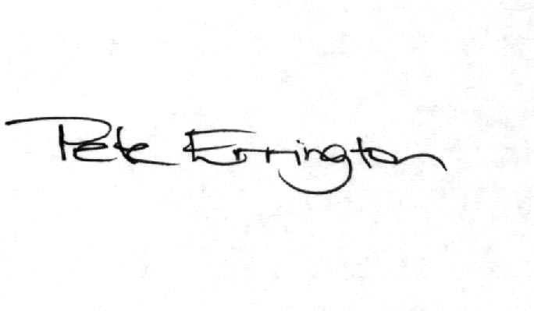
Pete Errington
Homes Builders Federation
Regional Policy Manager (South, East and London)

