
Horsham District Council
Strategic and Community Plannng Department
Park North
North Street
Horsham
West Sussex
RH12 1RL 2 June 2008
BY EMAIL ONLY

Dear Sir/Madam
HORSHAM STRATEGIC HOUSING LAND AVAILABILITY ASSESSMENT

Thank you for the opportunity to comment on Horsham’s Strategic Housing Land Availability Assessment. We would like to make the following comments:

Stage 2: Determining which sources of site will be included in the assessment

We welcome the inclusion of urban extensions and new free standing settlements when assessing potential sites for housing. As the Panel report on the South East Plan commented, strategic gap style policies (non-statutory local landscape designations) should not be “used in an inflexible way, as long-term restraints on opportunities for sustainable development in urban fringe locations”.

Stages 6 and 7

It maybe already be the council’s intention (paragraph 4.22) but we would strongly recommend that the council involves housebuilders in these stages of the process. Their input will be invaluable in helping to assess the likely unit yields of sites and their deliverability and developability.

Stage 7d: Overcoming constraints

Consideration of the infrastructure requirements of development sites to ensure these are suitable, deliverable and developable is a key consideration. Infrastructure costs should be fairly apportioned between the public and private sector. Any expectation that all necessary infrastructure can be secured through section 106 in all circumstances would be unrealistic and unreasonable, especially when housebuilders are already providing affordable housing and are having to contend with higher design and environmental standards.

Stage 8: Review of the assessment

We welcome the reference in paragraph 4.25 to undertaking a risk assessment – a stage often omitted from other SHLAA methodologies we have commented on recently. However, we would refer the council to paragraph 43 of the CLG’s SHLAA practice guidance which states that if an insufficient number of deliverable sites is identified by the initial assessment, the first step should be to consider whether it is necessary to survey and assess additional sites, and/or to revisit the assumptions made about certain sites (e.g. thresholds or sites previously rejected on policy grounds).

This is an essential precursory step before the council proceeds to the next two stages.

We hope you have found these comments useful. We look forward to being involved further in Horsham’s SHLAA exercise.

Yours faithfully
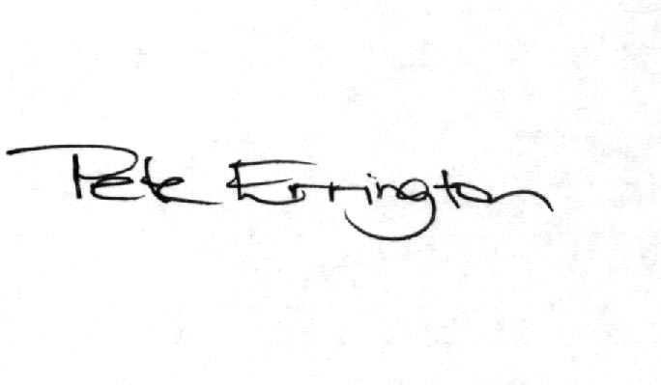
Pete Errington
Homes Builders Federation
Regional Policy Manager (South, East and London)

