

BY EMAIL ONLY

Policy & Design Team

Eastleigh Borough Council

Civic Offices

Leigh Road

Eastleigh

Hants SO90 5YN

22nd May 2008

Dear Sir / Madam,

EASTLEIGH BOROUGH SHLAA METHODOLOGY

Introduction

Thank you for consulting the Home Builders Federation (HBF) on your council’s proposed SHLAA methodology. HBF generally welcomes the approach proposed in the document and the fact that the methodology is in general accordance with the government’s SHLAA practice guidance. We do have a few comments, however, though these are concerned with matters of detail rather than principle. These are set out below in the order in which they appear in the document.

Paragraph 6

Firstly in respect of paragraph 6 of the draft methodology we would point out that the SHLAA should not be seeking to identify the ‘theoretical’ potential for sites to be developed; rather that it should be concerned with discovering the ‘actual’ potential of sites to be developed. Urban Capacity Studies in days gone by were concerned with theoretical capacity which is why they were largely a waste of time. SHLAAs are focussed on outcomes and delivery rather than process and policy formulation. This reference should be corrected.

Paragraph 16b

HBF is somewhat concerned at the way the council proposes to deal with consultation and stakeholder engagement in the SHLAA.

Obviously we very much welcome the fact that there is to be stakeholder involvement. However, it would appear that this is largely focussed at either end of the study in terms of commenting on the methodology and suggesting sites for inclusion at the beginning of the process and then commenting on the finished product at the end. HBF considers that there is a missing stage in the middle.

The SHLAA guidance refers in a number of places to continuous stakeholder involvement throughout the process. We are concerned, therefore, that the council is proposing to present stakeholders with a fait accompli and only asking them to comment on that once the assessments have been completed rather than allowing them the opportunity to assist and inform those assessments as they are being made. The terminology does not help as it is referred to in 16b as the “completed assessment”. HBF would respectfully suggest that an assessment could not be considered “complete” at that stage as it has not allowed for adequate stakeholder engagement at this stage.

It could also be quite dangerous for the council to go down this route given how contentious these matters can be if misunderstood by general members of the public. It may be, therefore, that the council’s ‘final’ version contains sites which stakeholders consider should not be included because, for example, they do not meet one or all of the PPS3 ‘ables’. We would suggest it would be better from a public perception and management point of view for there to be discussion with stakeholders on the sites identified by the council as part of the assessment process and prior to the publication of a final document (even a draft final document) in order to avoid this confusion and in order that the process is as robust as it can be. HBF would be happy to try to facilitate such engagement amongst its Members if the council would find that helpful.

Table 1

HBF has some concerns about the use of the phrase “well related to existing settlements” in the latter part of this table. Who decides whether a site is or is not “well related” and what criteria or tests does the assessor apply in making such a judgement ? The methodology should provide a definition or list of criteria along with an explanation of how they will be applied to explain this in order that the assessment process can be seen to be as transparent as possible.

We also wonder why the council is seeking to assess sites which are currently under-construction. If they are under-construction we would suggest it is fairly clear that they are available etc and that the yield is pretty certain.

Table 3

HBF notes the reference to empty properties in this table. We would welcome clarification in the methodology of how the council plans to deal with empty properties (by which the term actually seems to mean empty homes according to the second column of the table).
We would point out that bringing empty homes back into use, while obviously a laudable and worthwhile objective, does not create net additions to the dwelling stock as those empty homes already form part of the existing dwelling stock. Their state of occupancy or otherwise is largely irrelevant in terms of this SHLAA exercise and we would advise that no allowances should be made for in either the SHLAA, the 5 year supply calculation or the housing trajectory, for bringing empty homes back in to use.

Paragraph 27ii

HBF is curious as to why this potential search area for an SDA is excluded from the study. We would have thought that the opportunity presented by the need to carry out a SHLAA would have been beneficial in informing the future search for an SDA. Clearly any sites in this area would need to be considered for future development on a comprehensive basis rather than individually. However, the SHLAA process is supposed to assist in informing future policy rather than being tempered because of what may emerge as policy at some point in the future. HBF suggests that this paragraph be deleted and replaced with one which explains that the SHLAA will assess sites in this area but that they may not be taken forward individually as part of the SHLAA process but may be considered in a comprehensive manner given the SDA issue.

Paragraph 27iii

Following on from the comments made in respect of Table 1 above we consider it is contrary to the CLG SHLAA guidance to rule out sites at an early stage in the process on such a vague notion (certainly one which is at present undefined) as being poorly related to existing settlements. The aim of the SHLAA should be to identify all possible sites. It may be that some are later ruled out on the grounds after assessment that they poorly relate to existing settlements. But it is wrong to rule them out on those grounds at the outset.

It may be the case, for example, that the SHLAA is unable to identify sufficient sites to meet its 15 year trajectory target. That being the case, one of the options open is to revisit those sites which may have been ruled out and reconsider the policy judgements which underpin those decisions to rule sites out and to consider whether those policies remain valid or need to be amended. If all sites have been assessed in a transparent manner such a re-appraisal of sites is straightforward. If sites are ruled out early on and not assessed then the council is likely have to go back to square one and re-do the assessment.

Therefore we consider that sites deemed not to relate well to existing settlements are not automatically ruled out early on but rather, their proximity to existing settlements is one of the factors which inform the assessment process and a decision is taken on whether or not to rule them out later in the process.

Table 4

HBF would like to see some evidence or explanation behind these yardstick densities in terms of examples of schemes which have been developed at these densities and in these locations in recent years. Clearly the 50dph density for the town centre is likely to be reasonable., However, we are concerned that the council is proposing to automatically assume the PPS3 minimum density of 30 dwellings per hectare in the rural areas (and even 40dph in the village centres) where this may not be acceptable locally or politically. If the evidence doe support these densities then there is no harm including a few examples in the methodology. If it doesn’t it suggests they may be on the high side in these more peripheral locations.

Paragraphs 37, 38 & 40

Following on from the comments made in respect of paragraph 16b above, HBF is concerned that the proposed methodology is missing out a stage of stakeholder engagement (namely that of commenting on the site assessments prior to the publication of the draft or final report) and is, instead, relying on a matrix completed by those undertaking the assessment to address all of the PPS3 ‘ables’. This matrix is not a reasonable surrogate for the expertise and experience of those local landowners, developers, housebuilders and agents and the insights they could bring to the assessment process. Furthermore, looking at the matrix itself, we are not sure that the “survey” element could actually reveal the information being expected. For example, what information could a site visit yield on the costs of the imposition of certain council design or other standards or other policy requirements; certainly compared to the insights of those who actually design and implement schemes for a living ?

We maintain, therefore, that there should be an additional stage of engagement with stakeholders on the site assessments before the final document is put in the public domain.

Paragraph 42

Just to reiterate the point that, rather than simply look to broad locations or windfalls, a third option open to the council is to revisit the earlier assessments and consider whether the policy judgements applied to certain sites remain valid and whether or not there needs to be an amendment to policy through the DPD process in order to release more suitable identified sites. One such policy may be the one dealing with the reasonable proximity of sites to existing settlements, for example.

Sites Pro Forma Guidance Note

Finally, turning to the guidance note which accompanies the potential sites pro forma HBF is concerned that the council is potentially misleading readers by stating that the assessment will only make “realistic assessments of brownfield land available….”.
The actually purpose of a SHLAA is to make assessments of all potential development land regardless of whether it is brownfield, greenfield or any other colour of bounded agricultural land unit. It may have put people off from completing the forms if it was interpreted, as I read it, that the study was only really interested in brownfield sites.

I hope you find these comments helpful and I trust they will be considered and the methodology amended and clarified prior to work commencing on the study in earnest. Either way I would be pleased to be kept informed of progress on the SHLAA as it evolves.

Yours faithfully,

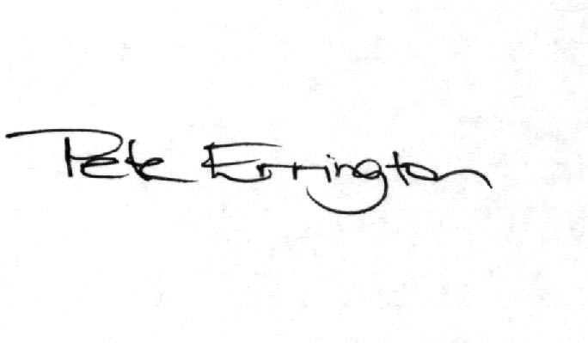

Pete Errington
Home Builders Federation
Regional Policy Manager (South, East & London)

