

BY EMAIL ONLY

Development Control Section
South Block
Compass Centre
Chatham Maritime
Chatham
Kent ME4 4YH

14th April 2008

Dear Sir/Madam,

DEVELOPER CONTRIBUTIONS GUIDE

Introduction

I refer to the above document on which HBF was consulted earlier in the year.

HBF did not submit any comments on the document at the time. This was not because we did not have any concerns or comments to make but because, due to other work pressures and commitments at the time, it was not possible for us to meet the specified 11th January deadline. However, my attention has been drawn to the relevant webpage on your council’s website which refers to consultation on the document finally having finished on the 14th March. Had HBF been informed that the consultation period had been extended by over 2 months then those reasons would not have applied and we could (and would) have submitted comments. It is most unfortunate and unhelpful that this extension of deadline was not more widely advertised as this has prejudiced our ability to engage in this piece of work.

It is also of great concern to note from the same webpage that, if consultation ended on the 14th March, a report was presented to a council committee less than 2 weeks later. Given the timescale for the production of committee reports in advance of committee meetings it is highly likely that the report to the 27th March meeting would have had to have been written and finalised prior to the end of the extended consultation period.

This begs two questions:

- Firstly, whether those councillors at the 27th March committee were really fully appraised of the nature and extent of comments which were submitted on behalf of house builders and the development industry; and
- Secondly, whether the final version of the guide (which I note was also presented to the 27th March committee) was properly informed by the results of the consultation period given that the final version of the guide was written, along with the committee report itself, before the 14th March close of the consultation period or, at best, so soon afterwards.

HBF is aware that some such representations were submitted but it would appear that the councillors attending the 27th March meeting were not given any clear indication of the nature and extent of objections submitted. Nor any detail of the precise way in which the guide itself was modified or amended in response to those representations

Again, this is most unhelpful and hardly in the spirit of what is supposed to be a frontloaded planning system founded on principles of proper and open stakeholder involvement and transparency and clarity in the decision making process. Both the regulations and Government policy guidance clearly set out the procedures to be followed when producing Supplementary Planning Documents. Regardless of whether or not HBF submitted objections to the Guide itself, the point has to be made that these procedures and regulations have apparently not been followed in this case as there appears not to have been the required summary and reporting of the representations made available to those responsible for deciding how to proceed towards the adoption of the document. On that basis the legality of the document and the process by which it was prepared must be questionable, to say the least, and the degree of weight to be attached to the final adopted guidance must be very limited as the council will not be able to demonstrate it has complied with all the relevant procedures.

It is HBF’s view that, prior to proceeding to Cabinet with a recommendation for adoption of the SPD (which we note is scheduled for the 22nd April) the document must be re-presented to an appropriate council committee accompanied by an officer report summarising and commenting on the representations received and clearly setting out how the Guide has been amended by way of response to those representations. This officer summary should be circulated separately to those who submitted representations prior to the preparation of the committee report. If this proper consideration of objections received does not happen, the document itself must be open to challenge.

I hope that you will see fit to act on these comments and I would be pleased to be kept informed of progress on this document and other related LDF matters.

Yours faithfully,

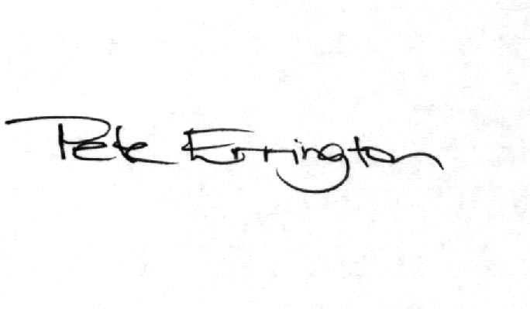

Pete Errington
Home Builders Federation
Regional Policy Manager (South, East & London)

