

BY EMAIL ONLY

Forward Planning Section

Dover District Council

White Cliffs Business Park

Dover

Kent

CT16 3PJ

7th May 2008

Dear Sir/Madam,

DEVELOPMENT CONTRIBUTIONS SUPPLEMENTARY PLANNING DOCUMENT

Introduction

Thank you for consulting the Home Builders Federation (HBF) on your council’s draft development contributions SPD. HBF has a number of comments to make on this document. Essentially we object to the fundamental principle of what is proposed as we consider it to be fundamentally unsound and contrary to Government policy and guidance. HBF suggests that the SPD should be withdrawn.

General Principles

HBF and house builders do not object to the principle that they should be required to make provision for, or fund, the infrastructure made necessary by new development. Nor do we object to the principle of a standard tariff approach as one means of achieving this. However, this has to be within the context set by Government policy on the use of planning obligations set out in Circular 5/2005.

The council claims that it’s proposed approach has been prepared in accordance with the provisions of Circular 5/2005. HBF would disagree. We consider that the council has selected certain parts of Circular 5/2005 with which the requirements are claimed to be in accordance (e.g. parts of the standard formulae / charge approach) but has largely ignored the fundamental principle of the five tests.

HBF is extremely concerned that the council is merely seeking to tax development as a way of paying for improvements to local recreation facilities principally for the benefit of the existing population which should more appropriately be paid for by the council itself from revenues generated locally and through central Government funding.

Circular 5/2005

As noted in the document Circular 5/2005 (paragraph B5) sets out five tests ALL of which must be met for a planning obligation to be considered acceptable. Obligations should be:
- relevant to planning;
- necessary to make the proposed development acceptable in planning terms;
- directly related to the proposed development;
- fairly and reasonably related in scale and kind to the proposed development; and
- reasonable in all other respects.

Paragraph B9 of the Circular makes clear that planning obligations must not be used solely to resolve existing deficiencies in infrastructure provision or to secure contributions to the achievement of wider planning objectives that are not necessary to allow consent to be given for a particular development.

Paragraphs B33 to B35 of the Circular deal with the issue of standard charges and formulae. These paragraphs make it clear that such charges can only be applied in the context of the five tests set out above and that they should not be applied in a blanket form regardless of actual impacts.

The same applies to the use of pooled contributions where councils are required to demonstrate both the direct relationship between the development and the infrastructure and that the scale of what is sought is proportionate to the impact caused (paragraph B21).

HBF’s view is that the proposed approach completely ignores these facets of the circular and, instead, is seeking to apply a fixed and standard tax on all new residential development across the district regardless of the scale of impact caused by that development and the nature and extent of provision already prevalent in an area.

Evidence & Justification

The document contains no information on the relationship between development which is likely to come forward in the district and the nature and extent of existing provision of facilities and amenities across the district.

Thus, there may be parts of the district where new development would not have an impact on a certain type of facility because there is a surplus of provision of that facility in the area or spare capacity to absorb additional use. There may be other parts where there are sufficient facilities but they require upgrading. There may be other parts where there is a shortage of provision and any additional development would create additional impacts which require mitigation. The point being that the Circular 5/2005 approach to administering planning obligations requires these actual impacts caused by new development to be taken into account; even in the standard charge or formulae approach. The council’s approach does not do this. It merely sets a fixed blanket tax on all new residential development. Therefore it is contrary to Government policy and so, fundamentally unsound.

Helpfully, there is information given in the document on open space provision by ward. This shows that there is a great variation of provision by locality with some areas exhibiting levels of provision per 1,000 population many times that of other areas. However, there is no proposal to vary the level of tariff on the basis of existing provision. Hence our concern that the council is proposing little more than seeking to tax new development as a way of making up for existing deficiencies in provision rather than seeking developers pay for, or provide, only what is needed to serve, or mitigate the impact of, their development.

Previous Consultation

It is interesting to note that Appendix 3 to the document sets out a summary of the discussion of a stakeholder workshop held on the 19th September 2007. Paragraph 1.10 of that note states that:
“Tariffs should include a full costing for infrastructure needs in the district for the LDF period. Costs would be divided between the council and developers accordingly, and the tariff set at a rate that is viable from the perspective of all parties”.

Paragraph 1.17 goes on to record the low land values prevalent in the district and in Dover town in particular compared to elsewhere.

While the document includes details of the costings for the delivery of new infrastructure, it is a shame that the council has sought to dis-regard the warnings of stakeholders about imposing additional costs in low land value areas and areas of marginal viability in a declining market. Similarly that it has sought to ignore comments about factoring in developer contributions alongside public and other Government funding to enable the delivery of new and improved infrastructure. Instead it is seeking to pass on these full costs to the development industry when this is wholly unjustified.

It should be borne in mind that it is not just the £4,290 per unit which is at issue. This tax is additional to a plethora of other costs and requirements placed on new development by the council and other public agencies, not least significant of which are the requirements for other services and facilities and delivering affordable housing and high levels of the Code for Sustainable Homes. If the council is to achieve the ambitious plans set out in its emerging core strategy then it will need to provide some hard evidence of development economics to the EIP inspector or its plans will come to nothing.

There is little point HBF going into the detail of the calculations or methodologies for estimating tariff liabilities for different developments as our objections are to the fundamental principle of what is proposed. Put simply we consider that developers should not be required to pay for these improvements to existing facilities. They should be required to make provision only for the impact caused by their own development but not general improvements to leisure and recreation provision on the district. Hence our call for this SPD to be withdrawn.

Yours faithfully,

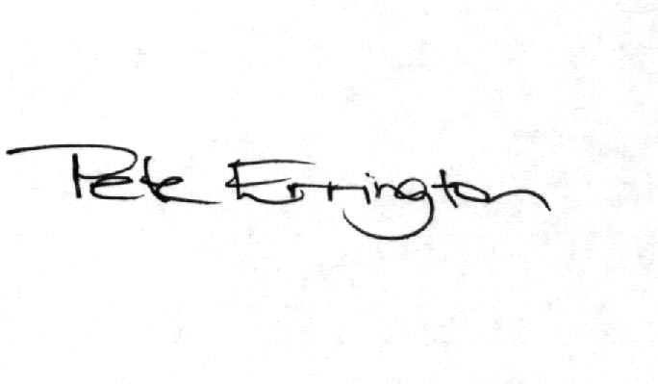

Pete Errington
Home Builders Federation
Regional Policy Manager (South, East & London)

