

BY EMAIL ONLY

Forward Planning Section

Dover District Council

White Cliffs Business Park

Dover

Kent CT16 3PJ

7th May 2008

Dear Sir/Madam,

CORE STRATEGY PREFERRED OPTIONS

Introduction

Thank you for affording the Home Builders Federation (HBF) the opportunity of influencing the preparation of your council’s core strategy DPD. Clearly, it is difficult to make any substantive comment on what may emerge in the LDF at some point in the future given this fairly early stage in the process. The devil is very much in the detail with many of these policy issues and it is only when we see the detailed wording of policy and actual requirements that we can comment in any detail. What follows, however, at least sets down a few markers in response to the options raised in the document which we hope can be taken on board as the more detailed policy wording evolves.

Chapter 4 – Land Options

HBF would support the council in aiming for Option 4 as its long term strategy goal. Option 1 should not even be considered as it is below the current position set out in the emerging SE Plan. Option 2 is the SE Plan Panel report figure and this should really be considered the minimum realistic option. Option 3 goes beyond the Panel’s figure in order to deliver the transformational goals the strategy sets itself. However, it is not significantly above the Option 2 SE Plan panel EIP figure. Figure 4, on the other hand, is substantially above this figure and would, if delivered, achieve these other strategic goals.

However, given the gap between Options 3 and 4 HBF considers that the council should not be bound by Option 3 as an option. Rather it should consider this the minimum option the strategy should set out to actually deliver on the ground albeit in the context of the longer term context of working towards Option 4. It may be that the submitted version of the plan should set out to achieve Option 3 ½ as a way of bridging the gap between Options 3 and 4.

Whichever option is finally chosen HBF does have one concern about the way these options are presented and that is in terms of the allowance for 120 dwellings per year from windfall development and the 600 allowance for vacant homes.

Dealing first with the latter, bringing back vacant homes into use, which obviously a worthy and laudable objective, does not create net new additions to the dwelling stock. As the name suggests, it is merely bringing back into use homes which are already built and have already been counted once as completions when they were built (or are built into estimates of the existing stock). As such it is to be considered over and above the SE Plan housing targets which are concerned with the delivery of net additions to the dwelling stock.

Turning secondly to the matter of windfalls, PPS3 (paragraph 59) and the accompanying good practice guidance on carrying out SHLAAs make it clear that allowances should not be made for windfall development. One exception exists and that is namely where the council is able to provide robust and credible evidence that it is unable to identify sufficient sites for development. The council has not provided such compelling evidence. Therefore the windfall allowances should be deleted from the housing trajectory in the core strategy and the council should, instead allocate additional land for development which can be identified in the allocations DPD.

Indeed HBF is extremely concerned that the strategy does not make any reference to the council having carried out a SHLAA as part of the evidence base under-pinning the housing aspects of this core strategy. There is not even reference on the council’s LDF webpages to a SHLAA featuring in the evidence base under-pinning the core strategy. Based on recent experience of local authorities elsewhere in the south east about to get to EIP with high windfall allowances and no evidence base in the form of a SHLAA, HBF would advise that the council is highly likely to have its strategy declared unsound and the Inspector may not even be willing to undertake an examination in the absence of such a crucial piece of supporting information.

The LDF process is all about delivery and the council will need to convince the Inspector that its ambitions are sufficient well evidenced as to be robust and considered sound. Particularly in this case where those ambitions are fairly lofty and given the acknowledged difficulty of delivery some of the major strategic options proposed in the document. The council will have to demonstrate in the submitted document and through the EIP how these difficulties can and will be overcome, by whom and by when and will have to set out what contingency is in place should they not be overcome in order to ensure that the overall housing target will be met.
Again HBF would suggest that the best way of addressing this would be in the form of a SHLAA. This should have been carried out already. If it has not, which would appear to be the case, HBF would urge the council to give this matter urgent attention between now and the document being submitted to Government.

In terms of the various approaches to how this could be presented in the submitted core strategy HBF would support Approach 2 as this most closely accords with the views expressed above.

Section 6 – When should it happen ?

Following on from the above comments it is interesting to note that one of the questions in this section is “are the assumptions about the start and completion times of major schemes reasonable?” HBF would suggest that it is the very reason why the Government requires local authorities to carry out SHLAAs to answer questions such as this. The council should not be proposing a strategy when it does not know the answers to questions as fundamental and important as these. These questions about delivery and timing and so on should be addressed through the process of carrying out a SHLAA in accordance with the Government’s practice guidance and with the full involvement of landowners, developers, house builders and others in order that these questions can be answered. Consultation on a draft strategy is too late to start asking these questions.

Policy CP5 (& DM8)

HBF questions the legal basis for the council seeking to commute a sum from developments in one location to fund affordable housing in another. We consider this to be contrary to the provisions of Circular 5/2005 which, until it is ultimately superceded by finalisation of Government’s plans for the CIL, remains Government policy on the matter of planning obligations. Until such time as the legislation changes HBF would argue that this is not something which can legally be required or sought.

HBF also objects to the suggestion that local authorities will seek to influence the precise size, type and mix of market housing. HBF has long criticised local authority policies on housing mix. Over-zealous intervention in the market through the planning system has largely been responsible for the change in the balance of development occurring across the south east in recent years to the extent that that balance itself is now drawing substantial criticism

PPS3, the regional assembly and even the recent panel’s report into the draft South East Plan all make it clear that it is not acceptable or helpful for local authorities to seek to dictate the size and type of housing provided by the private sector.

They may seek to influence it through negotiation. They may seek to prescribe the mix of affordable housing where this is fully supported by robust and credible evidence. But they must not restrict the ability of developers to respond to the market.

Thus, in addressing this issue in the core strategy the council should be guided by the results of its SHMA, once available. It should seek to devise sensible policies in conjunction with house builders rather than seeking to impose requirements on them.

Policy DM3

HBF is concerned that this policy is straying into matters of detail which are already more than adequately covered elsewhere; not least the Code for Sustainable Homes and building regulations. Paragraph 1.8 of PPS12 is relevant. These requirements will also impose significant financial burden on the house building industry and so impact on development viability and already high house prices. Sub-criteria (iii) & (iv) of paragraph 26 of PPS1 are relevant here.

The bottom line is that the C4SH imposes ever more stringent requirements to be introduced through Building Regulations whereby developers will be obliged to comply with the Code as of April this year, meet Code level 3 by 2010, Code level 4 by 2013 and full zero carbon Code level 6 by 2016. Developers will have to meet these exacting standards as they will be a legal requirement. HBF would suggest that the council is forgetting the fact that new housing is already many times more energy efficient than the existing stock. The house building industry is continuing to improve the energy efficiency of new dwellings and new dwellings built now are already 40% more energy efficient than those built only 5 years ago. If the council really wishes to forge ahead with this eco agenda then it should focus its attention on those areas which are not being addressed by other legislative regimes and where the real energy efficiency and eco gains can be made (e.g. the existing stock). It should not seek to impose arbitrary targets over and above (or in advance of) existing and emerging legislative requirements which specify particular techniques or procedures as this may well be counter-productive in the long run. Any targets must be properly justified with evidence as to their suitability and appropriateness and also taking into account the costs of implementation and so their impact on development viability and so overall housing delivery.

Policy DM20

HBF’s view on this policy is that the council should only seek to afford to the relevant designation a degree and level of protection which accords with the status of the designation. It should not seek to afford the same degree of protection to locally designated areas of value as to national and international designations such as SSSIs, AONB, etc.
Therefore, rather than having one policy on this matter there should be a hierarchy of policies each with requirements appropriate to the level of protection afforded by each particular level of designation.

I hope that these comments will be taken on board by the council prior to it submitting the core strategy to Government and for examination. I would, of course, be happy to discuss any of these matters with you further should you so wish. Otherwise I look forward to being kept informed of progress on the LDF preparation process as it goes through the statutory procedures.

Yours faithfully,

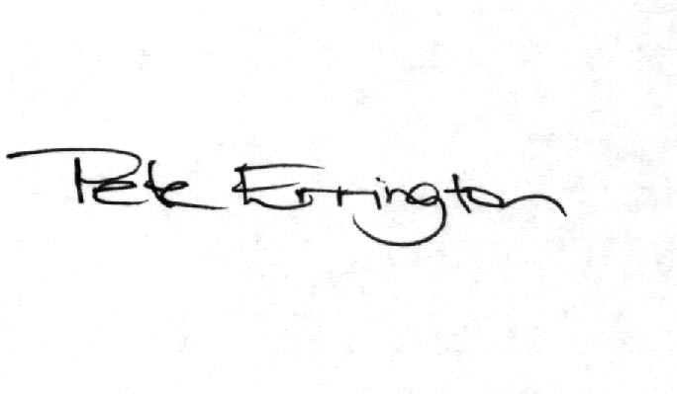

Pete Errington
Home Builders Federation
Regional Policy Manager (South, East & London)

