

BY EMAIL ONLY

MDE DPD Consultation

Tonbridge & Malling Borough Council

Gibson Drive

Kings Hill

Kent

ME19 4LZ

2nd May 2008

Dear Sir/Madam,

MANAGING DEVELOPMENT DPD – ISSUES & OPTIONS

Introduction

Thank you for affording the Home Builders Federation (HBF) the opportunity of influencing the early drafting of your council’s Managing Development DPD. Clearly, it is difficult to make any substantive comment on what may emerge in the LDF at some point in the future given this early stage in the process. The devil is very much in the detail with many of these policy issues. However, what follows at least sets down a few markers which we hope can be taken on board as the more detailed policy wording evolves.

Climate Change Mitigation

Option 1 would be HBF’s selection.

There is no justification or unique circumstance given to explain why Tonbridge & Malling should do anything other than require compliance with the already challenging national standards which will be introduced as mandatory requirements through the Code for Sustainable Homes and successive changes to the building regulations. Certainly there is no justification given, nor any evidence provided, as to why the council should seek to advance the timescale of the C4SH. There is no evidence of any unique local circumstance why this may be necessary, Nor is any evidence provided of the cost implications of the requirements associated with Options 2 & 3 and so the impact on development viability and the knock-on effects of that on overall housing delivery.

HBF is concerned that the council is mis-representing the true facts about these latter cost and delivery considerations on the basis of no hard evidence and is misleading readers of the document into believing these are reasonable and realistic options. They are not. Government is addressing this issue nationally through the C4SH, something house builders are signed up to, and seeking anything more onerous than this will actually be counterproductive.

Renewable Energy Generation On-Site

Any policy in this DPD has to be consistent with the policy approach set out in the over-arching core strategy DPD. On that basis there is no need for an additional policy in this DPD as the matter is already more than adequately covered by the adopted core strategy policy. It would be unsound to seek to make the adopted core strategy policy more onerous or restrictive through this DPD. HBF therefore objects to both Options 1 and 2 under this heading

Micro-Renewables

HBF supports the view set out in the draft amendment to PPS1 and the subsequent working draft practice guidance to draft PPS1 amendment that, while local authorities may reasonably seek to encourage or support the use of renewable energy in the district they should not go so far as to specify the means or technology by which this be achieved. As noted in paragraph 3.37 of the practice guidance, such policies need to be flexible so as to make the best use of emerging technology and to allow innovation.

Waste Minimisation

Again HBF is concerned that the council is proposing to alter policy which has only recently been adopted in the core strategy. Policies in DPDs have to be consistent with core strategy policy in order for the whole LDF to be consistent and co-ordinated and in order to be found sound. It is fundamentally unsound, therefore, for policies in a development management DPD to be more onerous or exacting that policies in the overarching core strategy. Indeed, if the matter is already covered in sufficient detail in a core strategy there is no need for a further policy in this DPD as this could only result in confusion and delay.

Sustainable Drainage

HBF and its member companies are keen supporters of the principles of SUDS. However, the major drawback to their more widespread take-up is because of a reluctance on the part of statutory undertakers and local authorities to take on responsibility for their long term maintenance and upkeep. Before finalising its policy position on SUDS the council must demonstrate it has resolved this problem.

It may be that the council could even take the lead and show willingness to adopt these facilities itself given that it is the council that is requiring their implementation. Either way, the costs and responsibilities for long-term maintenance should be factored in alongside all the other costs loaded on to development when considering development viability and overall housing delivery.

Water Efficiency

HBF is concerned that the council is proposing to stray away from mainstream spatial planning and into the realms of other regulatory regimes. Comments made above in respect of the C4SH apply here. It is being introduced as a mandatory statutory requirement and developers will have to comply with these future legal requirements. There is no need or justification for the council to consider any additional requirements as this can only result in confusion, conflict and delay.

Climate Change – Summary

On all of the above points HBF is concerned that the council is straying into matters of detail which are already more than adequately covered elsewhere; not least the C4SH and building regulations. Paragraph 1.8 of PPS12 is relevant. These requirements will also impose significant financial burden on the house building industry and so impact on development viability and already high house prices. Sub-criteria (iii) & (iv) of paragraph 26 of PPS1 are relevant here.

The bottom line is that the C4SH imposes ever more stringent requirements to be introduced through Building Regulations whereby developers will be obliged to comply with the Code as of April this year, meet Code level 3 by 2010, Code level 4 by 2013 and full zero carbon Code level 6 by 2016. Developers will have to meet these exacting standards as they will be a legal requirement. HBF would suggest that the council is forgetting the fact that new housing is already many times more energy efficient than the existing stock. The house building industry is continuing to improve the energy efficiency of new dwellings and new dwellings built now are already 40% more energy efficient than those built only 5 years ago. If the council really wishes to press ahead with this eco agenda then it should focus its attention on those areas which are not being addressed by other legislative regimes and where the real energy efficiency and eco gains can be made (e.g. the existing stock). It should not seek to impose arbitrary targets which specify particular techniques or procedures as this may well be counter-productive in the long run. Any targets must be properly justified with evidence as to their suitability and appropriateness and also taking into account the costs of implementation and so their impact on development viability and so overall housing delivery.

Question 22 – Countryside Policy

HBF takes the view that there is no justification for automatically carrying forward any of the existing countryside policy. Rather its purpose and justification should be reviewed in the light of more recent Government guidance set out in PPS7 and the comments of the SE Plan EIP Panel’s Report regarding Green Belt and Gaps.

The Natural Environment

Dealing with all of these Options together, HBF’s view is that the council should only seek to afford to the relevant designation a degree and level of protection which accords with the status of the designation. It should not seek to afford the same degree of protection to locally designated areas of value as to national and international designations such as SSSIs, AONB, etc. Each policy should be clear as to the reason for and purpose of each policy designation and it should be worded in such a way that its impact can be monitored. Finally the cost implications associated with the creation and maintenance of any new habitats or environments should also be factored into assessments of development viability alongside all of the other costs imposed on new development in order that the council can demonstrate its housing target will be achieved.

Theme 4 Local Character & Quality of Life

Dealing with all of these questions and options together HBF’s view is that, whatever approach is finally decided upon must take into account the impact on future development. If there are to be changes proposed which tighten up on opportunities for urban infilling and redevelopment then the assumptions which underpin the SHLAA, housing trajectory and 5 year supply calculation must be amended accordingly.

Open space

Dealing with all of these options together HBF’s view is that the council should adopt an approach based on the provisions of PPG17 and Circular 5/2005. In other words, development should only be required to make provision for the open space requirements made necessary by the development and should not be required to make up solely for deficiencies in existing provision. The council should undertake an audit of open space provision by local area and identify the areas of surplus and under-provision and areas where existing provision could be improved. In areas of over-supply (compared to adopted standards) it is likely there will be spare capacity to accommodate new development without requiring additional provision in from new development. However, the opposite will be the case in areas poorly provided with open space or where existing provision is of poor quality. In all cases, however, what is sought must reflect these supply and quality considerations and there should not be a single blanket policy which applies without exception across the district.
I hope that you will find these comments helpful and that they will be taken on board when the council comes to draft policies for the development plan document in earnest.

I would, of course, be happy to discuss any of these matters with you further should you so wish. Otherwise I look forward to being kept informed of progress on the LDF preparation process as it goes through the statutory procedures.

Yours faithfully,

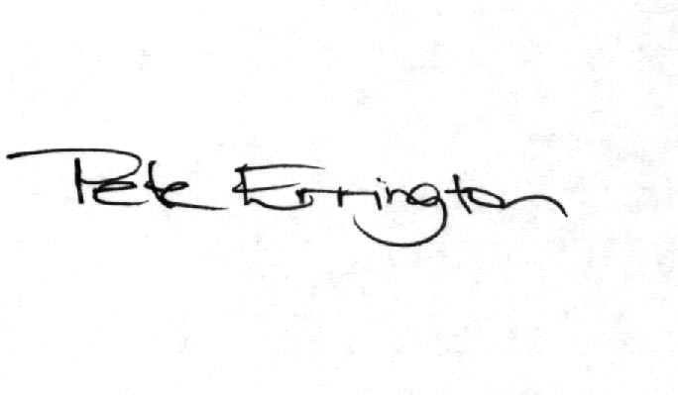

Pete Errington
Home Builders Federation
Regional Policy Manager (South, East & London)

