
BY EMAIL ONLY

Planning Policy Team

Havant Borough Council

Civic Offices

Havant

Hants PO9 2AX
30th April 2008
Dear Sir / Madam,

HAVANT CORE STRATEGY PREFERRED OPTIONS

Further to my letter of 25th April there is one further comment I wish to make on the preferred option which I omitted from my previous representations.

While it is acknowledged that, technically, the council is within its rights not to register what follows as a duly made objection given that it has been submitted after the deadline for comments, nonetheless what follows raises an important issue and it gives the council advanced warning of the tone and nature of future representations HBF will make to the submitted version of the core strategy. It is also a point we will pursue with vigour through the EIP process so I thought it only helpful to raise it now in order that the council has time to fully consider the implications of what is proposed and in order that we were not criticised for raising this fundamentally important point late in the day.

The point relates to paragraph 4.18 of the core strategy preferred options and the reference to housing mix and space standards.

HBF is concerned that this important matter is hidden away in the text of the preferred options when, if it is as is claimed, the council’s preferred option, it should have been given greater prominence in the document as it will have a significant impact on the viability of new housing and so overall housing delivery in the borough. It is an odd way of writing a supposedly clear and transparent policy document meant to engender stakeholder involvement and confidence in the process to include a proposed policy (CS9) in the document supposedly dealing with housing mix yet to omit what appears to be the real crux of the housing mix issue (certainly the most contentious and important aspect of the policy) and hide this away in the supporting text. This is less than helpful.

Firstly, on housing mix in terms of size and type, HBF has long criticised local authority policies on housing mix. Over-zealous intervention in the market through the planning system has largely been responsible for the change in the balance of development occurring across the south east in recent years to the extent that that balance itself is now drawing substantial criticism

PPS3, the regional assembly and even the recent panel’s report into the draft South East Plan all make it clear that it is not acceptable or helpful for local authorities to seek to dictate the size and type of housing provided by the private sector.

They may seek to influence it through negotiation. They may seek to prescribe the mix of affordable housing where this is fully supported by robust and credible evidence. But they must not restrict the ability of developers to respond to the market.

Thus, in addressing this issue in the core strategy the council should be guided by the results of its SHMA. It should seek to devise sensible policies in conjunction with house builders rather than seeking to impose requirements on them.

Turning now to the issue of space standards this is not something which falls within the remit of spatial planning. Therefore it is not something which the council has the power or authority to require. Again, it can seek to negotiate with developers for the provision of new accommodation to certain standards. But it cannot unilaterally mandate that those standards are adhered to. Even if it could, this would have to be something addressed through both the SHMA in terms of robust and credible supporting evidence of the need for accommodation to meet certain prescribed standards. It would also have to be factored into the SHLAA as it will obviously impact on the future capacity of sites and so site viability and, again, the achievement of the overall housing target.

These are significant considerations which will have a major impact on the deliverability and soundness of the overall core strategy and, as such, should have been given greater prominence in the preferred options document in order that stakeholders could have considered these matters more fully in their representations. The council is urged, therefore, to consider these comments in the work it undertakes preparing the submitted version of the document in spite of the comments being submitted after the end of the consultation period (though only shortly after).

In the meantime, until this matter and the evidence under-pinning it has been subject to thorough and independent testing through the EIP process and given the surreptitious way in which this matter is treated in the preferred options, there can certainly be no justification for the council seeking to require private sector developers to adhere to EP or HC space standards for dwellings on non-EP sites or which do not qualify for HC funding.

Yours faithfully,
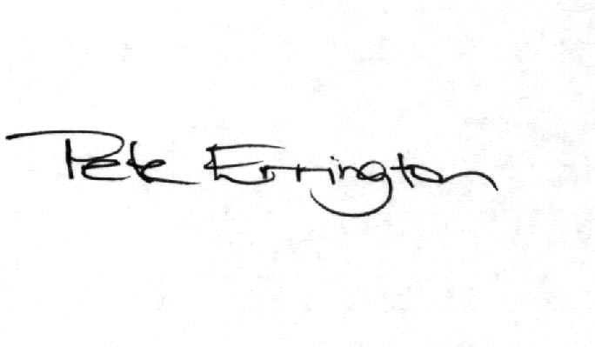

Pete Errington
Home Builders Federation
Regional Policy Manager (South, East & London)

