

BY EMAIL ONLY

Planning Policy Team

Havant Borough Council

Civic Offices

Havant

Hants PO9 2AX

25th April 2008

Dear Sir / Madam,

HAVANT CORE STRATEGY PREFERRED OPTIONS

Introduction

Thank you for consulting the Home Builders Federation (HBF) on your council’s core strategy preferred options. HBF has a number of comments on the document and these are set out on the attached sheets in the order in which they appear in the document.

I trust these matters will be considered and the strategy amended prior to its submission to Government. Either way, I would be pleased to be kept informed of progress on this document and all other related LDF matters.

Yours faithfully,

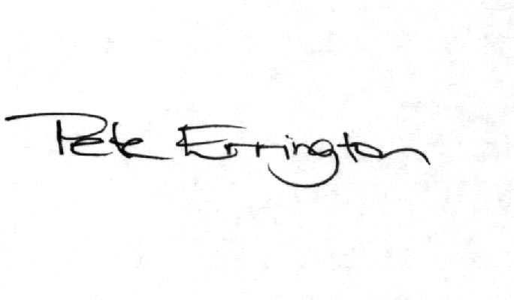

Pete Errington
Home Builders Federation
Regional Policy Manager (South, East & London)

Policy / Paragraph No: Policy CS1 – Protection and Enhancement of the Environment

Reason for Objection: Policy is wholly unreasonable, un-implementable and contrary to Government policy

Relevant PPS11 Test(s) of Soundness: iv, vi, vii, viii, ix

Change Sought: re-wording of policy

Comment:

It is wholly unreasonable to require all development to meet all of the criteria listed when the majority of those criteria will not apply to all development. For example, why should a development in Leigh Park be required to enhance woodland in the Forest of Bere or the Chichester Harbour AONB ? That would be wholly unjustified and unreasonable under the requirements of Circular 5/2005. Yet, as worded, all development must meet all criteria and most criteria require development not only to protect certain features (which may not be unreasonable – “not create an adverse impact on” may be a better form of wording) but also enhance them.
The policy should be amended so that only those criteria which relate to particular developments or locations are required to be met and this must only address issues related to preventing adverse impact on features of acknowledged importance rather than requiring that they be enhanced in the case of all development.
Policy / Paragraph No: Policy CS2 – Efficient Use of Resources

Reason for Objection: Policy is excessive unreasonable and unjustified and contrary to Government policy

Relevant PPS11 Test(s) of Soundness: iv, vi, vii, viii ix

Change Sought: re-wording of policy

Comment:

Government is introducing a series of requirements through the Code for Sustainable Homes which will require improving energy and efficiency in new housing development through a series of step change targets to be imposed through the building regulations. As they are to be implemented through the building regulations they will be mandatory and there is a clear process for their monitoring and implementation.

The C4SH imposes will require developers to comply with the Code as of May this year, meet Code level 3 by 2010, Code level 4 by 2013 and full zero carbon Code level 6 by 2016.

There is no need or justification for Havant to seek to exceed these already extremely challenging targets nor to advance the timescale for their implementation.

HBF would suggest that any policy on resource use should also take account of the fact that new housing is already many times more energy efficient than the existing stock. The house building industry is continuing to improve the energy efficiency of new dwellings and new dwellings built now are already 40% more energy efficient than those built only 5 years ago. If the council really wishes to press ahead with this eco agenda then it should focus its attention on those areas which are not being addressed by other legislative regimes and where the real energy efficiency and eco gains can be made. It should not seek to impose arbitrary targets which specify particular techniques or procedures as this may well be counter-productive in the long run. Any targets must be properly justified with robust and credible evidence as to their suitability and appropriateness and also taking into account the costs of implementation and so their impact on development viability and so overall housing delivery.

Policy / Paragraph No: Policy CS3 – Effective Use of Land & Infrastructure

Reason for Objection: Policy is unrealistic and inflexible

Relevant PPS11 Test(s) of Soundness: vii, ix

Change Sought: re-wording of policy

Comment:

It is unrealistic and unreasonable to require all new or improved infrastructure to be provided on-site. It simply does not reflect the reality of either development proposals or infrastructure requirements. Most schemes are likely to require the provision of, or contribution towards the provision of, infrastructure off-site as well as, or in lieu of, on-site provision. The policy should be sufficiently flexibly worded to allow for this reality of the development process.
Policy / Paragraph No: Policy CS8 – Housing Provision

Reason for Objection: Inclusion of windfall allowance is contrary to Government policy. Lack of inclusion of a housing delivery / PMM policy

Relevant PPS11 Test(s) of Soundness: iv, vi, vii, viii, ix

Change Sought: Discounting of windfall allowance from housing trajectory and inclusion of a clearer policy commitment to monitoring, managing and delivery of housing target.

Comment:

HBF has set out our comments on the council’s SHLAA in our letters to the council dated 7th June and 31st August 2007. These address our concerns regarding the SHLAA generally and the windfalls issue in particular.

Turning to the issue of delivery the policy is unclear as to exactly how the council will ensure the delivery of its housing target. The policy needs to explain how exactly the council will adjust the pace of delivery of housing by bringing forward or holding back new development. It needs to set out what these developments are which could be brought forward if required and what are the processes and mechanisms by which these will be released. The detail of this can be addressed in SPD but there should be more detail than at present included in the policy.

Finally, in view of the fact that housing targets are minimum targets and given that Havant is part of the PUSH growth area, HBF considers that the words “or holding back” are unnecessary and inappropriate for inclusion in the policy. They should be deleted.
Policy / Paragraph No: Policy CS9 – Affordable Housing

Reason for Objection: Policy is not supported by robust and credible evidence

Relevant PPS11 Test(s) of Soundness: vii, ix

Change Sought: deletion of 40% target

Comment:

The SE Plan panel recommended a target level of affordable housing provision of 30-40% across the PUSH authority areas. The council has not provided robust or credible evidence that requiring a level of provision at the top of this indicative range, when added to all other planning obligations and development requirements (not least the C4SH requirements), will not adversely affect site viability and so overall housing delivery. If this target percentage is to properly tested at the EIP the council must undertake a financial viability study which assesses the impact of such a high level of affordable housing alongside these other requirements.

