

BY EMAIL ONLY

Planning Services

Spelthorne Borough Council

Knowle Green

Staines

TW18 1XB

16th April 2008

Dear Sir/Madam,

RE-ADVERTISED SPELTHORNE CORE STRATEGY

Introduction

Further to our letter of objection to the original submitted core strategy dated 27th July 2007 and subsequent correspondence with the Inspector HBF wishes to reiterate the concerns raised previously. In terms of these re-advertised proposals HBF has two objections both of which relate to policy omissions rather than proposed policy wording. Our previous comments and concerns remain outstanding.

The first omission relates to the lack of a policy to deal with contingency in housing provision. As we stated previously, the council place a very high reliance on windfall development, something which is contrary to both Government policy and guidance. We will no doubt debate this at the EIP. However, the fact remains that, whatever the Inspector decides on the windfalls issue, there is no policy in place in this core strategy to ensure continuity of housing supply and to guarantee delivery of the housing target. This is an unsound approach to spatial planning and the strategy should include a policy which sets out how any shortfalls in housing provision on a year by year basis will be met. The current policy approach, as we stated in our previously submitted objections, is a plan-review approach rather than a plan-monitor-manage approach; something also contrary to Government policy.

Our second objection relates to the lack of a policy dealing with Green Belt review. Our objection on this was also previously set out and those concerns remain outstanding. The council should not be proceeding to EIP without having undertaken a review of the Green Belt boundaries – something suggested may be necessary by the SE Plan EIP Panel in their report.

This is closely related to the windfalls issue as, rather than relying on unidentified windfalls, the council should be identifying sites for development through the SHLAA process and this is likely to necessitate consideration of sites in the Green Belt given the characteristics of Spelthorne borough.

Yours faithfully,

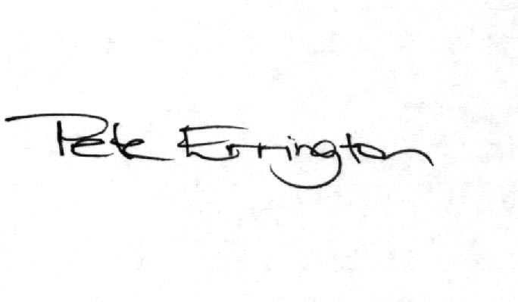

Pete Errington
Home Builders Federation
Regional Policy Manager (South, East & London)

