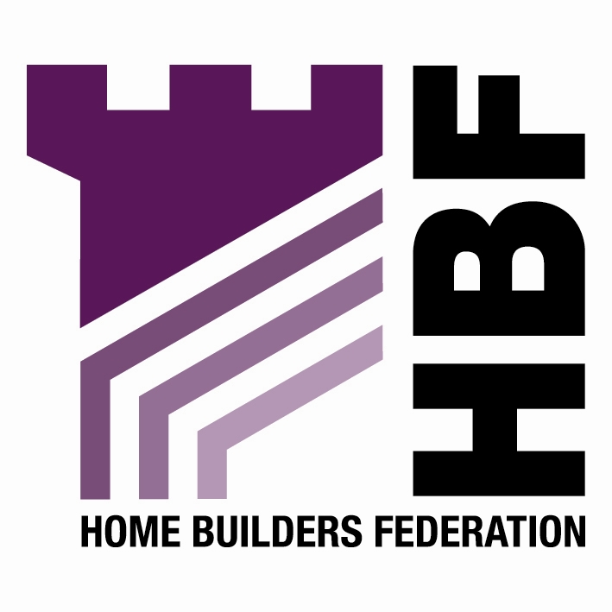

BY EMAIL ONLY

James Ives

Senior Policy Planner

New Forest District Council

Appletree Court

Lyndhurst

Hants SO43 7PA

16th April 2008

Dear James,

NEW FOREST SHLAA METHODOLOGY

Introduction

Thank you for consulting the Home Builders Federation (HBF) on your council’s proposed SHLAA methodology. I am afraid to say that HBF has a number of concerns about what is proposed; not least that the council seems to be undertaking more of an update of the urban capacity study rather than a SHLAA as required by PPS3 and set out in the accompanying practice guidance.

Stage 1

While there is nothing wrong, per se, with using the UPS as a basis for the study as explained in Stage 1, this cannot be the only basis for the SHLAA as, by definition the UPS only looked at urban sites whereas the SHLAA is supposed to investigate all sites, not just urban sites. Therefore we are concerned that the site search only appears, according to this text in Stage 1 at least, to be covering land within the defined settlements. It may be the case that suitable sites are put forward adjacent to these settlement boundaries. If landowners or developers are suggesting such sites as part of this process then they should be assessed.

It may be that they are subsequently ruled unacceptable as part of the assessment process. However, the policy ‘filter’ should not be applied right at the start of the study.

This is supposed to be a technical exercise largely independent of existing policy constraints (other than obvious national and international designations such as SPA, SSSI and National Park etc) as it is supposed to inform and test whether there is a need to review existing policies in order to ensure than housing targets will be delivered. The fact that the council’s draft core strategy policies currently propose a restrictive approach to development in the countryside is largely irrelevant at this initial stage of the SHLAA. That policy may not be an appropriate policy in view of the need to deliver the housing target so it should not be identified as a constraint which prevents sites being included in the SHLAA from the outset.

Having said all of that, looking at later stages in the methodology (Stage 4) there is a reference to including “reasonable locations” outside the settlements. There would appear to be an inconsistency between the two parts of the methodology and it should be clarified whether the assessment is including just sites within the settlement boundaries or not. The methodology should also define what is meant by the term “reasonable locations” and should explain how this will be interpreted and applied in practice. Again, HBF would be concerned if the council were seeking to strike out sites too early in the SHLAA process. We are looking for reassurance from the council that this will not be the case.

Stage 2

The same applies to the open space and cemetery designations in Stage 2. Unless the council has also undertaken robust audits of the provision and need for such amenities then it is unacceptable to rule out such land at this early stage in the process. There may be parts of the district where there is a shortfall of open space (or allotments or similar) and where existing facilities are rightly protected, However, there may be other parts of the district where this is not the case. There may also be other circumstances where it is the quality of provision which is more important than the amount of provision and that releasing part of a site for development can ultimately result in a better more usable facility in the long run. The point being that urban open space is not a nationally important resource (in the same way as an SSSI, AONB or National Park is) and so should not be ruled out at the outset unless other studies and evidence suggest such an approach is appropriate and necessary.

Stages 9 & 10

HBF is also concerned at the approach set out at Stage 9. This is not a broad locations approach; it is just a windfall allowance. Paragraph 59 of PPS3 is very clear on how windfalls should be treated. The PAS / POS guidance is a document which has no formal status and has not be endorsed by Government. It has not even been subject to any consultation. HBF’s view is that, while the document contains some useful advice on the relationship between the carrying out of a SHLAA and the LDF process, on the matter of broad locations / windfalls, it is plain wrong.

I attach a copy of correspondence from CLG which addresses these points about the status of the PAS/POS guidance and the way it treats the broad locations / windfalls issue. You may wish to consider this before placing too much reliance on this non-statutory document in justification for your proposed approach.

PPS3 and the good practice guidance are both very clear on how the issue of windfalls should be treated. Put simply they should not be included, certainly not in the early years of the SHLAA / strategy period.

There is one exceptional circumstance set out in PPS3 as to when windfalls may be accepted. That is where the council is able to provide robust evidence that it is not possible for them to identify sufficient sites. The fact that windfalls have come forward in the past is largely irrelevant. The fact that the SHLAA is going down to a threshold of five dwellings should mean that it is possible to identify sites meaning that the PPS3 exceptional circumstance does not apply. I also attach a copy of a recent SEERA report on the windfalls issue which you also may wish to consider prior to finalising the methodology.

It is also somewhat strange that the council is proposing to include a windfall allowance for sites of 10 or more dwellings when the SHLAA is looking to identify sites down to five dwellings. The methodology claims there will not be a double count. However, if sites of five to 9 dwellings are counted as potential identified sites in the same way as other identified sites then clearly there will be a double count. HBF would suggest this is all the more reason not to include windfall allowances. At the very least, if a windfall allowance is going to be included, it should be for sites of 4 or less dwellings only.

I trust these matters will be considered and the methodology amended and clarified prior to work commencing on the study in earnest. Either way I would be pleased to be kept informed of progress on the SHLAA as it evolves.

Yours sincerely,

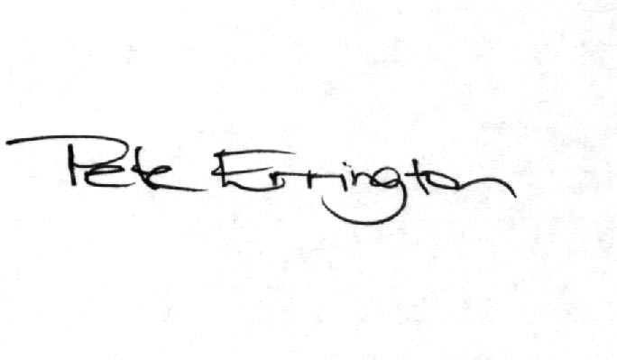

Pete Errington
Home Builders Federation
Regional Policy Manager (South, East & London)

