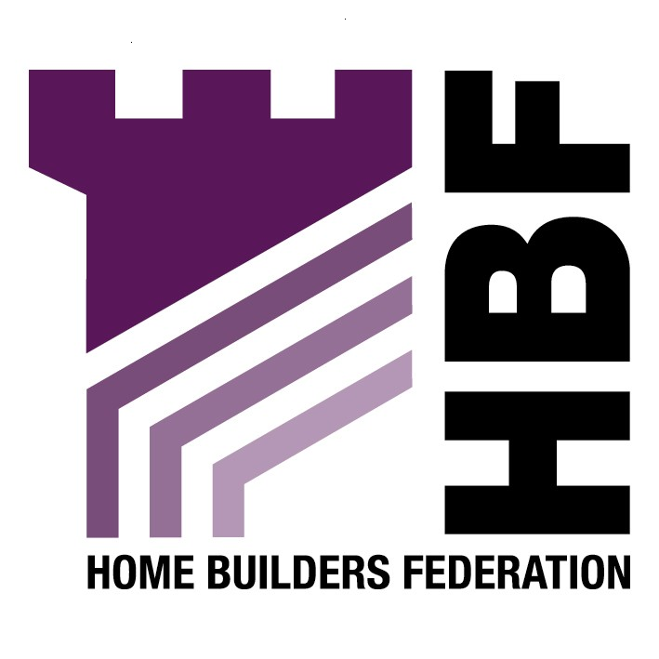

Sent by email: planning.policy@hullcc.co.uk

Planning Policy Team
Hull City Council
FREEPOSTHU 152
Kingston House
Bond Street
Hull
HU1 3BR

Dear Sir or Madam

Re: Sustainable Development Supplementary Planning Document

Thank you for consulting the HBF on the above document. Please find our comments below that are concerned with some of the issues introduced in the SPD rather than answering the specific questions set by the Council.

General Comment

HBF is concerned that this draft SPD does far more than simply expands or supplements the existing adopted policy. Rather, that it introduces a raft of onerous and prescriptive policy requirements on the house building industry which should more properly be included in a DPD in order that their implications can be tested through the process of independent examination.

Theme 2 – The Built Form

We note the reference in this section (paragraph 2.1) to the Code for Sustainable Homes. HBF supports in principle Government’s policy to seek to improve the quality and energy performance of new housing development beyond levels set out in current building regulations. The industry is signed up to the principle of a ten year time frame to securing zero carbon development as set out in the current raft of consultation documents allied to PPS1. We consider this to be a very challenging target as it will require substantial changes in practices, techniques and procedures currently employed throughout the house building industry. Perhaps more importantly, however, it requires significant changes and 'up-skilling' in the supply industries and energy industries if new and emerging technologies are to be developed to such a degree that their reliability and quantity of supply can be guaranteed. This is far from being proven at present; hence the ten year timescale. Nonetheless we believe it to be an achievable challenge provided that the various stakeholders work in collaboration towards a single and clearly defined set of objectives.

While the industry is working towards integrating the Code for Sustainable Homes in their standard building practices, this is a gradual process, and we would be concerned if overly prescriptive and locally defined design standards obstructed housing delivery.

The housebuilding industry simply cannot operate effectively in a climate whereby each individual council has their own increasingly onerous and poorly justified policy, therefore the HBF would be concerned about the detailed content of policies relating to such matters and awaits further documents to supplement these general comments.

HBF is concerned about the reference in paragraph 2.8 to Lifetime Homes. Meeting the needs of an ageing population in a practical way is important and homebuilders wish to help with solutions. We cannot, however, look at the needs of the ageing in isolation from those of our customers as a whole. The needs of the elderly themselves also vary widely, and the universal application of the Lifetime Homes standard to all new homes would be at the same time a disproportionate and insufficiently targeted response. It is not a panacea.

The critical issue facing people in the housing market today is affordability. Many young people are struggling to get on the property ladder. A disproportionate, one-size-fits-all approach to applying Lifetime Homes standards would adversely affect homebuilders' efforts to keep housing affordable and meet the needs of customers in younger age groups.
Theme 4 – Water Management
The HBF is extremely concerned about the statement in paragraph 4.9 that states ‘each residential unit with a private garden should have a water butt fitted to each separate gutter to collect rainwater from the roof’. This seems totally unreasonable and a very detailed, prescriptive requirement that the HBF would strongly to object to. The SPD should include policies to achieve the aim to make efficient use of water resources but not with such prescriptive requirements.
Theme 6 – Waste and Recycling

Similarly to the comment above, the HBF would like to submit the same comment with reference to the statement in paragraph 6.3 that states ‘where appropriate composting bins should be included in new development to allow residents to reuse organic waste on their gardens’.

Thank you again for giving the HBF the opportunity to comment. We trust you will take our comments on board and look forward to receiving further information regarding the progress of the document.

Yours sincerely

Gina Bourne
Regional Planner – Northern Region

Home Builders Federation

