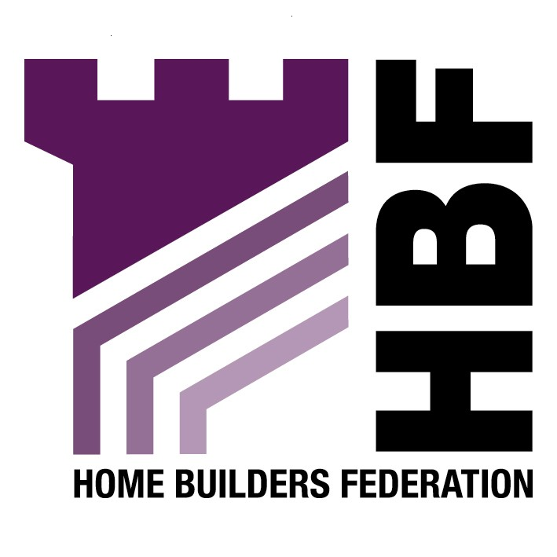
Emailed to: strategic.planning@rochdale.gov.uk

Strategic Planning
Telegraph House
Baillie Street
Rochdale
OL16 1JH

17 April 2008

Dear Sir or Madam

Re: Energy and New Development Supplementary Planning Document

Thank you for inviting the Home Builders Federation to comment on the above draft supplementary planning document. We have made the following general observations in relation to the scope of the document:

Paragraph 1.8 of PPS12 makes it clear that planning policies should not seek to duplicate or cut across matters more appropriately within the scope of other legislative regimes. Energy efficiency in building use and construction is manifestly the responsibility of the building regulations. The result of a recent review of Part L is that all new homes built after April 2006 will be 40% more energy efficient than new homes built in 2002. That is a massive and extremely rapid improvement in performance and new homes are now many tens of times more energy efficient than the existing stock. There must come a point at which, if we are to make real efficiency gains, more attention is diverted to the real culprit, namely the existing stock, rather than constantly going for the easy option of further restrictions on new building. These requirements are making new homes ever more expensive at a time when affordability is a very serious concern and also at a time when these features are still not wanted by consumers. Efforts should be focussed on changing public perception of the issue if this is not to be a very costly mistake.

HBF supports in principle Government’s policy to seek to improve the quality and energy performance of new housing development beyond levels set out in current building regulations. The industry is signed up to the principle of a ten year time frame to securing zero carbon development as set out in the current raft of consultation documents allied to PPS1. We consider this to be a very challenging target as it will require substantial changes in practices, techniques and procedures currently employed throughout the house building industry. Perhaps more importantly, however, it requires significant changes and 'up-skilling' in the supply industries and energy industries if new and emerging technologies are to be developed to such a degree that their reliability and quantity of supply can be guaranteed. This is far from being proven at present; hence the ten year timescale. Nonetheless we believe it to be an achievable challenge provided that the various stakeholders work in collaboration towards a single and clearly defined set of objectives.

It is worrying, therefore, to find that through the wording of this draft policy that we are not working to a single set of policy objectives. Rather, that each council is proposing to set their own targets which may be less well defined or clear and with less understanding of the implications of those targets. The housebuilding industry simply cannot operate effectively in a climate whereby each individual council has their own increasingly onerous and poorly justified policy. We are already seeing a situation develop whereby individual authorities and regions are seeking to out-do other authorities and/or regions by seeking to develop the most onerous targets. Having a plethora of different targets and policies in operation can only be counter-productive, not only to achieving the overall carbon reduction targets, but also to the need to deliver a substantial step-change in housing supply in the North West region.

If the Government is to achieve its house building targets and work towards the delivery of 240,000 new dwellings per year to 2016 and 3 million by 2020 (250,000 higher than the previous target) then it must set in place a level policy playing field nationally. If the Code for Sustainable Homes is to have any value then it must be rolled out on a consistent basis nationally. If individual authorities are allowed to establish their own interpretations of, or alternatives to the Code, the Code itself will serve no purpose.

Thank you again for giving the Home Builders Federation the opportunity to comment on the draft SPD. We look forward to your consideration of our objections and trust we will be kept informed of the future progress of the document.

Yours sincerely

Gina Bourne

Gina Bourne
Regional Planner – Northern Regions
Home Builders Federation

