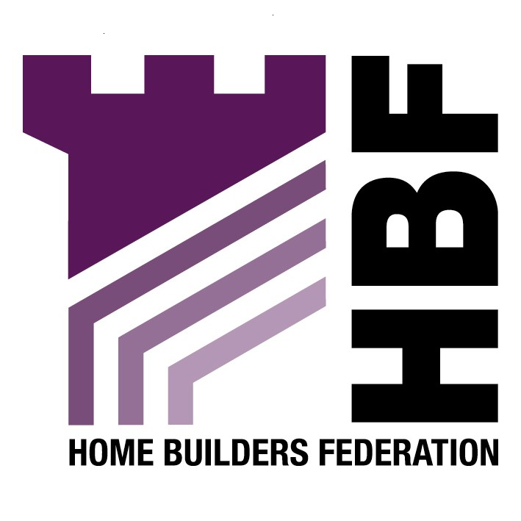

Sent by email: gemma.jones@epnbc.gov.uk

Planning Services
Ellesmere Port & Neston Borough Council
Council Offices
4 Civic Way
Ellesmere Port
Cheshire
CH65 0BE

24 April 2008

Dear Sir or Madam

Re: Ellesmere Port & Neston Borough Council Core Strategy Issues and Options Paper

Thank you for consulting the HBF on the above document. Please find our comments below –

Strategic Sites

HBF objects to the identification of four sites as being of strategic importance within the Core Strategy issues and options, as referred to in paragraph 5.37 and subsequent sections. PPS12: Local Development Frameworks paragraph 2.12 states ‘the core strategy should contain clear and concise policies for delivering the strategy which will apply to the whole of the local planning authority’s area or to locations within it, but should not identify individual sites. These should be dealt with under site specific allocations development plan documents or area action development plan documents’.

Notwithstanding the above objection, the HBF is concerned that the identification of these strategic sites is not founded on a robust and credible evidence base. PPS12 paragraph 2.15 states ‘the identification of sites should be founded on a robust and credible assessment of the suitability, availability and accessibility of land for particular uses or mix of uses’. PPS3 also supports the importance of an evidence based policy approach, paragraph 11 states ‘Local Development Document policies should be informed by a robust, shared evidence base, in particular, of housing need and demand, through a Strategic Housing Market Assessment and land availability, through a Strategic Housing Land Availability Assessment (SHLAA). It is noted that the glossary states Ellesmere Port and Neston will produce its first SHLAA in May 2008.

Housing Key Issues & Options

Question 35 - Should the RSS target of 80% of new housing in the district being on previously developed sites by adopted or is there a case for a higher target?

The HBF objects to the inclusion of a density requirement. Density should not be a driver of housing, but more an outcome. The overriding concern should be ensuring that what is proposed is the right scheme for the site. Prescriptive density requirements are not helpful, and will not help deliver the right types of development.

However, should a density target be included in subsequent Core Strategy stages it should be based on the RSS target and not an increased target. The Secretary of State’s Proposed Changes to the draft RSS have been published for consultation (20 March 2008) and this document has taken forward the Panel Reports recommendation with regard to the target for new housing being in previously developed sites at 80% for Ellesmere Port and Neston. Therefore given the RSS is at an advanced stage, HBF would suggest that this policy holds even more weight.

Question 36 – Should the Core Strategy plan for a level of housing provision even higher than the draft RSS (given that the RSS targets may be set as a minimum) and more akin to meeting the potential of a minimum of 500 homes per year as set out in its growth point bid?

The HBF considers it is appropriate for the Core Strategy to plan for a level of housing provision even higher than the draft RSS and the Secretary of State’s Proposed Changes to the draft RSS that have been published for consultation (20 March 2008). The housing figures in the draft Regional Spatial Strategy (RSS) were calculated using the 2003 based ONS Sub National Population Projections. Since the RSS was published these figures have been updated a number of times – increasing not decreasing housing figures - with the result that the original numbers can now be seen to be completely out of date. Notwithstanding the most recent information and the changes and increases in the Proposed Changes document it is clear that the housing figure remains wholly deficient to provide adequate dwelling numbers for the region.

In view of the overwhelming level of information which all points to an increase in the housing requirement we that planning for a level of housing provision even higher than the draft RSS would more closely reflect the increased housing need and demand in the district using the up to date evidence and as set out in its growth point bid.

Question 37 – Should the affordable housing target be set at:

- The existing level of 25% or
- 25-30% or
- 30-35% or
- Higher than 35%

Question 39 – should the thresholds for sites on which affordable housing should be provided be set at PPS3 levels of 15 dwellings or should lower thresholds be introduced across the whole or part of the district given the scale of need and lack of opportunities in the Neston and rural areas?

The issue of affordable housing cannot be divorced from consideration of the issue of overall supply. If housing requirements are set at rates lower than the need and demand for new housing then it should not be a surprise to anyone that the affordability of housing in relation to local incomes is worsening.

In seeking to determine what is an appropriate policy approach to securing affordable housing provision, consideration has to be given to the effects on overall housing supply. Particularly the viability of development sites which is a key theme of PPS3. Setting a higher percentage target or lower site size threshold is wholly counter productive if that target / threshold impacts on development viability and so prevents sites coming forward. Or, if achieving that target means compromising so heavily on other policy objectives and planning obligation requirements that the overall quality of development is adversely affected.
Climate Change Key Issues & Options
Question 54 – should the Core Strategy require 10% of energy requirements to be met on site or should a higher target be set? If so, what should this be?

Question 55 – should this target be applied to the threshold of 10 dwellings or 1000m2 or should a lower threshold of 5 dwellings/500m2 be set?

Question 56 – should the Code for Sustainable Homes Level 3/BREEAM excellent standard rating be sought on all residential/developments over a certain threshold?

HBF supports in principle Government’s policy to seek to improve the quality and energy performance of new housing development beyond levels set out in current building regulations. The industry is signed up to the principle of a ten year time frame to securing zero carbon development as set out in the current raft of consultation documents allied to PPS1. We consider this to be a very challenging target as it will require substantial changes in practices, techniques and procedures currently employed throughout the house building industry. Perhaps more importantly, however, it requires significant changes and 'up-skilling' in the supply industries and energy industries if new and emerging technologies are to be developed to such a degree that their reliability and quantity of supply can be guaranteed. This is far from being proven at present; hence the ten year timescale. Nonetheless we believe it to be an achievable challenge provided that the various stakeholders work in collaboration towards a single and clearly defined set of objectives.

While the industry is working towards integrating the Code for Sustainable Homes criteria in their standard building practices, this is a gradual process, and we would be concerned if overly prescriptive and locally defined design standards obstructed housing delivery.

The housebuilding industry simply cannot operate effectively in a climate whereby each individual council has their own increasingly onerous and poorly justified policy, therefore the HBF objects to the proposed requirements as set out in questions 54 to 56.

Thank you again for giving the HBF the opportunity to comment. We trust you will take our comments on board and look forward to receiving further information regarding the progress of the document.

Yours sincerely

Gina Bourne

Gina Bourne
Regional Planner – Northern Region

Home Builders Federation

