

Planning Policy Team
West Oxfordshire District Council
Elmfield Office
New Yatt Road
Witney OX28 1PB 12th May 2008
BY EMAIL ONLY

Dear Sir/Madam
WEST OXFORDSHIRE STRATEGIC HOUSING LAND AVAILABILITY ASSESSMENT

Thank you for consulting with the Home Builders Federation and affording us the opportunity to comment on West Oxfordshire’s SHLAA methodology. We would like to register our interest in participating in the SHLAA study since the involvement of house builders is critical to the success of preparing an effective SHLAA and housing trajectory.

We broadly welcome West Oxfordshire’s SHLAA since this generally follows the Government’s model set out in its Practice Guidance document and the staged approach to carrying out the survey. We do, however, disagree with the way the council has chosen to interpret this guidance in one or two instances, but subject to appropriate adjustments, we would generally support the approach outlined.

Our comments which follow relate to the relevant paragraph in the council’s document.

Stage 2: Determining which sources will be included in the assessment

Para 2.8

A windfall allowance is not permitted at this early stage of the SHLAA. The early stages of the SHLAA are about identifying specific sites and calculating as accurately as possible (by utilising industry knowledge and the expertise of other stakeholders such as utilities providers) a realistic assessment of the likely number of units which can be expected from each identified site. It is precisely because windfalls cannot be planned for in advance with any of certainty or accuracy that they are excluded from the early stages of the survey. Windfalls must only be included as a last resort, once all other avenues of land supply have been exhausted or the original survey criteria revisited. Even then they must not be relied upon too heavily (a housing trajectory which includes too great a windfall allowance runs the risk of being declared invalid).

Thus the purpose of the SHLAA is to plan for housing delivery by a) ensuring that as far as possible an adequate supply of land necessary to accommodate the local authority’s housing target is identified; and b) that obstacles to developing land can be identified in advance allowing a partnership between council and other stakeholders to emerge so as to plan to remove those obstacles (for example, in the case of difficult to remediate brownfield land or where the infrastructure needs of a location are considered so great that a local s106 strategy is necessary).

The consideration of windfalls should therefore be relegated to their proper place in the SHLAA study, namely stage 10.

Figure 2: sources of supply

Existing residential areas

To clarify, this part of the survey should not be confused with calculating possible yields from broad locations. Calculating the number of possible homes from broad locations forms stage 9 of the SHLAA (but only if necessary, and following an extensive survey and assessment of identified sites). Stage 2 is strictly about identifying specific sites within existing residential areas. This may have been the council’s intention anyway, but this should be clarified.

Flats over shops

A calculation of the number of flats over shops which could be brought back into use should not be included in the SHLAA. In the previous Urban Capacity Study methodology flats above shops had indeed been regarded as a legitimate source of land for housing supply (see Tapping the Potential) but this is no longer the case. When considering how to plan to deliver three million homes by 2020 the Government specifically excluded this category from the SHLAA methodology because, like empty homes, the planning system has little or no control over whether a flat above a shop can be brought back into circulation as housing. Consequently they must be discounted. Flats above shops may well make a valuable contribution and help the council to exceed its targets – and therefore they should be treated as a welcome bonus – but they cannot be included within the scope of the SHLAA survey as part of a planned approach to ensuring housing delivery.

Land not previously developed

We note that no reference has been made to the need to consider Green Belt sites within in the survey. This is surprising considering that it may be better and more sustainable to develop Green Belt sites (for all types of development, not just housing) than developing possibly scarcer green field sites in existing developed areas. Figure 4 on page 11 of the Government’s practice guidance states that consideration should be given to:

- Sites in rural settlements and rural exception sites
- Urban extensions
- New free standing settlements

All three latter categories could fall within the Green Belt.

The council, however, may feel that it has a sufficient supply of suitable and developable brownfield land in its service centres which it wishes, quite legitimately, to prioritise first. Nevertheless, if the result of the initial SHLAA survey and assessment is a failure to identify a sufficient supply of developable sites adequate to support the council’s housing trajectory (allowing for only a small allocation from broad locations and last resort – windfalls), then the council may have to re-visit the Green Belt question. The methodology should make explicit reference to this. The council cannot dismiss this possibility.

Stage 4: Determining which sites and areas will be surveyed

Para 2.17

The council states that it would not be appropriate to search for sites in every rural settlement for reasons of practicality and sustainability. We accept that it may be necessary to focus the survey, at least initially, in strategically preferred locations although this filtering should only be done at a later stage of the SHLAA, but the survey should not exclude certain eminently suitable and developable locations in small villages where the development of new housing is especially important in helping to meet housing need. For example, housing in villages is needed to meet a range of requirements: affordable housing for existing residents on low-wages; market-housing for existing residents ineligible for affordable housing but who may wish to stay in the area for one reason or another (family, friends, work etc); or market housing necessary to attract new residents to help sustain rural services (and in turn help reduce the need for commuting and the concomitant carbon emissions).

Given the much documented problems afflicting rural locations, these are as much in need of regeneration and measures to help foster sustainable communities as urban locations. Such an approach is supported by feedback from the council’s own Sustainable Community Strategy (see page 5 of the emerging Core Strategy Issues and Options consultation).

Thus, in the first instance, the survey must utilise all existing data to identify potential sites in all locations and not restrict the survey to preferred locations in the service centres. Restrictions can play a role at Stage 7 (see stage 7a of the Government’s practice guidance) but not before then.

Para 2.21: Areas excluded from the survey

The Government’s practice guidance on page 11 describes how certain ‘clear cut’ designations such as international environment designations may be excluded from the parameters of the survey. However, designations such as conservation areas should not be excluded as they do not, necessarily, represent an absolute barrier to housing development (see for example PPG15, paragraph 4.16 which states: “While conservation (whether by preservation or enhancement) of their character or appearance must be a major consideration, this cannot realistically take the form of preventing all new development). Conservation areas, therefore, should not be excluded from the survey at this stage and nor should ‘sites in the open countryside’ or ‘public open space’ at this stage in the assessment. Such areas, may be dismissed at stage 7 (policy restrictions – see page 16 of the practice guidance), but only if a sufficient supply of developable and deliverable land has been identified to feed the 15 year housing trajectory. As the council correctly states in paragraph 2.18 of this document, if insufficient sites are identified, then the council may have to revisit some of its earlier assumptions. So it is best to survey as extensively as is reasonably possible at the outset, and then for the council to refine its lists of sites to reflect its strategic preferences for the direction of development.

Stage 7: Assessing when and whether sites are likely to be developed

We note that this stage will also include stage 6: estimating the housing potential of each site. We would recommend, if feasible, for developers to be involved in all the assessments included at this stage of the SHLAA (i.e. assessing housing potential, suitability, availability and achievability).

Stages 9 and 10: Broad locations and windfalls

We would emphasis, in accordance with PPS3 and the practice guidance that broad locations and windfalls must not be included in the SHLAA or contribute to the housing trajectory until a reasonable attempt has been made to identify specific sites and all the stages 1 to 7 adhered to. This includes revisiting earlier assumptions about preferred locations for development (i.e. the service centres vs remoter villages strategic model) and reconsidering any policy restrictions.

We repeat, the emphasis must first be on identifying sufficient suitable and deliverable sites before broad locations and, lastly, windfalls are considered. We would refer you to the letter from Nick Tennant of Communities and Local Government, dated 7th April, to Nigel Clark of Baker Associates, on this issue. The letter clarifies the need to take a tiered approach and to “identify as many specific deliverable/developable sites for housing as is practicable, over at least a 15 year period”.

I hope you have found these comments useful. We would welcome continuing the dialogue with the council and look forward to participating in its forthcoming SHLAA.

Yours faithfully
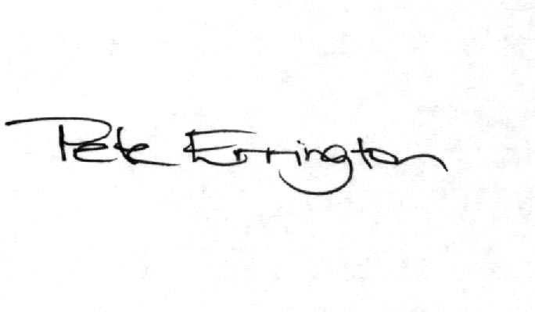
Pete Errington
Homes Builders Federation
Regional Policy Manager (South, East and London)

