

SPD Consultations
Planning Services
Rushmoor Borough Council
Council Offices
Farnborough Road
Farnborough
GU14 7JU 3rd April 2008

BY EMAIL

Dear Sir/Madam

RUSHMOOR TRANSPORT CONTRIBUTIONS DRAFT SPD
RUSHMOOR CAR & CYCLE PARKING STANDARDS DRAFT SPD

Thank you for consulting the Home Builders Federation on these two draft SPDs.

We note both documents and have a few comments to make which are set out below.

RUSHMOOR TRANSPORT CONTRIBUTIONS DRAFT SPD

2.2 Status of the document

We note that the draft SPD is based upon saved policies from Rushmoor’s Local Plan Review and while we welcome the reassurance in the preceding section 2.1 that the policy will be reviewed annually as part of the Annual Monitoring Report, we would also like reassurance that this SPD will be re-issued for consultation once Rushmoor has an adopted Core Strategy, or whichever is the relevant DPD, to ensure that the SPD is in alignment with any DPD policies.

4.2 National policy context

Regarding the boxed text dealing with the interpretation of Circular 5/2005, a slightly more accurate interpretation would read that the pooling of contributions is permissible only so long as the collected monies are used to provide infrastructure that relates to an individual site, or collection of associated developments. Obligations should not be used to support the delivery of more generalised services across the borough. This would, we would suggest, include contributions to maintain the ‘wider transport network’ as Hampshire’s Local Transport Plan endeavours to do. As paragraph B9 of Circular 5/2005 states, pooled contributions cannot be used to “resole existing deficiencies in infrastructure provision”. This is possibly a minor point since the Council appears to have reflected this principle elsewhere in the draft document in its approach to its town centre and urban extension SPDs, but perhaps this point should be clarified and, if necessary, the guidance in the box amended to reflect this important principle of Circular 5/2005?

4.5 Local policy context

Policy IMP1 of Rushmoor’s Local Plan Review (2000) states that sites of over 1 hectare will be liable to contribute towards infrastructure, yet the Hampshire County Council Transport Contributions Policy, upon which this draft SPD is in part based, seeks contributions from all developments of a single unit upwards. We are a little unclear and would welcome clarification if it is the intention of the Council to apply a threshold? Or have we simply misread this?

RUSHMOOR CAR & CYCLE PARKING STANDARDS DRAFT SPD

6.1: Application of maximum parking standards

We are anxious about the impact on marketability that a 50% limit on parking (one space per two homes) would have in areas of high accessibility. Some town centre schemes (where social inclusion/regeneration objectives are being pursued) may need to provide at least a space per dwelling, so we would welcome some flexibility on the part of the council when negotiating with developers.

---------------------------------------------------

I trust these comments are helpful and hope they can be reflected in the redrafted SPD before it proceeds to adoption.

Yours faithfully
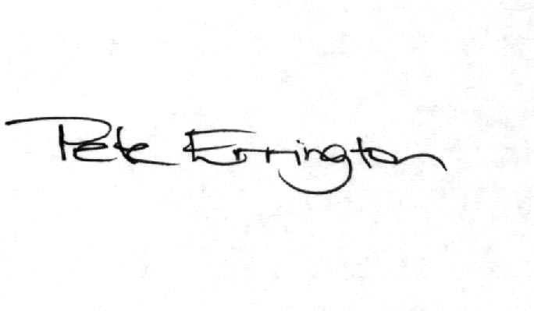
Pete Errington
Homes Builders Federation
Regional Policy Manager (South, East and London)

