
Policy & Conservation
Tonbridge & Malling Borough Council
Gibson Building
Gibson Drive
Kings Hill
West Malling
Kent ME194LZ 18th April 2008

BY EMAIL

Dear Sir/Madam

TONBRIDGE & MALLING BOROUGH COUNCIL: AFFORDABLE HOUSING SPD

Thank you for consulting the Home Builders Federation on Tonbridge & Malling’s draft Affordable Housing SPD. The HBF would like to make the following comments (by paragraph):

1.3.3

We welcome this section but we would welcome clarification regarding whom will be liable to pay for this financial analysis. Or is the assumption that the costs will be shared equally between the developer and council?

1.4.5

While we welcome the re-drafted paragraph, we feel that the SPD should reflect the need for the council – in some circumstances – to prioritise the supply of affordable housing over and above any other s106 benefits that might be sought for the community.

3.1.2

It is necessary to point out that paragraph 22 of PPS3 states that the likely proportions of housing tenure and size must be based upon the findings of a Strategic Housing Market Assessment (SHMA) – in other words a robust and credible evidence base. The CLG Practice Guidance describes how SHMAs differ from previous housing studies (such as the Housing and Market Needs Assessment carried out by Tonbridge & Malling in 2005) in that they focus upon meeting market need as much as predicting social housing need. We can see little evidence of any assessment of market need in either this document or the Core Strategy. Once a SHMA has been completed, the guidance in this SPD, and the core strategy, may need to be altered accordingly.

3.2.2

Although by no means unique to Tonbridge & Malling we should point out that there is a fundamental tension between policies of urban containment and the desire to maximise the supply of family-sized, affordable homes built to the minimum sizes and environmental standards stipulated by the council in section 5. These latter objectives can only be realistically achieved if the council increases the supply of developable land. If the council fails to do so then it may secure well designed, spacious and environmentally friendly homes but it will have fewer of them and consequently overall housing affordability across the borough will become worse for many people. The council could be faced with the situation where only the richest, the very poorest, or those fortunate enough to be classified as ‘key workers’ can be housed.

We would like the council to acknowledge this problem and we look forward to working with the council in identifying suitable, developable and deliverable sites through its forthcoming Strategic Housing Land Availability Assessment (SHLAA).

3.6.2

The requirement to build affordable homes to the Lifetime Homes standard is not mandatory and therefore cannot be enforced. It is therefore contrary to PPS12. Nor is there any policy relating to this requirement in the Core Strategy. Any requirement to build homes to this standard should be deleted. Developers will, nevertheless, endeavour to build a proportion of affordable homes to this standard where this is feasible.

3.7.1

The most user-friendly type of housing for wheelchair-users and the elderly is the bungalow. Unfortunately, current planning policy actively discourages their construction. Instead the elderly are encouraged to live in high density schemes the upper storeys of which will need to be serviced by lifts. The cost of maintaining lifts will create affordability problems because of rising service charges. We merely point this out to demonstrate the illogicality of such policies and the way that planning, having created a policy in one area, then ties itself in knots trying to resolve unforeseen consequences (see the later comments on service charges in section 8).

3.8.1

The concept of key worker or essential workers is socially divisive and hardly conducive to creating sustainable communities. It conveys the impression that lower paid workers such as cleaners, shop workers, waiters, security guards, bank clerks etc are no more important to the economy than certain types of public servant. The failure to provide all groups, whatever the nature of their employment, with access to housing is as great a threat to social inclusion and mixed neighbourhoods as lack of affordability is for the aforementioned professions. We therefore recommend that any policy seeking to give preferential treatment to ‘key workers’ is dropped. The equitable solution must be to increase housing supply by increasing the supply of developable land, and not to ration housing to certain groups. The concept should be dropped from the SPD and the core strategy in due course when the latter document comes to be revised.

4.1.1

Site suitability has a different meaning within the context of PPS3 and the associated SHLAA practice guidance and relates to the suitability of a site for housing. As paragraph 37 of the SHLAA practice guidance states, a ‘suitable site’ is one which “offers a suitable location for development and would contribute to the creation of sustainable, mixed communities”.

We suggest for purposes of clarity that the words ‘site viability’ (for this is really what is at issue) are substituted for ‘site suitability’.

We are unsure what is meant in the first bullet point by “the need for development to be attractive to the lenders of private finance”. Is the council referring to mixed-development schemes where there is a need to encourage a commercial developer to provide housing, including a proportion of affordable housing? Or is the council referring to shareholders in house building companies seeking a return on their investment? We would welcome clarification.

4.1.2

While we welcome the broad recognition of development viability conveyed by this paragraph it is, nevertheless, slightly mischievous in its wording: the need for a developer to pay for essential infrastructure is not a pre-requisite for delivering affordable housing, it may be all that the developer is able to afford (at least in the early phase or phases, until the sale of market homes provides sufficient capital to subsidise the building of affordable homes. Furthermore, the percentage of these delivered may have to be lower than the council’s target 40%).

Nevertheless, it is essential to recognise the improvements to the borough brought about by a developer’s investment in the local infrastructure and this will be an important community benefit in its own right, helping to open up a new location for further development or helping to regenerate a pre-existing district. To clarify: securing affordable housing on some development sites may not be the most important planning priority. Investment in other forms of infrastructure may take precedence. This should be spelt out in the paragraph. If Tonbridge & Malling disagree then we would like to discuss this further with the council.

4.2.9

In selecting rural sites it will be necessary to involve not just parish councils but other stakeholders including housebuilders. The appropriate mechanism for identifying and assessing the suitability of sites is the SHLAA. This should be reflected in this paragraph.

5.1.2

In accordance with PPS3 the LPA cannot determine the size, type and tenure of the market element of homes. Based upon market and commercial information available to them housebuilders are the best placed to respond to market demand in specific areas. This should be made explicit in the text otherwise the guidance will be contrary to government policy.

5.1.8

The council cannot insist that housebuilders exceed the standards set in relation to dwelling size by the Housing Quality Indicators. They have been fixed at this level for good reason by the Housing Corporation to ensure site viability. To exceed these standards could jeopardise viability and, consequently, the supply of affordable homes. This requirement should be deleted.

We are unclear what is meant by the last sentence in this paragraph (“Units designed around minimum standards are considered unsustainable and can lead to estate management difficulties.”). The council should explain what this means.

6.2.6

We note that in the absence of Housing Corporation funding (or other public subsidy) the council will consider alternative arrangements. We would welcome a clearer statement from the council as to what these alternative arrangements could be: would it, for example, include allowing for a lower percentage of affordable housing to be delivered (20% instead of 40% for example)?

6.2.8

The council should acknowledge that in some circumstances even ‘normal’ brownfield site remediation costs may be of such magnitude and cost that this will impact on the viability of delivering the expected quantity of affordable housing (aside from any other s106 objectives that the council might wish to levy). This should be reflected in the SPD.

8.1.7

Putting to one side the question why housebuilders should have to enter into long-term maintenance arrangements in the first place (we build houses, we are not landlords – the latter is a function of the RSL) we strongly object to any attempt to cap service charges at no more than 10% of the rent. The escalating cost of service charges is indeed a problem, but they only reflect current market rates for goods and services. To require housebuilders to absorb these costs themselves is unreasonable. Such a requirement goes well beyond the bounds of land use planning and should be a matter for negotiation between the builder and RSL.

This requirement should be deleted.

----------------------------------------------------------

I trust these comments are helpful and hope they can be reflected in the redrafted SPD before it proceeds to adoption. I would also welcome a response from the council regarding those specific issues where the HBF has sought clarification.

Yours faithfully
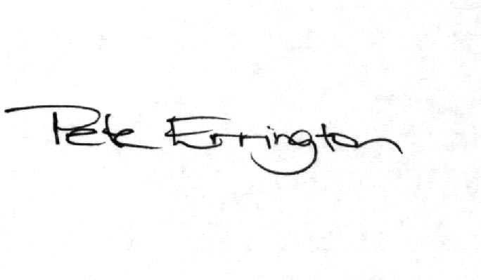
Pete Errington
Homes Builders Federation
Regional Policy Manager (South, East and London)

