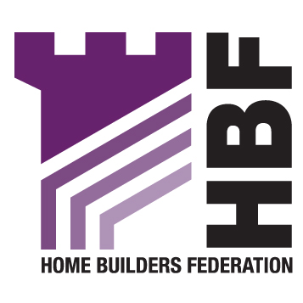

The Head of Planning and Transport
Reading Borough Council
Civic Centre
Reading
RG1 7AE

14th March 2008

READING BOROUGH COUNCIL STRATEGIC HOUSING LAND AVAIALBILITY ASSESSMENT (SHLAA)

Thank you for consulting with the HBF on Reading’s SHLAA methodology. We welcome the clear way the document has been set out and how it closely follows national guidance, but we do have the following observations to make:

Paragraph 1.9

Paragraph 1.9 of the methodology document states:

“All sites, considered deliverable and developable, will be subject to sustainability appraisal as part of the preparation of that DPD.”

While it is true that the SHLAA is no guarantee that land identified as deliverable and developable will be developed, the local planning authority has an obligation to consider those actions necessary to ensure that sites do become deliverable should these emerge as preferred options for development as a result of the preparation of the local development framework (the Core Strategy and Allocations DPD). Bullet point three of paragraph 8 of the CLG’s practice guidance states that when preparing the LDF the local authority will identify:

“Whether action would need to be taken to ensure sites will become deliverable (including infrastructure investment) or whether plan policies need to be reviewed to enable sites to be developed for housing.”

Thus, the Council must through its Sustainability Appraisal identify what actions or policies are necessary to bring forward for development those sites it has identified for at least the first 10 years of its housing trajectory but ideally for the whole 15 years of the plan period (see paragraph 7 of the SHLAA practice guidance). We would welcome clarification from the council that this is the meaning and intention behind this sentence.

Paragraph 2.2: Stage 1: Planning the Assessment

The list of key local considerations which is derived from paragraph 19 of the CLG SHLAA practice guidance distorts bullet point 3 which states that key stakeholders need to be included throughout the assessment process not just consulted upon the methodology. Paragraph 12 of the SHLAA practice guidance states:

“Key stakeholders should be involved at the outset of the Assessment, so that they can help shape the approach taken. In particular, housebuilders and local property agents should provide expertise and knowledge to help the partnership to take a view on the deliverability and developability of sites, and how market conditions may affect economic viability. Key stakeholders should also be involved in updating the Assessment from time to time.”

It is quite clear from the above that house builders need to be involved in the assessment process to suggest sites and to help assess the economic viability of bringing forward sites identified for development. We would therefore welcome clarification from Reading as to how and when it will involve house builders in the Assessment process.

We recognise that time constraints on both sides – local authority and house builder – may mean it is difficult for interested parties to be involved as much as they would like throughout the process, but the HBF would recommend at the very least holding a stakeholder workshop to help assess the deliverability and developability of the sites identified once the stage 5 (carrying out the survey) has been completed. The HBF would be happy to assist in coordinating this involvement.

Stage 2: Determining which sources of sites will be included within the Assessment

Sites not within the planning process:

We note that Reading has omitted from its methodology consideration of urban extensions, rural settlements, rural exception sites and free standing sites despite what the SHLAA practice guidance says. This may be because, as an urban authority, there is no scope for development in these directions. We would welcome clarification on this matter.

Stage 4: Determining which sites and areas will be surveyed

Specific locations outside settlements:

We note that the above category has been omitted from the methodology. Is this because, as queried above, Reading is a predominantly urban local authority with little or no latitude to consider possible sites in rural settings or within the green belt? This should be clarified.

Stage 6: Assessing the housing potential of each site

In addition to using examples of recent development in Reading to estimate housing yields, the HBF would strongly recommend engaging house builders at this stage as they are likely to have more up-to-date market and financial information to hand, including data on land and construction costs as well as other information relating to site viability (see paragraph 32 of the SHLAA practice guidance).

Stage 7: Assessing when and whether sites are likely to be developed

Stage 7a: Suitability

We believe the site suitability list drawn up may be too restrictive and the Council could be limiting the potential number of sites which could contribute to meeting its housing requirement. Some deliverable sites may be located in areas which the council might not feel are suitable, but which nevertheless could contribute to meeting its five year housing supply. For example, in accordance with Government guidance and if supported by evidence, it may be possible to release more former employment land for residential use. Also, the boundaries of many conservation areas are broadly drawn and these can include derelict sites that lend themselves to pocket re-development.

Potential sites should be assessed as part of the SHLAA even if subsequently they are ruled out as unavailable or unsuitable because they are needed for other purposes or because of other policy constraints. At the very least the council should consider what infrastructure or actions might be necessary to turn previously unsuitable sites into suitable ones and transfer these sites onto the 10 year and 15 year lists.

Stage 7c – achievability

The emphasis here should be on whether there is, in accordance with paragraph 40 of the practice guidance, a “reasonable prospect that housing will be developed on the site at a particular point in time”. If, as your methodology suggests, there are “significant viability problems with development” then the council should not rely on these to meet its forward 10 or 15 year housing target.

Stage 9: Identifying and assessing the housing potential of broad locations

Stage 10: Determining the potential of windfalls

We welcome the adherence to national policy and guidance with regard to the reliance on broad locations and windfalls. These should only be relied upon if the SHLAA demonstrates that the council is unable to identify sufficient sites to meet its housing requirement. Furthermore, the housing requirement should be taken as that recommended by the South East Plan EIP Panel since it is highly unlikely that the Secretary of State’s proposed modifications to the SE Plan will lower this requirement when the report is eventually published.

Once work has started on the SHLAA it should soon become clear whether or not the council is likely to identify sufficient sites to meet its requirements. Drawing upon the knowledge of its officers, the council may already have some idea whether or not this is likely. If it looks likely in advance that insufficient sites will be identified to meet its 15 year requirement the SHLAA may want to include a ‘broad locations’ survey element. The same applies to windfalls. Of course, if it appears likely that a surfeit of deliverable sites will be identified then this part of the survey will not be necessary.

We hope that these comments will be taken on board prior to work commencing on the SHLAA survey proper, especially our recommendation regarding the involvement of house builders in helping the council assess deliverability and developability. The HBF looks forward to being involved further in this important piece of work.

Yours faithfully

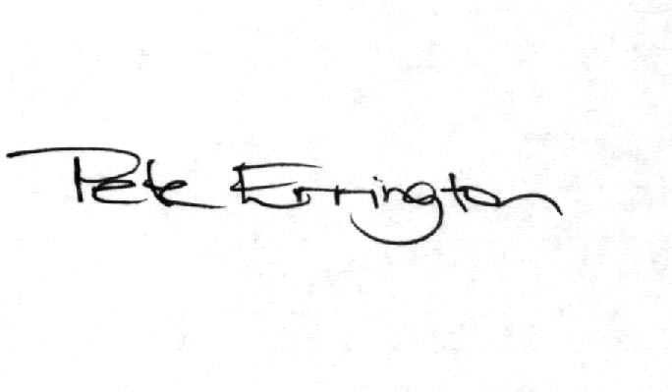
Pete Errington
Homes Builders Federation
Regional Policy Manager (South, East and London)

