
Lucy Howard
Gosport Borough Council
Town Hall
High Street
Gosport
Hampshire
PO12 1EB 14th March 2008

Dear Ms Howard

GOSPORT STRATEGIC HOUSING LAND AVAILABILITY ASSESSMENT (SHLAA)

Thank you for consulting with the HBF on Gosport’s SHLAA methodology. We welcome the clear way the document has been set out and how it closely follows national guidance, but we do have the following observations to make:

Stage 1: Planning the Assessment

We believe that paragraph 13 distorts the guidance contained in bullet point 3 of CLG SHLAA practice guidance (page 10) by suggesting that housebuilders and other stakeholders need only be consulted on the methodology. PPS3 and the practice guidance is clear that key stakeholders need to be included throughout the assessment process. Paragraph 12 of the SHLAA practice guidance states:

“Key stakeholders should be involved at the outset of the Assessment, so that they can help shape the approach taken. In particular, housebuilders and local property agents should provide expertise and knowledge to help the partnership to take a view on the deliverability and developability of sites, and how market conditions may affect economic viability. Key stakeholders should also be involved in updating the Assessment from time to time.”

It is quite clear from the above that house builders need to be involved in the assessment process to suggest sites and to help assess the economic viability of bringing forward sites identified for development. We would therefore welcome clarification from Gosport as to how and when it will involve house builders in the Assessment process.

We recognise that time constraints on both sides – local authority and house builder – may mean that it is difficult for interested parties to be involved as much as they would like throughout the process, but the HBF would recommend at the very least holding a stakeholder workshop to help assess the deliverability and developability of the sites identified once the stage 5 (carrying out the survey) has been completed. The HBF would be happy to assist in coordinating this involvement.

Stage 2: Determining which sources of sites will be included within the Assessment

Sites not within the planning process:

We note in figure 1 that Gosport has omitted from its methodology consideration of urban extensions, rural settlements, rural exception sites and free standing sites even though consideration of these is recommended in the CLG SHLAA practice guidance. We assume this is because, as an urban authority, Gosport has little scope for development in these directions. Clarification that this is the case would be welcome.

Stage 3: Desktop review of existing information

We agree that the assessment should take on board findings from earlier land-use studies but it is wrong to assume that sites once identified for employment or retail use should not be reconsidered as part of the SHLAA for possible transferral into residential use. The council should take into account Government policy on the reuse of employment sites. Potential sites should be assessed as part of the SHLAA even if they may subsequently be ruled out as unavailable or unsuitable because they are needed for other purposes. It is better, not to say more transparent, to assess or re-assess all sites as part of the SHLAA rather than assume that existing allocations need not be revisited.

Stage 4: Determining which sites and areas will be surveyed

Paragraph 25 suggests confining the survey to sites of 0.25 hectares in size and larger. The HBF suggests that it may be possible to look at sites smaller than this. The consensus emerging among other local authorities and consultants carrying out similar exercises is that smaller sites capable of yielding 6 or more dwellings is a sensible minimum starting size. Given the constraints on development in certain character sensitive areas, surveying smaller sites might help to identify sites where pocket developments are possible which are likely to prove more acceptable to the local community.

Stage 6: Estimating the housing potential of each site

While it will be important to take into account Gosport’s townscapes, local distinctiveness and Character Areas when assessing potential density, we feel an element of flexibility should be retained. Some sites in traditionally lower density areas may lend themselves to a higher density development than is generally in keeping with the area. If sensitively designed this may overcome local opposition. Conversely, a lower density development in a town centre location could introduce a broader range of housing types into the area, thereby helping to create mixed and sustainable communities. Flexibility, rather than rigidity, is the key.

Stage 7: Assessing when and whether sites are likely to be developed

The developability matrix is a useful framework for helping to assess the suitability of sites for development, but as with assessing the housing potential of specific sites, this should not be adhered to too rigidly in case too many potential sites from the survey database are disqualified. Sites faced by lesser physical or policy constraints could be brought forward for development by a developer who is able to overcome those barriers or once improvements in infrastructure render more sites suitable for housing (for example, if the South Hampshire Rapid Transport System ever materialises). More challenging sites could be rendered developable in time by imaginative/niche developers. So, while lesser and more challenging sites would need to be removed from the trajectory because there is no current prospect that they are either deliverable or developable, they should be retained on the database because of their future potential.

Stage 7a: Assessing suitability for housing

We note the inclusion of ‘residential amenity’ as a category at appendix 2. Amenity is a nebulous concept. It can be very subjective and it is difficult to measure what might be an unacceptable level of impact. We can see how this could be utilised by local interest groups to obstruct development (by citing ‘major barriers’ to development). We would prefer to see ‘amenity’ defined and the type of issues which will be assessed by the council listed. We would also prefer if the categories of constraint were defined in the appendix and, in terms of natural and heritage constraints, these confined to statutory designations. However, we recognise that this could represent too great a demand on council time, so perhaps a more constructive solution, would be to commit to monitoring the impact of the various constraint categories in case these are proving to be a barrier to identifying a supply of suitable land.

Echoing our comments under Stage 3 above, and in accordance with Government guidance, land allocated for employment should be reviewed to see if there is some spare capacity that could be transferred for other uses, especially residential.

Stage 7b: Assessing availability for housing

Input from landowners and other stakeholders throughout the survey process should assist in identifying land ownership and other problems and constraints. Involving stakeholders in stages 4 to 7 is strongly recommended.

Stage 7c: Assessing achievability of housing

We welcome the acknowledgement by the council that any assessment of viability needs to account for council’s own standards and policies as well as the availability of third party investment if the development is contingent upon the delivery of infrastructure.

Stage 8: Review of the Assessment

We welcome the adherence to national policy and guidance with regard to broad locations and windfalls. As your methodology states, these will only be considered if the SHLAA demonstrates that the council is unable to identify sufficient sites to meet its housing requirement. Furthermore, the housing requirement should be taken as that recommended by the South East Plan EIP Panel since it is highly unlikely that the Secretary of State’s proposed modifications to the SE Plan will lower this requirement when the report is eventually published.

Once work has started on the SHLAA it should soon become clear whether or not Gosport is likely to identify sufficient sites to meet its requirements. Drawing upon the knowledge of its officers, the council may already have some idea whether or not this is likely. If it looks likely in advance that insufficient sites will be identified to meet its 15 year requirement the SHLAA may want to include a ‘broad locations’ survey element. The same applies to windfalls. Of course, if it appears likely that a surfeit of deliverable sites will be identified then this part of the survey will not be necessary.

----------------------------------------

We hope that these comments will be taken on board prior to work commencing on the SHLAA survey proper, especially our recommendation regarding the involvement of house builders in helping the council assess deliverability and developability. The HBF looks forward to being involved further in this important piece of work.

Yours faithfully
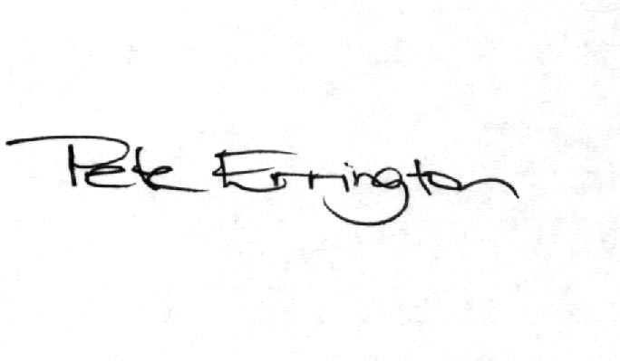
Pete Errington
Homes Builders Federation
Regional Policy Manager (South, East and London)

