

Bev Hindle
Head of Planning & Transport Policy
Bracknell Forest Borough Council
Time Square
Market Street
Bracknell
Berkshire RG12 1JD

28th March 2008

Dear Bev,

DEVELOPMENT MANAGEMENT AND ALLOCATIONS DPD – ISSUES

Thank you for affording the Home Builders Federation (HBF) the opportunity of commenting on the council’s issues & options paper for its LDF development management and allocations DPD.

Clearly it is difficult for HBF to make much in the way of detailed comments as a great deal depends on the precise wording of policies in terms of whether or not those policies are sound – the devil is very much in the detail. However, in so far as we are able to comment at this stage, our comments are set out on the attached sheets in the order in which they appear in the document.

One general comment which applies across the board, however, is that, in considering options and alternatives, the impact of policy requirements on development viability and so the overall delivery of housing must be factored in. It is a fundamental principle of the LDF system set out in PPS1 (paragraph 26) that local authorities should not impose disproportionate costs on, nor unnecessarily constrain, otherwise beneficial development and that they should have regard to the resources likely to be available for implementing its policies and the costs likely to be incurred in so doing. PPS3 is also clear that local authorities must meet their housing targets. Levels of under-delivery against housing targets as seen across the region going back very many years is not something which will be accepted under this new LDF process.

I trust these will be incorporated in future versions of the DPD and I would be pleased to be kept informed of progress on this and supporting evidence and studies as they evolve.

Yours sincerely,
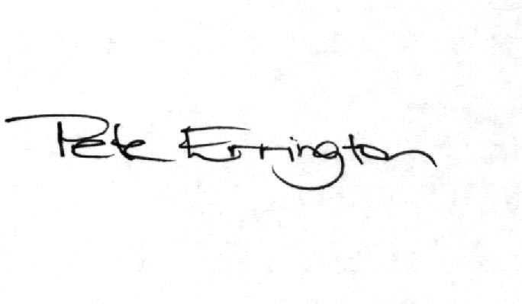
Pete Errington
Homes Builders Federation
Regional Policy Manager (South, East and London)

Question 2

In reality a combination of all 3 approaches is likely to be required.

Question 3

Probably option 2 as there would be no point including as policy option 1 as this is already national government policy which would apply anyway. However, whatever policy is finally devised should make it clear that density targets are just that and not hard and fast rules to be applied in each and every case. Every development site is unique and will require a bespoke response and this should be aided rather than hindered by policy. The prime consideration should be what is the best development outcome for the site and its surroundings rather than whether or not it complies with fairly arbitrarily determined density targets.

Question 7

Whichever option is chosen the policy should be proportionate to the issue in hand. It would not be proportionate to require all new homes to be built to lifetime homes standard. However, negotiating for a proportion may be.

Question 11

A combination of options 1, 2 & 4 is likely to be required. Option 3 would not accord with the provisions of Circular 5/2005.

Question 12

As with question 11 above, provision for new infrastructure should be in accordance with the provisions of Circular 5/2005 until such a time as it is finally replaced by a CIL or other taxation mechanism. This means meeting the five tests set out in the circular and taking into account the nature and extent of existing provision and the nature and extent of additional impact caused by the specific development proposed rather than blanket borough-wide targets.

Question 13

The council will be required to provide robust and credible evidence that it can deliver its housing target. It is a recommendation of the SE Plan EIP Panel that Bracknell’s housing target should be increased. If accommodating this increase requires an amendment to the Green Belt then that would be perfectly in accordance with Government policy. This will be a matter on which greater clarity is provided once Government finally responds to the SE Plan EIP Panel Report and once the council has finalised its SHLAA.

Question 16

PPS3, research commissioned and endorsed by SEERA and even the recent Panel Report into the draft South East Plan all make it clear that it is not acceptable or helpful for local authorities to seek to dictate the size and type of housing provided by the private sector. Therefore while any future policy may seek to influence housing mix of the market element of any scheme through negotiation and/or may seek to prescribe the mix of affordable housing where this is fully supported by robust and credible evidence, policies must not seek to prescribe the form and mix of market housing. Policies must not restrict the ability of developers to respond to the market.

Thus, in addressing this issue in the DPD the council should be guided by the results of its SHMA. It should seek to devise sensible policies in conjunction with house builders rather than seeking to impose requirements on them. On the basis of the evidence available at the moment we question the justification for any policy to address the mix of market housing.

Question 17

Low cost market housing performs a valuable function in a place such as Bracknell and so should be encouraged. It should be considered as part of a cascade mechanism to address the broader issue of affordable and key worker housing (see below).

Questions 18, 19, 20 & 21

New housing does not generate a need for affordable housing. It is only a material planning consideration because Government has made it so. On that basis, all new development should be treated equally and should be required to make some contribution to affordable housing provision. This would include commercial, retail and public sector development – not just market housing. However, if that is to happen, a more sophisticated policy mechanism will need to be devised compared to that which has operated in the past which factors in development viability, site specific considerations, the availability (or otherwise) of public subsidy and alternative forms of affordable housing (not just social rented).

Question 26

This should be an annual process and should address annual shortfalls as soon as they arise. Housing targets are now, to all intents and purposes, expressed as minimum targets to be exceeded wherever possible. On that basis there can be no justification for allowing a build-up of x-years of under-provision before something is done to address it. There is no longer any such thing as “over-provision” as the term is normally used. The only exception to this would be in terms of a major site coming forward unexpectedly which has strategic implications.
This will require the identification of a portfolio of allocations of different sizes and type and in a variety of locations which can be brought forward as soon as they are needed and to address varying sizes of shortfall.

The policy mechanism needs to explain how the AMR process will actually result in sites being released and so should set out what decisions will need to be taken by whom and by when to allow this to happen.

