

BY EMAIL ONLY

Planning Policy Team

Regeneration Directorate

Dartford Borough Council

Civic Centre
Home Gardens
Dartford
Kent DA1 1DR

11th March 2008

Dear Sir/Madam,

DARTFORD CORE STRATEGY PREFERRED OPTIONS

Introduction

Thank you for affording the Home Builders Federation (HBF) the opportunity of commenting on your council’s core strategy preferred options. Clearly it is difficult to comment in detail on general options such as those presented in the document as, like with a lot of the planning process, the devil is in the detail. HBF will submit more substantive comments once we see some actual policy wording on which we can comment. It is also of limited value to make detailed comments at this stage given that they do not go before an independent Inspector.

However, we set out a few general comments below (rather than specific objections to specific proposed policies) which hopefully can be taken into account when it comes to prepare the final policy wording.

Process – PPS12

Firstly, in terms of process, HBF was initially concerned that the document does not actually do what it says on the tin; that it does not set out a series of preferred options for consultation but, rather, merely sets out what is the council’s preferred option on a variety of matters. However, upon closer inspection, this assessment was found in the appendix !

On re-reading the early part of the document, however, HBF is concerned that the document is not particularly clear as to what its preferred development strategy actually is.
Option 1 talks about the focus on major strategic sites and that the council will not look favourably on infill. The document seems to be suggesting that option 1 is the preferred approach in terms of a development strategy. However, options 2 & 3 go on to imply a degree of infill which is confusing. Clearly the actual development strategy is an amalgamation of approaches 1, 2 & 3. Yet there is an inconsistency between them by way of this comment on infill. Hopefully the final strategy will be more clearly expressed in the submitted version as a single, internally consistent development strategy, rather than a series of individual, seemingly contradictory components.

Housing Delivery

That said, HBF welcomes the council’s approach to housing supply (preferred approach 10) and the focus on delivery of the housing target (preferred approach 11). We support the flexible approach described in the document and the mechanism set out for monitoring and managing progress towards meeting this target. However, we consider there are other matters set out in the document which may conspire against the achievement of that target.

Infrastructure Tariff

Not least of these is the infrastructure tariff (preferred approach 15) which, if it is to be included in the final document must focus not so much on the level of the tariff but the detail of how that money will be spent, what infrastructure it will be spent on and when that infrastructure will be delivered and by whom. HBF is concerned that, at present, this is a weakly justified and fairly arbitrary tax on development. The proposal needs to be supported by much more evidence and detail if it is to be considered sound.

Development Strategy

Related to the tariff and jumping back to preferred approach 1, HBF is not clear as to the council’s justification for this preferred approach where it refers to the problems of the impact of smaller development on infrastructure. Given that the infrastructure tariff would apply to all developments comprising two dwellings or more, this argument simply does not hold water. So, while HBF does not object to the principle espoused in preferred approach 1 of focussing on major sites, we do not consider there is a justification for this being the sole focus of new development. The reason why the council has not met its housing targets in the past is because of delays associated with the delivery of major strategic sites. The approach to housing supply must include a portfolio of sites of different size and in different locations which can provide some contingency if there continue to be delays with these major sites. This seems to be the approach spelt out in preferred approaches 10 and 11 but there appears to be an inconsistency between these and preferred approach 1 which, as stated above, must be addressed in the final submitted version of the strategy.

Housing Mix

Turning to preferred approach 19, HBF supports the general thrust of seeking to create mixed and balanced communities. However, we also warn against over-zealous interference in the operation of the private market. It is precisely such intervention in the form of PPG3 which has resulted in the dramatic shift from building what was a variety and mix of size and type of unit to one which focuses heavily on flats.

PPS3, the regional assembly and even the recent panel’s report into the draft South East Plan all make it clear that it is not acceptable or helpful for local authorities to seek to dictate the size and type of housing provided by the private sector.

They may seek to influence it through negotiation. They may seek to prescribe the mix of affordable housing where this is fully supported by robust and credible evidence. But they must not restrict the ability of developers to respond to the market. Continuing recent trends of building the very high levels of flatted development is neither sustainable nor desirable in the long term and does not create mixed and balanced communities.

Thus, in addressing this issue in the core strategy the council should be guided by the results of its SHMA. It should seek to devise sensible policies in accordance with Government policy and in conjunction with house builders rather than seeking to impose requirements on them.

I hope that you will find these comments helpful and that they will be taken on board when the council comes to draft actual policy wording for the submitted core strategy. I would, of course, be happy to discuss any of these matters with you further should you so wish. Otherwise I look forward to being kept informed of progress on the LDF preparation process as it goes through the statutory procedures.

Yours faithfully,

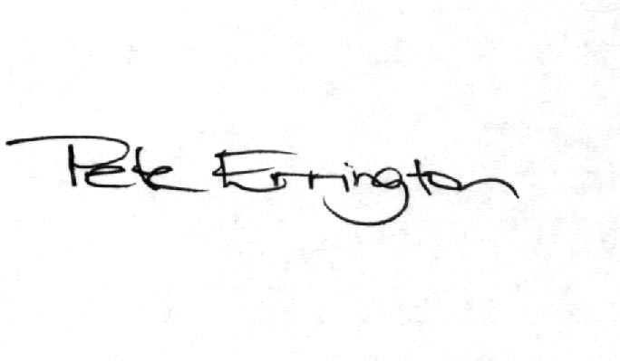

Pete Errington
Home Builders Federation
Regional Policy Manager (South, East & London)

