

BY EMAIL ONLY

Planning Policy Team

Clerk & Chief Executive’s Department

Mole Valley District Council

Pippbrook

Dorking

Surrey RH4 1SJ

29th February 2008

Dear Sir/Madam,

CORE STRATEGY FURTHER ISSUES & OPTIONS CONSULTATION

Introduction

Thank you for affording the Home Builders Federation (HBF) the opportunity of influencing the early drafting of your council’s LDF.

HBF has a number of comments to make on the document, largely elaborating on what we said in our comments on the original issues and options consultation in our letter of 31st January 2006. These comments are set out in response to the specific questions below.

Question 3

HBF considers that it is right as a matter of principle, and in accordance with Government policy, to prioritise the development of previously developed land in the existing urban areas. However, it is unlikely to be a sufficiently robust strategy for this to be the only source of development over the next 20 years. It is likely that some Greenfield land will need to be released for development and the core strategy should include a policy mechanism to facilitate this release should it prove necessary in order to maintain continuity and sufficiency of supply. Such a policy mechanism should be based on the principles of Plan Monitor Manage and should explain what will be monitored and by whom and what action will be taken by whom and when if the results of that monitoring indicate housing targets are not being met. The precise details of how this may operate could be set out in SPD allied to the Annual Monitoring Report process, but there must be a trigger policy in the core strategy.
Question 4

PPS3 (paragraph 59) is very clear on the role of windfalls in the housing land supply assessment. Government is steering local authorities away from their traditionally passive and reactive roles in the development process (merely processing planning applications which the private sector choose to submit) to a much more positive and proactive role which seeks to influence where future development comes forward. This is a more spatial approach to planning compared to the previous traditional land use planning approach and allows development to be considered in the round alongside other community, service and infrastructure requirements.

Furthermore, as the CLG practice guidance on SHLAAs makes clear, a high past rate of windfall development is not necessarily sufficient justification for inclusion of a windfall allowance in future housing trajectories. Your council has been involved in the SEERA working group looking at PPS3 and the issue of windfalls in particular and SEERA will shortly be considering a report which provides further guidance on this. Quite simply the approach should follow that set out in PPS3 and the CLG practice guidance and no allowance should be made for windfalls as set out in those documents. If they do come forward they will obviously count towards housing supply and will affect the way in which the PMM policy (referred to above) is applied. If they don’t, then not counting them ensures there is proper planned provision in place to ensure housing targets are met (or exceeded now that they are to be considered minimum rather than maximum targets).

Question 6

While the issue of climate change is an important (if not ‘the’ most important) issue society needs to address in coming years it is not something unique to Mole Valley and is not something that the council, unilaterally, can solve on its own. This is a global phenomenon and it needs to be addressed globally. Clearly local action will help but this has to be balanced against other spatial planning objectives. Not least of which is ensuring that everyone has the opportunity of a decent and affordable home. New housing is already many times more efficient than the existing stock and will increase further through the gradual ramping up of standards (which legally must be complied with) through the changes to the Building Regulations set out in the Code for Sustainable Homes. The housebuilding industry has committed to achieve these targets and has pledged to meet Government’s 2016 commitment. So, new housing development is covered in terms of ‘doing its bit’ for climate change.

It is HBF’s view (supported by Government guidance in PPS1 and PPS12) that the planning system should not seek to involve itself in matters already more than adequately addressed by other legislative regimes. Where the planning system can play a role is in dealing with issues not covered by other legislative regimes such as finding ways of securing improvements to the existing stock and seeking energy efficiency improvements through non-residential development and influencing peoples’ behaviour to ensure they make sensible choices when faced with decision which have climate change impacts (which is actually most decisions !). So the core strategy should address measure to improve the existing stock which obviously comprises the vast majority of housing and should focus on policies which achieve these behavioural shifts.
Question 7

The same general points expressed above also apply to Question 7. You can’t save the planet simply by requiring houses to be built with no car parking. This issue needs to be addressed sensibly and across the board. Singling out any particular policy solution which only addresses a tiny part of the problem will create more and probably unforeseen problems than it solves. Large parts of Mole Valley are relatively rural. This does not mean that the only policy response is not to allow any housing because there is poor public transport. At the very least, one thing it suggests is that ways of improving public transport accessibility in rural areas should be investigated. There needs to be a grown up and sensible debate around this issue rather than knee jerk reactions which go for the quick-win solutions rather than those which will really make a difference.

I hope that you will find these comments helpful and that they will be taken on board when the council comes to draft actual policies for the core strategy in due course. I would, of course, be happy to discuss any of these matters with you further should you so wish. Otherwise I look forward to being kept informed of progress on the LDF preparation process as it goes through the statutory procedures.

Yours faithfully,

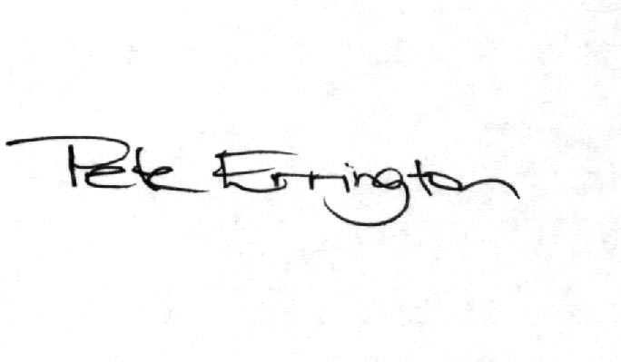

Pete Errington
Home Builders Federation
Regional Policy Manager (South, East & London)

