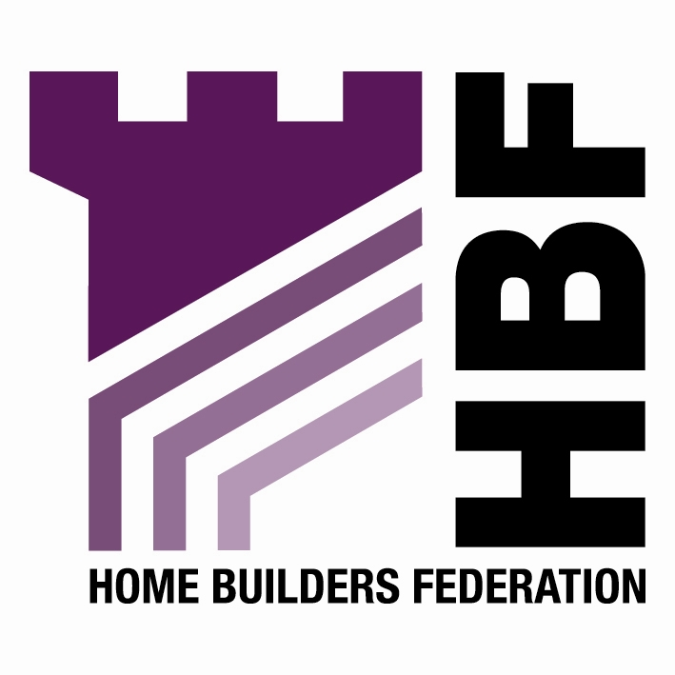

BY EMAIL ONLY

Liz Carey

Planning & Sustainability

Queen Victoria Road

High Wycombe

Bucks HP11 1BB

8th April 2008

Dear Mrs Carey,

DRAFT SHLAA METHODOLOGY

Thank you for consulting the Home Builders Federation (HBF) on your council’s draft SHLAA methodology. HBF has a couple of comments to make on the proposed approach. These primarily relate to the way it is proposed to deal with the issues of windfalls and broad locations. Attached to this letter (email) is a copy of the recent SEERA regional planning committee report on windfalls and how local authorities should deal with them, along with a copy of a recent letter from CLG to the planning consultants Baker Associates regarding the issue of broad locations and the PAS / POS guidance.

Firstly it should be stated that Government policy guidance on the carrying out of SHLAAs and the way windfalls should be treated is very clearly set out in PPS3 and the CLG SHLAA practice guidance. Paragraph 59 of PPS3, in particular, clearly sets out the expectation that windfalls should not be taken into account in the early years of a SHLAA or housing trajectory unless one exceptional circumstance can be robustly demonstrated by evidence. That exceptional circumstance is that it can be proven that there are genuine local circumstances which prevent sites being identified. The SEERA report suggests that it is only possible to demonstrate such circumstances by the process of going through a SHLAA. It cannot be pre-determined from the outset. The CLG practice guidance also makes it clear that the nature of the anticipated land supply is not, in itself, justification for including a windfall allowance. Rather (paragraph 25) it is a justification for searching for smaller sites than may otherwise be the case through the SHLAA.

Secondly, turning to the PAS / POS guidance, this document has no formal status. It is not official Government policy. Nor has it been endorsed or sanctioned by Government in any way. It has not even been subject to any consultation. HBF’s view is that it mis-interprets and selectively applies one sentence in PPS3 and takes this completely out of context from the rest of PPS3 to make an assertion about broad locations (and so windfalls) which is plain wrong. This matter is clarified in the CLG correspondence attached. For this reason HBF is very concerned that the council is proposing to adopt an approach in its methodology which is based on this flawed assertion in a document which carries no weight. HBF’s view is that the council should follow the methodology set out in the official CLG practice guidance and should not address the windfalls / broad locations issue until right at the end of the SHLAA process. The aim of undertaking a SHLAA is to identify specific sites in order to provide certainty and clarity in the LDF and decision-making processes. It is not primarily to identify areas where windfall allowances will be applied. This would not move us any further forward in the new era of spatial planning through a collaborative LDF process. It would merely be a continuation of current practice which is neither helpful nor appropriate.

Finally, turning to a more detailed comment, in terms of Stage 7 and the assessment of developability and deliverability it is vital that the issue of viability is considered as part of this assessment. This also needs to take into account the cost of complying with the council’s own existing and emerging policies on planning obligations, infrastructure requirements and affordable housing as well as other emerging ‘planning’ costs such as meeting ever higher levels of the Code for Sustainable Homes and requirements for Lifetime Homes , the various infrastructure tariffs which are in operation and the CIL.

I hope that you will find these comments helpful and that they will be taken on board prior to work starting in earnest on the SHLAA.

I would, of course, be happy to discuss any of these matters with you further should you so wish. Otherwise I look forward to being kept informed of progress on the SHLAA as it evolves.

Yours sincerely,

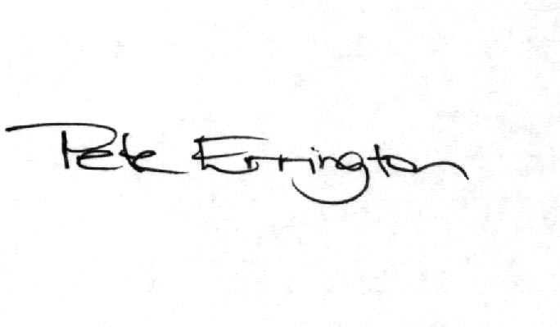

Pete Errington
Home Builders Federation
Regional Policy Manager (South, East & London)

