

BY EMAIL ONLY

Louise Phillips

Planning Policy Team Leader

Tunbridge Wells Borough Council

Town Hall

Tunbridge Wells

Kent TN1 1RS

24th March 2008

Dear Louise,

SHLAA METHODOLOGY INFORMAL CONSULTATION

Introduction

Thank you for affording the Home Builders Federation (HBF) the opportunity of commenting on a first draft of your council’s SHLAA methodology. Given that we have already met to discuss the approach the council is likely to take and given that this, in the main, follows CLG’s national SHLAA guidance, HBF does not have a great deal of comment to make. However, there are a couple of areas where HBF would like to see further refinements in the methodology before work begins on the study in earnest. These are set out below.

Question 1 - Stage 7a

The first concern relates to the proposal to undertake stage 7a of the CLG SHLAA guidance so early in the process. As I stated when we met, I can appreciate the council’s desire to minimise the workload of carrying out a SHLAA. However, the final outcome still has to be technically robust.

The process of carrying out a SHLAA should be a technical assessment divorced from policy considerations as the process of undertaking the SHLAA may suggest a need for a review of those policy considerations. It would appear that the proposal to bring forward stage 7a involves making policy judgements about the suitability of sites based on existing policy. However, if the SHLAA was done in the proper order as set out in the CLG guidance, it may suggest a need for a review of those existing policies in order that housing targets can be met.
If such a policy review was needed and stage 7a had been carried out so early in the process the only sites which would have been assessed in any detail through the SHLAA process would be those compliant with existing policies leaving nothing left to be brought forward earlier than anticipated should the housing trajectory show targets were not being met. However, the SHLAA process should allow a range of sites to be identified which are in varying levels of compliance with existing policies but which could be suitable (and the other PPS3 “ables”) should policies need to change in order to ensure targets are met. The council’s proposed approach would mean that such site would have been ruled out at the early stage and not assessed in detail as part of the SHLAA. This cannot be a ‘sound’ way forward.

HBF would prefer, therefore, that the assessment was carried out in the sequence set out in the CLG guidance in order that the assessment is as complete and robust as possible. Otherwise, it may be necessary for stage 7a to have to be repeated later in the assessment meaning that it would actually duplicate effort rather than save time. So, while we are fully supportive of the need to minimise the workload this should not be at the expense of a comprehensive survey. All reasonably foreseeable sites should be included, particularly where there is a likelihood they will be promoted for development during the course of the strategy period. Such sites may well be ruled out by the council on policy grounds as part of the assessment process but they should be included in that assessment process so that the decision making process is transparent and obvious.

As stated at the meeting, it may be possible for this concern to be overcome by undertaking a full assessment of any site which the owner requests be assessed regardless of how this scores on the council’s current-policy-based suitability screening. As I suggested, it is in the council’s interest to undertake a full assessment of all those sites where it is known from discussions with developers there are likely to be planning applications in order that the SHLAA evidence base can inform any appeal.

Question 2 - 5-Year Supply of Deliverable Sites

HBF has some concerns about some of the comments in the early part of section 4 where the methodology says a number of times that it “is reasonable to assume” various things about the deliverability of sites in the next five years. HBF would suggest that it may not be reasonable simply to make these assumptions and that, instead, these assumptions should be supported by detailed information from developers about likely future completion rates on those allocated and permitted sites. This is part of the purpose of carrying out a SHLAA to remove assumption and speculation and replace this with fact and certainty. HBF would suggest that the council contact the owners of all of these sites and incorporate their views about delivery over the next five years to inform this part of the assessment.

Question 4 – Windfall Supply

Again, as stated at our meeting, HBF’s view on windfalls is as set out in PPS3 which makes it absolutely clear that these should not be counted in the early years of supply. As is clear from the recent SEERA planning committee report on the matter (copy attached for your information), windfalls should be the last port of call for development opportunity.

The council should not be starting from the presumption that a windfall allowance will be included in the assessment. The council should carry out the assessment as per the CLG guidance and then consider the issue of windfalls right at the end of the process after it has identified all possible development opportunities. Even then, it will need to be demonstrated that there are exceptional circumstances which have prevented the identification of sites. Paragraph 59 of PPS3 is absolutely clear in this regard and this is followed through in the CLG guidance.

Stage 4 – Settlement Hierarchy

HBF does not object to the principle of the council having such a hierarchy provided that it does not affect the SHLAA process and that all sites are assessed equally. The settlement hierarchy is a policy-based hierarchy and the SHLAA process is supposed to inform future decisions about whether or not there may be a need to need to review existing policies in order to ensure that the housing requirements will be met. Therefore, sites should not be ruled out early in the process merely because they do not conform to this pre-determined hierarchy. The determination of which sites may or may not be allocated through a future DPD are policy decisions and not technical assessments which should influence the scoring or weighting in a SHLAA; certainly not in the early stages. Again, this concern may be overcome by a commitment to fully assess every site likely to be put forward by developers in the coming years. Clearly the council will have a good idea of which those sites are from future local plan inquiries, informal discussions with developers and other consultation processes.

Questions 7, 8 & 9 – Sites to be Surveyed – a summary

Until reaching this stage in the methodology HBF was not clear that the council was proposing to carry out the SHLAA in such a sequential approach. It may be reasonable to have a policy which seeks to comply with PPS3 in terms of prioritising the development of PDL, however, that is a very different thing to an old PPG3-style sequential approach. As stated above, a SHLAA is supposed to be a technical exercise to identify potential development sites and, as such, is supposed to be largely free from policy constraints (other than the obvious high level policy constraints such as SSSI, AONB, SPA and so on). HBF had not appreciated from earlier discussions nor from the early parts of the methodology that the council was planning on carrying out the SHLAA in this sequential manner which, in essence, seems to be suggesting stopping the work once sufficient sites have been found to meet requirements.
This is not the purpose of a SHLAA. The purpose, as stated a number of times above, is to identify (within reason) all potential development sites which meet the criteria set out in PPS3. The aim is to identify more than enough sites in order that they can then, as a matter of policy, be prioritised through the LDF process. The SHLAA should not aim to perform that prioritisation function.

HBF considers that this sequential ‘staged’ approach described in paragraphs 4.37 to 4.57 does not comply with the requirements of either PPS3 or the CLG guidance. The assessment should consider all suitable development sites equally as part of the assessment process (in terms of the process of carrying out the assessments and site visits) with the policy judgement only coming at the end of the process. Therefore, HBF does not agree with this approach.

Question 11 – TUCA

While the TUCA approach can be a useful general indication of density ranges and site yield it should not be the single determining factor and should be modified to reflect information which becomes apparent upon conducting more detailed assessments of individual sites and discussions with landowners / developers. This flexibility should be built-in to the methodology.

Question 14 – Small Site Windfalls

HBF’s answer to this question is “no” for the reasons set out under the ‘windfall supply’ heading above. Paragraph 59 of PPS3 applies.

I hope that you will find these comments helpful and that they will be taken on board prior to work commencing on the SHLAA. Either way I would be pleased to be kept informed of progress on the SHLAA as it evolves.

Yours faithfully,

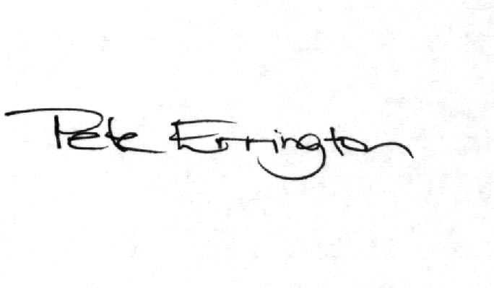

Pete Errington
Home Builders Federation
Regional Policy Manager (South, East & London)

