

BY EMAIL ONLY

Planning Policy Team

Woking Borough Council
Civic Offices
Gloucester Square
Woking
Surrey GU21 6YL

4th March 2008

Dear Sir/Madam,

WOKING SHLAA METHODOLOGY

Introduction

Thank you for affording the Home Builders Federation (HBF) the opportunity of influencing the methodology for this study. Given that we have already had some input via the stakeholder workshop and that the document fairly closely mirrors the CLG SHLAA guidance, our comments on this document are fairly limited. In fact they are two-fold.

Firstly on question 9 and the issue of deliverability and developability a key determinant of this is often a local authority’s own planning policies. They can have a significant impact on the nature and form of development and also the cost of bringing it forward. Woking is renowned for its cutting edge approach to climate change policies but there are also very costly (for developers / landowners) policies on affordable housing provision and the delivery of planning obligations which apply across Surrey. The methodology should make it clear that the impact of these policies will be factored in to any assessment of developability and viability.

Secondly, on point 9 (paragraph 9.2) HBF considers that this mis-interprets PPS3 guidance on how windfalls should be treated. They are not there as a fallback to be included in cases where windfalls have formed a significant component of supply in the past. Paragraph 59 of PPS3 is clear that windfalls should only be included where there are genuine local circumstances which prevent the identification of specific sites for development. If it is ultimately deemed appropriate and necessary to incorporate a windfall allowance the SHLAA should set out what are those genuine local circumstances and how they have been factored into the assessment based on a transparent interpretation of the available evidence.

I hope that you will find these comments helpful and that they will be taken on board prior to work commencing on the SHLAA in earnest. Otherwise I look forward to the opportunity for further involvement (of both HBF and its Members) in this study as it progresses.

Yours faithfully,

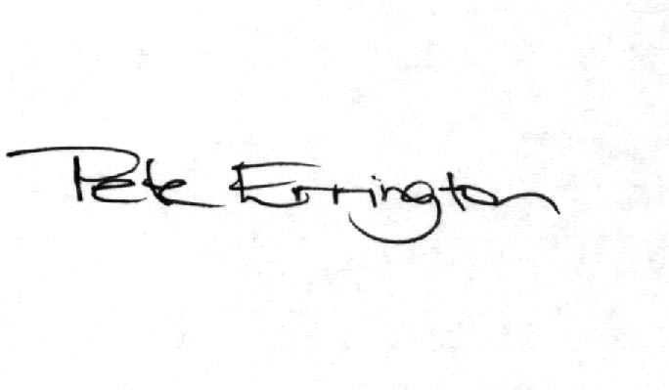

Pete Errington
Home Builders Federation
Regional Policy Manager (South, East & London)

