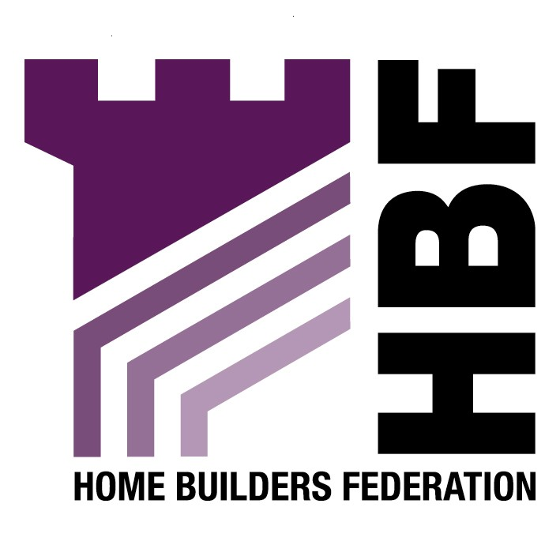
Emailed to ldf@doncaster.gov.uk
Doncaster Council LDF Team
Development and Planning
2nd Floor
Danum House
St Sepulchre Gate
Doncaster
DN1 1UB

09 January 2008

Dear Sir or Madam

Housing, Transport, Retail, Employment and Local Waste: Allocations and Detailed Policies: Issues and Options

Thank you for consulting the Home Builders Federation (HBF) on the above document. Please find to follow our comments in relation to the key questions set out in the document.

We trust you will take our comments into account and look forward to receiving further information regarding the progress of the document.

Yours faithfully

Laura Edwards

Laura Edwards (maternity cover for Gina Bourne)
Regional Planner – Northern Region

Home Builders Federation

Chapter 1: Housing
Housing Density
HQ2:

It is considered that the density of a development should be assessed on a site-by-site basis. The document should recognise that in some cases it is appropriate for densities below the minimum of 30 dwellings per hectare where justified. This view is supported by paragraph 47 of PPS3. The requirement for the totality of development to be at a density of 30 dwellings per hectare must allow for some development at lower densities to enable the provision of a full range of housing. There should not be either a minimum or maximum amount of housing per square hectare. The housing mix should determine density based on topography, net developable area, space about dwelling standards/ stand off distances, buffer zones, landscaping tress, etc.

Apartments
HQ3

The HBF is supportive of Option 4. It is not for the Council to try to limit apartment developments. It is appreciated that the planning system’s involvement in the housing mix is becoming of increasing importance. However, HBF members believe that the public sector should not dictate housing sizes, mix or specification on private sector sites. Private individuals buying a home make choices about price, location, dwelling type and size; plot size etc. according to their income and personal requirements. The state has no place restricting the availability of certain types of housing, which in practice amounts to telling certain households what they should or should not buy. Over- designing houses today must not limit the flexibility of houses to meet tomorrow’s needs.

However, if the local authority planning departments are to become involved in this, which seems inevitable, it would seem sensible to adopt a flexible approach which could be applied by all developers.

Private Gardens
HQ4
The HBF supports Option 4. The Council cannot expect to achieve conflicting/ incompatible aims such as increasing the density of housing developments and increasing garden size. It should not seek to impose prescriptive standards as all developments must respond to the nature and character of their location. Developers seek to build the type of homes that people want and can afford reflecting the nature of the specific local market in which the development is located. What works in one part of Doncaster may not be appropriate in another.

Urban design in housing areas.
HQ5

The HBF supports Option 4. Having a general policy which refers to ‘best practice residential urban design guidance’ like “Building for Life” would provide greater certainty for developers by what is meant as “good design.” However, the Council should not develop any prescriptive checklists related to this guidance as many of the criteria will not be appropriate in every context. There still needs to be room for flexibility.

Sustainable housing design
HQ7

The HBF supports Option 2, provided the reference to “Ecohomes” is removed as this has been superseded by the Code for Sustainable Homes. The Council should not seek to accelerate the nationally agreed Code for Sustainable Homes timetable. There is a danger that new technologies may be introduced prematurely to address locally imposed requirements rather than using nationally proven methods. A nationally agreed framework is the best way of ensuring all new homes are carbon zero by 2016. Staged national delivery of improved levels of the code for sustainable homes will ensure pioneering technologies are robust, meet customer expectations and are backed by proper warranties. A multitude of differing targets around the country put these efforts at risk. It is important that all LPAs: accept this framework as a legitimate national route for effective progress, and; do not take it upon themselves to try to move faster than the timetable outlined in the national documents.

Imposing higher/ local standards, particularly in the context of other Section 106 demands may have a detrimental impact on viability and ultimately the supply of much needed housing.

Flexible housing
HQ8

The HBF supports Option 3. It is not “doing nothing” as Building Regulations will be updated at the appropriate time. The internal layout of buildings falls under the Building Regulations and therefore does not fall within the remit of the Town and Country Planning legislation. The HBF, therefore, very much objects to the imposition of any additional standards by local authorities seeking to control the internal space dimensions of new market housing. We would draw your attention to paragraph 30 of Planning Policy Statement 1 (PPS1), which states that:

“Design policies should not replicate, cut across, or detrimentally affect matters within the scope of other legislative requirements, such as those set out in the Building Regulations for energy efficiency.”

There are cost implications and the benefit to occupiers in certain types of development is questionable. Dwelling access arrangements are a Building Regulations matter, addressed under Part M: Access To and the Use of Buildings. It is our view that this more than adequately addresses issues of access.

Public Open Space in New Housing Developments
HQ10
Option 3

The provision of open space should be related to the impact of the development to be in accordance with Circular 05/05. Therefore, it is appropriate that it is only required with family dwellings.

HQ11
Option 2

Ten or more family dwellings is an appropriate threshold from which to apply the open space policy. On smaller sites it may be impractical to apply the policy. There is also the danger that requiring open space on smaller sites will render them unviable.

HQ12
Option 1

The Council should not require developers to provide public open space if it is not directly related to the impact of the development. Circular 05/05 test (iii) states that planning obligations must be “directly related to the proposed development.” Therefore, it is not appropriate for the Council to impose requirements on developers to make up for existing local deficiencies.

HQ15
Option 3

The HBF objects to a separate LDF policy on renewable energy. This policy fails to take into account the fact that many sustainable design matters will very soon be covered by the Code for Sustainable Homes, and that in order to reduce CO2 emissions, 10% renewables provision on site might not be the most appropriate means of achieving this overall reduction, either technically or financially. The HBF believes that any requirement for renewable energy provision upon new development should be delivered through the higher stages of the Code for Sustainable Homes. As this is a framework and timescale to which the industry is committed to delivering. The HBF consider that the application of locally based energy performance standards would be unhelpful in facilitating the broader delivery of higher energy performance and consumption standards from new housing.

HQ16
Option 3

On the use of sustainable urban drainage systems (SUDS) these should be encouraged or sought where appropriate rather than be required in all cases as there remain unresolved difficulties in implementing them in certain circumstances. There are also outstanding problems and uncertainties regarding long term management which must be resolved before SUDS can reasonably be a pre-requisite for all development.

HQ17
Option 2

It is considered reasonable for the Council to stipulate external space requirements for the storage of wheelie bins and recycling infrastructure, as this is to do with the use of land and so within the remit of the Town and Country Planning Acts.

Chapter 2: Transport
TQ4
Option 3

Latest government policy seems to be shifting away from the application of blanket restrictive parking standards, towards a more flexible approach taking greater account of local characteristics. The HBF supports a more flexible approach given that every site and locality is different. Whilst some can operate with very little parking provision, others cannot. If a lack of sufficient parking provision arises, the end result is often nearby approach roads being clogged up with parked vehicles. Which apart from being unsightly and inconvenient can also pose access problems.

