

BY EMAIL ONLY

Ian Hawkins

Principal Planning Officer

South Bucks District Council

Capswood

Oxford Road

Denham

Bucks UB9 4LH

23rd January 2008

Dear Mr Hawkins,

STRATEGIC HOUSING LAND AVAILABILITY ASSESSMENT

DRAFT METHODOLOGY

Thank you for affording the Home Builders Federation (HBF) the opportunity of commenting on this draft SHLAA methodology.

Given that the work is already underway and that the final report is to be produced in a matter of weeks there is probably little point HBF commenting in any detail on this methodology. Particularly when also considered in the context of South Bucks' low housing requirement and the supply situation highlighted in the report. I did want to make one point, however, and that relates to the issue of windfalls.

The council is obviously aware of what PPS3 says on the matter as this is referred to in the report. While the environmental constraints of the district are noted along with the limited resource available to carry out this work, the fact remains that the main purpose of carrying out an SHLAA is to try to identify what has previously not been identified (windfalls) in order to bring greater certainty of future housing delivery and greater transparency to the process.

Although the district does have a fairly high level of constraint, and whilst there may well be a justification for including a windfall allowance to some degree in the housing trajectory, that constraint is not absolute and does not automatically justify a windfall allowance.

Elsewhere in the region the view has been taken that the need to deliver additional housing has been of sufficient importance to justify seeking amendments to green belt boundaries in order to accommodate much needed new housing development. The high proportion of the district covered by green belt designation, in itself therefore, does not justify a straight-line extrapolation of past windfall rates. The council can still identify sites through the SHLAA process which, had they not been identified, would have come forward as windfalls. This would mean that future windfall allowances would be lower than past rates because of this identification exercise.

I wanted to flag this up as a potential area of concern now, though obviously I will be in a better position to comment on this issue when the council produces its final report in a few weeks which will no doubt address this matter in greater detail than in the draft methodology.

In terms of the stages of the study itself HBF is most interested in the considerations under-pinning assumptions about development viability and to ensure that these are realistic and factor in the full range of influences. Not least of these is any council's own planning policy requirements for affordable housing and other planning obligations which can dramatically affect site viability. We will be looking for evidence that these considerations have properly been factored into the viability / deliverability assessment. Again, we may wish to comment on this further once we see the first results of the study.

I hope these comments will be borne in mind when it comes to the drafting of the report and I look forward to seeing a copy of that report in due course.

Yours sincerely,
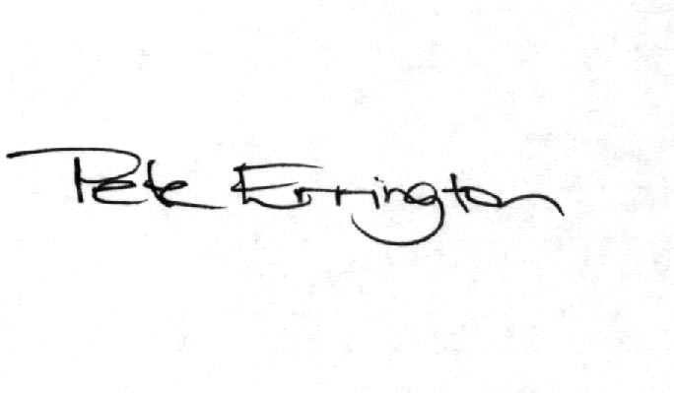

Pete Errington
Home Builders Federation
Regional Policy Manager (South, East & London)

