

BY EMAIL ONLY

Planning Policy Division

Bracknell Forest Borough Council

Time Square

Market Street

Bracknell

Berks RG12 1JD

3rd January 2008

Dear Sir / Madam,

SUSTAINABLE RESOURCE MANAGEMENT SUPPLEMENTARY PLANNING DOCUMENT

Thank you for affording the Home Builders Federation (HBF) the opportunity of commenting on this draft SPD.

HBF has one comment to make and that relates to the references in the document to the Code for Sustainable Homes. The Code is currently (until April at least) a voluntary Code of practice. Even when it becomes mandatory Code Level 3 does not become a requirement until 2010. This SPD seems to be requiring applicants for planning permission to demonstrate now how they will ensure compliance with Code Level 3 so advancing this requirement by more than 2 years.

Government’s recently issued addendum to PPS1 on Planning and Climate Change makes it clear that it is the role of the planning system to support, not pre-empt, the implementation of the Code for Sustainable Homes. Paragraph 33 of the PPS spells out that policy requirements for decentralised energy supply must be set out in a DPD and not an SPD in order that they are subject to independent scrutiny and testing alongside implications for other policy objectives. The same applies to the evidence which underpins such policy.

Paragraph 26 of the PPS requires local authorities to have an evidence-based understanding of the local feasibility and potential for renewable and low carbon technologies and that policy should be consistent with other housing and economic objectives and take on board viability considerations.

It is not apparent from the SPD that the council has such evidence or understanding and it has certainly not taken into account viability considerations other than in one very bland and generalised statement about costs being absorbed in the long-term in the non-technical summary of the sustainability appraisal. Either way, this is a matter to be tested through the DPD process and not introduced by SPD. On that basis, the references to applicants for planning permission having to demonstrate in their sustainability statements compliance with Code level 3 should be deleted from the SPD.

I trust that these comments will be taken on board and the document and policy approach be amended accordingly. Either way I would like to be kept informed of progress on this policy issue as it evolves.

Yours faithfully,
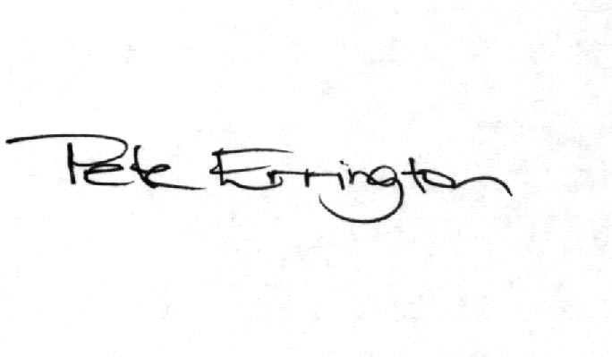

Pete Errington
Home Builders Federation
Regional Policy Manager (South, East & London)

