

BY EMAIL ONLY

Planning Policy Team
West Berks District Council
Council Offices
Market Street
Newbury RG14 5LD

10th January 2008

Dear Sir / Madam,

WEST BERKSHIRE PLANNING STRATEGY – HOUSING OPTIONS

Thank you for affording the Home Builders Federation (HBF) the opportunity of commenting on this draft document.

HBF has a small number of comments to make on the document. The main one relates to way it is proposed treating the urban extension to Reading as recommended by the South East Plan Panel Report. Whilst the council’s explanation is noted it is not, however, accepted as a reasonable way to plan for future housing provision in the district. The delivery of this urban extension to Reading will be a key component of the overall housing delivery strategy and the council must demonstrate, through its core strategy, that proper provision is made to facilitate its delivery in the same way as with the rest of its housing allocation. It is a pivotal component of the overall strategy (not just the housing element) in that it has broader implications for the provision of infrastructure and services which will have knock on implications for other development in the district. Particularly anything proposed in the eastern part of the district. Therefore, this matter must be addressed now as part of this core strategy rather than be left to some unspecified point in the future and rather than being relegated to a separate DPD. It certainly should not be treated as a “separate issue”.

Secondly HBF takes the view that the options do not adequately reflect the conclusions of the South East Plan Panel in their references in their report to the ability not only of the Newbury / Thatcham area to take “substantially” more development, but that there was scope for more development “in Hungerford and other smaller settlements” (paragraph 21.66 of the panel’s report). There is very little mention of these other smaller settlements in the document and no mention whatsoever of Hungerford.
Whilst HBF does not have a particular view on where development should be located given our Members many and varied land interests (our interest is mainly in ensuring that the overall housing requirement will be met) we felt it important to point out this apparent inconsistency with the Panel’s report. Furthermore, we suggest that the council more properly consider through this Options evaluation the opportunities for development in these ‘other smaller settlements’ alongside development in and adjacent to the larger urban areas. Particularly those settlements offering a range of facilities, amenities and opportunities for employment and so which would comply with sustainability criteria.

I trust that these comments will be taken on board and the council’s approach amended accordingly. Either way I would like to be kept informed of progress on this issue as it evolves.

Yours faithfully,
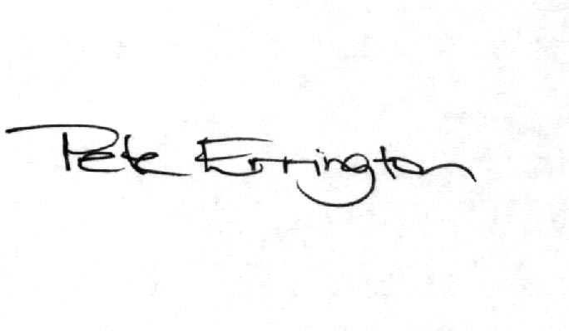

Pete Errington
Home Builders Federation
Regional Policy Manager (South, East & London)

