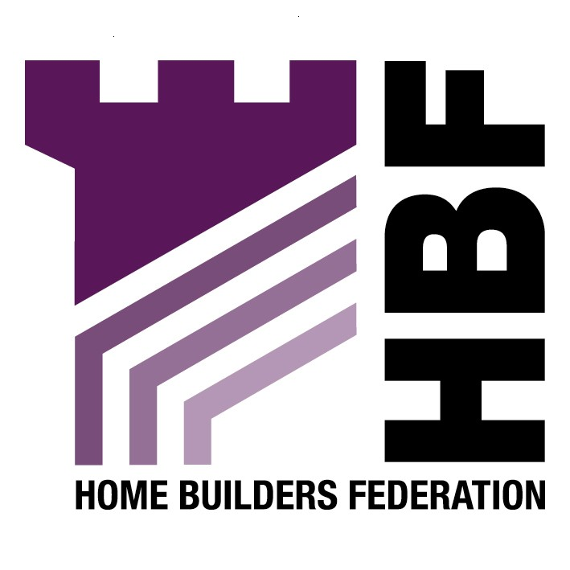

Emailed to implementation@sunderland.gov.uk

Director of Development and Regeneration
Planning Implementation (Urban Design)
Sunderland City Council
P0 Box 102
Civic Centre,
Burdon Road,
Sunderland
SR2 7DN

19 December 2007

Dear Sir or Madam

Sunderland Central Area Urban Design Strategy

Thank you for giving the Home Builders Federation (HBF) the opportunity to comment on the above document. The HBF have considered the proposed document and have made the following observations:

Objective 7: Achieve Environmental Sustainability
Energy

The HBF is opposed to the separate requirements for 10% of a development’s energy requirement to be generated by renewable energy. The industry is serious about reducing the carbon footprint of housing and is supportive of the Code for Sustainable Homes as well as being a signatory to the 2016 Commitment. Housebuilders are working to improve the energy efficiency of new housing and finding ways of incorporating energy efficient technologies (where relevant) in the design process. However, the industry believes that the best way to improve the energy efficiency of new housing stock and to promote renewable energy is through innovations in materials and technology development and the economies of scale available to house builders to incorporate the best of these new technologies in the construction process, not by setting arbitrary targets that are impossible to measurable. We feel that the prescription of minimum percentages for the incorporation of certain types of micro-renewable energy is neither constructive nor beneficial in helping to tackle the long-term challenges of climate change. Such an approach could fragment efforts to achieve economies of scale and prevent a concerted focus from the supply chain in developing the most promising new products efficiently.
The generation of energy via micro-renewables will do little to help reduce carbon emissions (for many reasons, but not least because of the energy consumed by domestic appliances inside the home). The reduction of CO₂ is best tackled through the design and construction of homes, improvements to the existing stock, changes in consumer preferences and individual behaviour and, at the macro-scale, through investment in cleaner power generation by Central Government. A plethora of micro-renewables spread across the UK’s 26 million existing homes, needing regular cleaning, routine servicing (by people in vans) and eventual replacement after a couple of decades, strikes us as an inefficient use of resources.

Moreover, many of these renewable technologies are in their infancy and are relatively untested. Only solar collectors are anything like a viable on-site option at the moment – all the other options currently available are expensive, inefficient and offer no security of supply in the longer term. This may adversely affect the saleability of housing schemes if people are wary of these untested technologies and the implication of break-down in the form of rising service charges or maintenance costs. These technologies will also add to the medium and long-term management costs of the socially rented sector.

Code for Sustainable Homes

The HBF welcomes the Council’s recognition of the Code for Sustainable Homes as a means of improving energy efficiency in new housing. However, the Council must be realistic when setting requirements. The Code is a staged introduction of energy improvements so that homes are carbon neutral by 2016. According to the timetable Code Level 3 should be reached by 2010, and Code Level 4 by 2013. Therefore, the Council should not seek to accelerate the timetable by imposing higher standards prematurely. Staged national delivery of improved levels of the code for sustainable homes will ensure pioneering technologies are robust, meet customer expectations and are backed by proper warranties. A multitude of differing targets around the country put these efforts at risk. It is important that all LPAs: accept this framework as a legitimate national route for effective progress, and; do not take it upon themselves to try to move faster than the timetable outlined in the national documents.

Thank you again for giving the HBF the opportunity to comment. We trust you will take our comments on board and look forward to receiving further information regarding the progress of the document.

Yours faithfully

Laura Edwards

Laura Edwards (maternity cover for Gina Bourne)
Regional Planner – Northern Region
Home Builders Federation

