

BY EMAIL ONLY

Head of Planning Policy & Projects

Slough Borough Council

Town Hall

Bath Road

Slough

SL1 3UQ

19th December 2007

Dear Sir / Madam,

SUBMITTED CORE STRATEGY

Thank you for affording the Home Builders Federation (HBF) the opportunity of commenting on your council’s submitted core strategy. HBF welcomes many aspects of the strategy, in particular regarding the extent of housing delivery proposed. However, we have one key concern regarding the translation of this delivery aspiration into reality and that relates to the issue of contingency provision and the (lack of) flexibility to deal with changing circumstances. This matter is addressed in respect of various policies of the strategy in which it is manifest on the following pages.

I look forward to the opportunity of elaborating on this matter at the public examination in due course.

Yours faithfully,
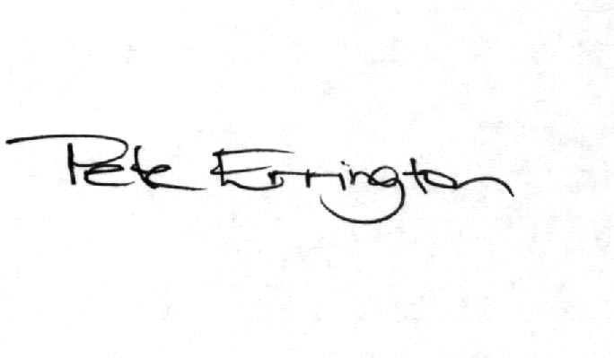

Pete Errington
Home Builders Federation
Regional Policy Manager (South, East & London)
Policy / Paragraph No: Core Policy 2 Green Belt & Strategic Gap

Reason for Objection: Overly restrictive & inflexible policy stance

Relevant PPS12 Test(s) of Soundness: vii, viii, ix

Change Sought: Inclusion of text in the policy / supporting text to include reference to the identification of reserve sites and circumstances for their release

Comment:

See comments on Policy CP3 below.

Given the lack of flexibility in the strategy to provide sufficient certainty that the housing requirement will be met, and in order to ensure compliance with PPS3, the strategy will need to identify additional land for development in the Green Belt / Strategic Gap to be held in reserve and its release controlled by a new PMM policy. This possibility should be recognised in this Gap / Green Belt policy.

Policy / Paragraph No: Core Policy 3 Housing Distribution

Reason for Objection: Lack of contingency provision

Relevant PPS12 Test(s) of Soundness: vii, viii, ix

Change Sought: Inclusion of a new policy to address PMM based on robust and credible evidence and a review of Strategic Gap policy and boundaries

Comment:

As stated in opening HBF welcomes the fact that the council is proposing to treat the housing target as a minimum and that it shows, in the housing trajectory appended to the strategy, an anticipated future housing supply well in excess of the SE Plan requirement.

However, we are concerned that there is not a sufficiently robust strategy in place to guarantee the delivery of this level of housing. There are high expectations of future delivery from a number of key town centre regeneration sites. However, it is acknowledged in the strategy that there are constraints to the delivery of some of these sites (paragraph 7.46). It is also recognised that, in respect of other sites – sites on which starts are to be expected within the next 18-24 months, in order that substantial numbers of completions can be achieved in the 2010/2011 year – that they do not yet even have the benefit of planning permission.

The council also includes a windfall allowance in its housing trajectory and housing policy totalling some 30 dwellings per year or 600 dwellings (over 10% of supply) over the course of the 20 year strategy period. This is contrary to PPS3 which states that no allowances should be made for windfalls in the first 10 years of the strategy period. There are exceptional circumstances referred to in PPS3 (paragraph 59). However, given that the council has not carried out a SHLAA (as detailed below) it is not able to demonstrate that these circumstances apply.

All of this suggests that the achievement of the levels of development set out in the housing trajectory is far from certain.

This uncertainty is compounded by the fact that the council acknowledges in the strategy (paragraph 7.45) that it has not carried out a Strategic Housing Land Availability Assessment. On that basis, the claim at paragraph 7.44 regarding consistency with PPS3, is one which cannot be substantiated. PPS3 and the PPS12 tests of soundness both oblige the council to build its strategy on a robust and credible evidence base. In the case of housing policy such an evidence base must comprise a SHLAA carried out in accordance with the Government’s practice guidance with the full involvement of stakeholders including local landowners, estate agents, house builders and developers.

The uncertainty is further compounded in that the plan has no contingency provision or even a contingency strategy to deal with delays or insurmountable problems with the delivery of these key sites. This is unacceptable in terms of the tests of soundness. The only mechanism which claims to address this issue is the annual monitoring report (paragraph 9.18). However, while the AMR will give an indication that there may be problems afoot, it does not provide any policy mechanism to address those problems. The only policy mechanism open to the council, on the basis of the strategy as it is currently formulated, would be to initiate a review of that strategy. That approach does not accord with the Government’s policy aspirations set out in PPS3; it is a Plan-Review and not a Plan Monitor Manage approach.

To address this key point, this strategy must include a policy which sets out how the results of annual monitoring will inform the operation of PMM. The policy would need to facilitate the release of additional identified sites for development if the results of monitoring (through the AMR) reveal that the trajectory (or the annualised housing requirement) is not being achieved as anticipated. The policy must explain what action will be taken, by whom and by when.

This has implications for other policies (namely CP2) in that the only additional land which could be identified to perform this contingency role would be outside the urban boundary on GreenBelt or in identified Strategic Gap. But, since the council has not complied with Government policy, nor the recommendations of the recent South East Plan panel, in terms of reviewing Gap boundaries, now is the time for this review to take place.

Put simply, and taking on board the comments of the Government Office for the South East to many South East local authorities in recent months, a strategy with no contingency or flexibility to deal with uncertainties and changing future circumstances, cannot be considered sound.
Policy / Paragraph No: Core Policy 4 Type of Housing

Reason for Objection: Lack of clarity

Relevant PPS12 Test(s) of Soundness: viii, ix

Change Sought: Inclusion of a text at paragraph 7.62 in the policy itself.

Comment:

HBF welcomes the flexibility provided by policy CP4 and the reference to a 30-50% target for affordable housing provision. However, whilst welcoming the flexibility, we consider that further text should be included in the policy in order to improve clarity and explain what factors will influence how the policy will be applied. As presently worded the policy is unclear and this could impact on housing delivery (and on the delivery of affordable housing delivery) due to the extremes of the range 30-50% and the cost implications of delivering affordable housing at either end of the range.

Developers and landowners should be able to have a reasonable indication of where, within that range, they will be expected to deliver affordable housing on any given site. The key factors will be, as recognised at paragraph 7.62 of the supporting text, the size and nature of the site and viability considerations. In order to improve clarity of the policy, therefore, this text should be incorporated into Policy CP4 itself rather than remaining as supporting text.

