

BY EMAIL ONLY

Head of Town Planning

Elmbridge Borough Council

Civic Centre

High Street

Esher

Surrey KT10 9SD

13th December 2007

Dear Sir / Madam,

PLANNING OBLIGATIONS & INFRASTRUCTURE PROVISION SUPPLEMENTARY PLANNING DOCUMENT

Introduction

Thank you for affording the Home Builders Federation (HBF) the opportunity of commenting on your council’s draft planning obligations SPD. HBF has a number of comments to make as set out below.

Circular 5/2005

Government policy on the use of planning obligations is set out in Circular 5/2005. Therefore, until such a time as it is superceded by any form of land value taxation or alternative planning charge, Circular 5/2005 remains the policy guidance against which to test the reasonableness or otherwise of policy requirements such as those set out in this draft SPD.

The circular sets out 5 tests, all of which must be satisfied in order for a planning obligation to be lawfully sought. Namely that planning obligations must be:

- necessary
- relevant to planning
- directly related to the proposed development
- fairly and reasonably related in scale and kind to the proposed development and
- reasonable in all other respects

Paragraph B7 of the circular makes it clear that planning obligations should never be used purely as a means of securing for the community a share of the profits from new development. Similarly, at paragraph B9, that they should not be used solely to resolve existing deficiencies in infrastructure provision.

Existing Provision of Facilities and Amenities

HBF is concerned that this SPD appears to be starting from the presumption that there is no existing provision of facilities in the borough and that all new development will need to make full provision for the needs new development will generate. That is clearly not the case.

Where there are deficiencies in provision and new development generates additional pressure on existing facilities, it is, of course, reasonable for new development to make additional provision. However, the nature and extent of that additional provision (or the payment of a tax towards its provision) should relate primarily to the extra pressure created by the new development rather than the extent of the existing deficiency in provision.

Conversely, however, whilst there are likely to be areas suffering deficiencies in provision, there will be other areas showing a surplus of provision (whether open space, school places, library capacity and so on) when assessed against the same standards. In those areas, there is no justification for seeking the same full provision / tax payment as some of the pressure generated by new development will be absorbed by surplus capacity at existing facilities. Cake cannot be both had and eaten in this regard.

The SPD must be amended to ensure that the nature and extent of any planning obligation (financial payment) sought takes account of existing surpluses and deficiencies in provision rather than simply looking at the demand generated by new development. What is actually sought should reflect those surpluses and deficiencies rather than simply adhering to the fixed district-wide standards. Not to do so would be to fail to comply with the tests set out above.

While HBF would acknowledge that the application of a standard tariff or tariffs does have its benefits in terms of consistency, clarity and simplicity of approach, any tariff should not seek to undermine the fundamental principles underlying Circular 5/2005 nor the tests set out therein. Standard charges can be applied but they must be applied flexibly in the full knowledge of, and taking fully into account, the level of existing provision and use of the facilities and amenities in question. Our fundamental concern of principle, therefore, is that this is not reflected in the draft SPD and this must be addressed if the requirements of the SPD are to accord with Government policy.

Residential Occupancy Rates

Secondly, turning to some more detailed comments, the first of these relates to the occupancy rates set out in the standard charges for residential development. These seem very high compared to the actual occupancy of new development. HBF notes from the footnote to Table 1 of the supporting document on the basis for calculating formulae and standard charges that the basis for these occupancy levels is a survey of the occupancy of new dwellings carried out 8-10 years ago. HBF would suggest that this is not a reasonable basis on which to estimate the occupancy of new development in view of the substantial change in the nature, type and size of residential units that have been built in the intervening 8-10 years. These occupancy rates should be based on more up to date information available in the form of the Government’s household forecasts in order that the planning obligations sought are not excessive and that they comply with the Circular 5/2005 tests.

The SPD should also provide a commitment to review these occupancy rates as new information becomes available on the same basis it will review the financial contribution figures themselves.

Different Types of Development

Secondly on points of detail and following on from the above, the SPD must also acknowledge that different types of development (brownfield / greenfield) may require different degrees of flexibility in the way in which these tax rates are applied. It will not be appropriate to seek the same scale of financial contribution from all types of development as the costs associated with bringing forward different types of development will vary. Again, whilst the benefits of a standard approach are recognised, there must be some in-built flexibility in their application on a site by site basis in order that much needed development is allowed to proceed.

Monitoring Fee

Thirdly, at a time when the planning application fees continue to rise and local authorities get ever higher settlements from Government through the Planning (and Housing) Delivery Grant, HBF objects to the fundamental principle of the application of a further fee for carrying out what should already be carried out as part of the statutory planning process for which local authorities are more than adequately funded and for which developers and applicants for planning permission already pay. This 5% monitoring fee is unjustified and inappropriate and should be deleted from the document.

Transport Charge

HBF is concerned that the fundamental premise on which this whole approach is costed is misplaced. It should not be the amount currently spent by the county council mitigating existing travel demands that should form the basis for any transport fee approach. Rather, developers should only be expected to mitigate against new travel demands to a level proportionate to the demand created by the development. In that regard, the current amount spent by the county council is irrelevant as it bears no relation to the demands likely to be generated by any new developments – many of which will incorporate mitigation features as a condition of being granted planning permission in the first place. And many of which will have a beneficial impact on trip generation compared to existing uses.

Thus, in considering the mitigation effects required (or the level of any fee to contribute towards any mitigation effects) this should take into account any existing trip generation arising out of a site before it is redeveloped as, clearly, this may have a beneficial effect in which case, under the provisions of Circular 5/2005, no fee payments could be justified.

This particular aspect of the SPD approach falls foul of some, if not all, of the 5/2005 tests. The sums sought are nowhere properly justified, explained or costed in the document, in terms of the impacts of development proposed. They are solely justified on the basis of current county council expenditure. Nor are they justified, explained or costed on the basis of any schemes in the pipeline which may seek to mitigate traffic impacts and/or travel demand to which additional development may reasonably be expected to fund or contribute. The whole approach is highly unsatisfactory. It cannot and does not take into account the fact that each development will be different and that whether or not any payment may or may not be required can only be determined in the context of each and every development.

Given that much new development makes use of land that is already developed and already has a traffic impact it is simply unacceptable to assume that new development always generates additional traffic impact. Nor is there any guarantee that any funds paid will be actually used to mitigate the traffic impact which may arise from a particular development. Instead, funds will simply be paid into a general pot and may be spent on unspecified schemes or projects which may be wholly unrelated to the development from which the original contribution was sought. Again, therefore, while the application of standard charges is acceptable under 5/2005 this is only where this does not undermine the fundamental principles underlying the Circular. This transport fee, in particular, does seek to undermine the principles of the Circular and must be totally reconsidered from first principles as described above.

I trust these comments are helpful and I hope they can be incorporated into the SPD before it proceeds to adoption. Either way I would be pleased to be kept informed of progress on this SPD in due course.

Yours faithfully,
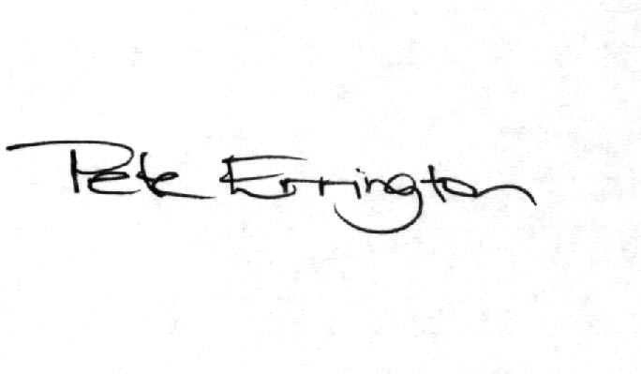

Pete Errington
Home Builders Federation
Regional Policy Manager (South, East & London)

