

BY EMAIL ONLY

Vale of White Horse District Council

Abbey House

Abingdon

Oxfordshire

OX14 3JE

13th December 2007

Dear Sir / Madam,

OPEN SPACE, SPORT & RECREATION SUPPLEMENTARY PLANNING DOCUMENT

Thank you for affording the Home Builders Federation (HBF) the opportunity of commenting on your council’s draft open space SPD. HBF has a number of comments to make as set out below.

Government policy on the use of planning obligations is set out in Circular 5/2005. Therefore, until such a time as it is superceded by any form of land value taxation or alternative planning charge, Circular 5/2005 remains the policy guidance against which to test the reasonableness or otherwise of policy requirements such as those set out in this draft SPD.

The circular sets out 5 tests, all of which must be satisfied in order for a planning obligation to be lawfully sought. Namely that planning obligations must be:

- necessary
- relevant to planning
- directly related to the proposed development
- fairly and reasonably related in scale and kind to the proposed development and
- reasonable in all other respects

Paragraph B7 of the circular makes it clear that planning obligations should never be used purely as a means of securing for the community a share of the profits from new development. Similarly, at paragraph B9 that they should not be used solely to resolve existing deficiencies in infrastructure provision.

HBF is concerned that this SPD appears to be starting from the presumption that there is no existing open space in the district and that all new development will need to make full provision for the needs new development will generate. That is clearly not the case.

Where there are deficiencies in provision and new development generates additional pressure on existing facilities, it is, of course, reasonable for new development to make additional provision. However, the nature and extent of that additional provision should relate primarily to the extra pressure created by the new development rather than the extent of the existing deficiency in provision.

Conversely, however, whilst there are likely to be areas suffering deficiencies in provision, there will be other areas showing a surplus of open space provision when assessed against the same standards. In those areas, there is no justification for seeking the same full provision as some of the pressure generated by new development will be absorbed by surplus capacity at existing facilities. Cake cannot be both had and eaten in this regard.

The SPD must be amended to recognise that the nature and extent of any planning obligation sought will take account of existing surpluses and deficiencies in provision rather than simply looking at the demand generated by new development. What is actually sought should reflect those surpluses and deficiencies rather than simply adhering to the fixed district-wide standards. Not to do so would be to fail to comply with the tests set out above.

There does seem to be one suggestion that this will be the case at paragraph 4.11 of the document. Elsewhere in the earlier sections of the document, however, the reader is left with the distinct impression that the standards will be applied regardless.

Secondly, turning to the occupancy rates set out at paragraph 2.8, these seem very high compared to the actual occupancy of new development. The SPD should provide the source and justification for these occupancy rates in order that their reasonableness can be assessed. The SPD should also provide a commitment to review these occupancy rates as new information becomes available on the same basis it will review the contributions in lieu figures. Similarly, the SPD should acknowledge that different types of development may require different degrees of flexibility in the way in which these rates are applied.

Finally the maintenance requirement for a period of 25 years, and the fact that this is required as a single rather than a staged payment, is excessive and unreasonable and is nowhere justified or explained in the document. It is clearly the case that the occupants of new development will be council tax payers in the district and there must be a reasonable assumption that longer term maintenance is something which should be borne from the public purse. It may be acceptable for maintenance payments to be sought but these should be for substantially less than 25 years.

I trust these comments are helpful and I hope they can be incorporated into the SPD before it proceeds to adoption. Either way I would be pleased to be kept informed of progress on this SPD in due course.

Yours faithfully,
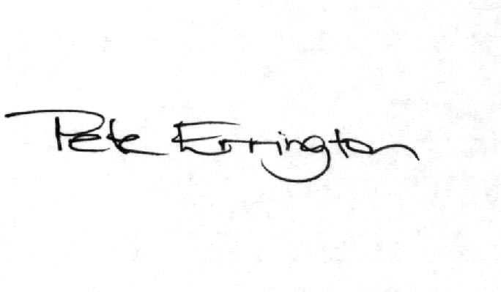

Pete Errington
Home Builders Federation
Regional Policy Manager (South, East & London)

