

BY EMAIL ONLY

Planning Policy Division

Mid Sussex District Council

Oaklands

Haywards Heath

West Sussex

RH16 1SS

3rd January 2008

Dear Sir / Madam,

SPACE STANDARDS SPD – SUSTAINABILITY APPRAISAL SCOPING REPORT

Introduction

Thank you for affording the Home Builders Federation (HBF) the opportunity of commenting on this scoping report.

The house building industry has a fundamental problem with local authorities seeking to prescribe the size and type of products built by the private sector in that it goes way beyond not only traditional land use planning but also spatial planning and impinges on matters better dealt with by other regulatory regimes. It will also have unintended, undesirable and perverse consequences on the achievement of housing delivery targets and the cost (and so price) of new housing. It is therefore contrary to Government policy making the whole approach unsound and possibly ultra vires.

We will make those comments in greater detail and more forcefully at the appropriate point in the evolution of this SPD. However, sticking to matters relevant to this stage in the process we consider that the scoping report is also fundamentally flawed as it takes an illogical and unreasonable view of what is ‘sustainable’ and so what is to be appraised.

Sustainability Appraisal

The usual definition of sustainable development is the Bruntland definition which talks about meeting the needs of today’s generations in a way which will not prevent future generations from meeting their own needs.

The key point is that it is about meeting identified needs; meeting them in as sustainable, efficient and effective way possible, but meeting them nonetheless. Not meeting clearly identified needs and so exacerbating the housing problems which exist (and remembering that the need for shelter is a basic human necessity) is inherently unsustainable.

The policy approach being advocated, therefore, despite being touted on the back of the sustainable agenda will, in itself, be unsustainable if it brings all new development to a stop. Cake cannot be both had and eaten. If Mid Sussex claims an extremely high need for affordable housing then it should be seeking to facilitate and encourage new development rather than placing increasing numbers of obstacles in its way. It is illogical to suggest that the industry will be able to build more dwellings that are both larger and cheaper at the same time as delivering large amounts of affordable housing and meeting other planning obligations unless the council is to make substantially more land available for development.

This scoping report does not address these most basic sustainability implications of the proposed policy approach in these terms. It does not consider the implications of requiring larger units of accommodation on the overall delivery of housing and meeting housing targets and the cost of compliance. Building larger units of accommodation means achieving fewer units on any given development site. In turn this makes those units more expensive in order that financial returns are maintained. At a time of extremely high house prices it is perverse to seek to increase the cost further of that already expensive commodity as customers will not be able to afford to buy the product. This is a key aspect of the whole sustainability agenda and must be factored in to the sustainability appraisal if the SA itself is not to be fundamentally flawed.

Process

In view of the above fundamental concerns, HBF is also concerned that the council is proposing to introduce these policy requirements through the use of SPD. PPS12 is clear that Supplementary Planning Documents (SPD) must be consistent with national and regional planning policies as well as policies set out in the local development framework (PPS12, paragraph 2.43).

Paragraph 2.44 of PPS12 goes on to state that SPD should not be used to avoid subjecting to independent scrutiny and testing policy which should more appropriately be included in development plan documents.

Yet this is precisely the situation here. The proposed policy approach suggested in this scoping report does far more than merely supplement existing adopted / saved policy. Rather it is likely to introduce wholly new and onerous policy requirements which will have widespread implications for the achievement of other policy objectives. This matter should not, therefore, be introduced as SPD but should be subject to proper scrutiny and independent testing through the DPD process.

I trust that these matters will be taken on board during the sustainability appraisal process. Either way I would like to be kept informed of progress on this policy issue as it evolves.

Yours faithfully,
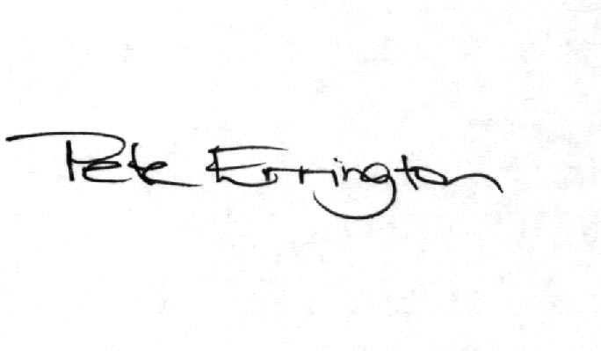

Pete Errington
Home Builders Federation
Regional Policy Manager (South, East & London)

