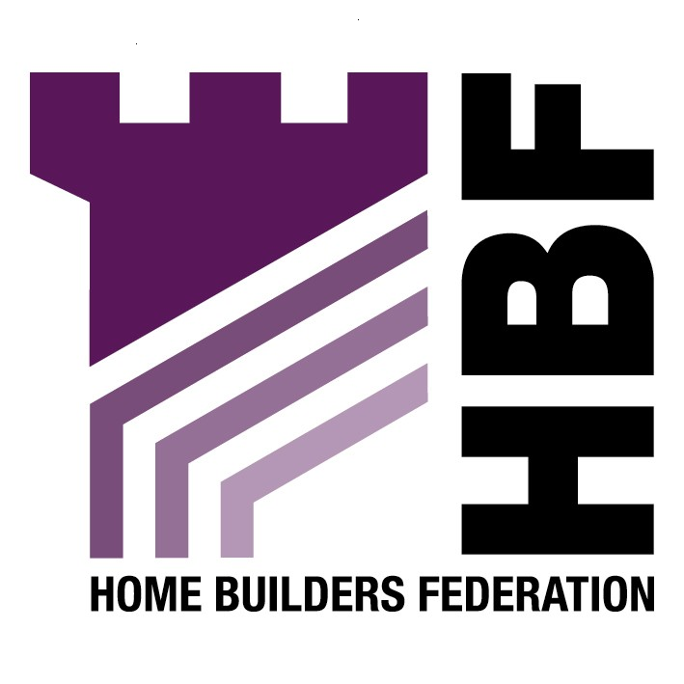

Emailed to forwardplanning@chester.gov.uk

Chester City Council
The Forum
Chester
CH1 2HS

02 November 2007

Dear Sir or Madam

Early consultation Draft SPD Sustainable Development

Thank you for giving the Home Builders Federation (HBF) the opportunity to comment on the above document. The HBF have considered the proposed document and have made the following observations:

Energy

The HBF would like to emphasise that sustainable development issues should be covered through the Code for Sustainable Homes as this is a nationally agreed timetable for the staged introduction of improvements to the energy efficiency of housing.

The HBF would object to separate requirements for the generation of renewable energy on site. The generation of energy via micro-renewables will do little to help reduce carbon emissions (for many reasons, but not least because of the energy consumed by domestic appliances inside the home). The reduction of CO₂ is best tackled through the design and construction of homes, improvements to the existing stock, changes in consumer preferences and individual behaviour and, at the macro-scale, through investment in cleaner power generation by Central Government. A plethora of micro-renewables spread across the UK’s 26 million existing homes, needing regular cleaning, routine servicing (by people in vans) and eventual replacement after a couple of decades, strikes us as an inefficient use of resources.

Moreover, many of these renewable technologies are in their infancy and are relatively untested. Only solar collectors are anything like a viable on-site option at the moment – all the other options currently available are expensive, inefficient and offer no security of supply in the longer term. This may adversely affect the saleability of housing schemes if people are wary of these untested technologies and the implication of break-down in the form of rising service charges or maintenance costs. These technologies will also add to the medium and long-term management costs of the socially rented sector.
In terms of sustainable design and construction this is not a matter for planning and is addressed through the building regulations and through the Code for Sustainable Homes.

Thank you again for giving the HBF the opportunity to comment. We trust you will take our comments into account and look forward to receiving further information regarding the progress of the document.

Yours faithfully,

Laura Edwards

Laura Edwards (maternity cover for Gina Bourne)
Regional Planner – Northern Region

Home Builders Federation

