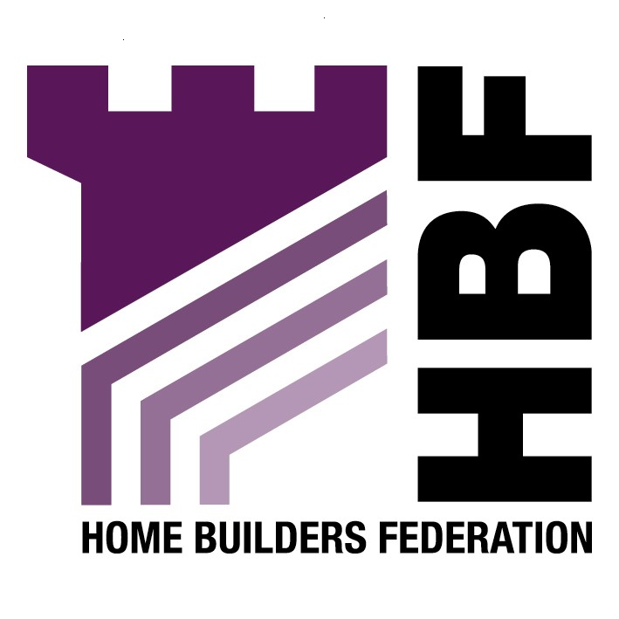
Emailed to strategic.planning@trafford.gov.uk

Trafford Council
Strategic Planning and Developments
First Floor
Waterside House
Sale Waterside
Sale
M33 7ZF

23 November 2007

Dear Sir or Madam

Development Management and Core Policies: Issues and Options

Thank you for giving the Home Builders Federation (HBF) the opportunity to comment on the above document. The HBF have considered the proposed document and have made the following observations:

SBE1 Design and Construction

Option 1: Yes. The Home Builders Federation supports the use of the Code for Sustainable Homes as a single national standard to improve environmental standards. However, the Council should ensure that it keeps to the Code timetable to ensure that environmental standards are increased gradually and supply chains are in place to meet the demands.

Option 2: No

SBE4 Renewable Energy

The HBF does not agree with any of the options and believes that the renewable energy policy should be removed from this document. The HBF believes that any requirement for renewable energy provision upon new development should be delivered through the higher stages of the Code for Sustainable Homes. As this is a framework and timescale to which the industry is committed to delivering. The HBF consider that the application of locally based energy performance standards would be unhelpful in facilitating the broader delivery of higher energy performance and consumption standards from new housing. In order to reduce CO2 emissions, renewables provision on site might not be the most appropriate means of achieving this overall reduction, either technically or financially.

In terms of on-site renewables the industry is serious about reducing the carbon footprint of housing and is supportive of the Code for Sustainable Homes as well as being a signatory to the 2016 Commitment. Housebuilders are working to improve the energy efficiency of new housing and finding ways of incorporating energy efficient technologies (where relevant) in the design process. However, the industry believes that the best way to improve the energy efficiency of new housing stock and to promote renewable energy is through innovations in materials and technology development and the economies of scale available to house builders to incorporate the best of these new technologies in the construction process, not by setting arbitrary targets that are impossible to measurable. We feel that the prescription of minimum percentages for the incorporation of certain types of micro-renewable energy is neither constructive nor beneficial in helping to tackle the long-term challenges of climate change. Such an approach could fragment efforts to achieve economies of scale and prevent a concerted focus from the supply chain in developing the most promising new products efficiently.
The generation of energy via micro-renewables will do little to help reduce carbon emissions (for many reasons, but not least because of the energy consumed by domestic appliances inside the home). The reduction of CO₂ is best tackled through the design and construction of homes, improvements to the existing stock, changes in consumer preferences and individual behaviour and, at the macro-scale, through investment in cleaner power generation by Central Government. A plethora of micro-renewables spread across the UK’s 26 million existing homes, needing regular cleaning, routine servicing (by people in vans) and eventual replacement after a couple of decades, strikes us as an inefficient use of resources.

Moreover, many of these renewable technologies are in their infancy and are relatively untested. Only solar collectors are anything like a viable on-site option at the moment – all the other options currently available are expensive, inefficient and offer no security of supply in the longer term. This may adversely affect the saleability of housing schemes if people are wary of these untested technologies and the implication of break-down in the form of rising service charges or maintenance costs. These technologies will also add to the medium and long-term management costs of the socially rented sector.
QH Quality Homes
QH1 House Type
Option 5.

The HBF believes that leaving the market to determine the type of residential units on site is the most appropriate option. HBF is concerned that the Council will dictate the provision of a mix of dwelling types in new developments in all cases. It will not be appropriate for the council to dictate this in all circumstances. This matter must be approached sensibly. Achieving mixed communities does not mean that all areas have to have the same mix of dwelling types. All areas are different, all housing markets are different and this needs to be considered on a sub-regional scale. Different areas perform different functions and this is often largely as a result of the housing mix in an area. The market assessment needs to consider the issue of complementarity between areas.

It is appreciated that the planning system’s involvement in the housing mix is becoming of increasing importance. However, HBF members believe that the public sector should not dictate housing sizes, mix or specification on private sector sites. Private individuals buying a home make choices about price, location, dwelling type and size; plot size etc. according to their income and personal requirements. The state has no place restricting the availability of certain types of housing (e.g. small affordable units), which in practice amounts to telling certain households what they should or should not buy. Also, by imposing size standards or housing mix on private housing sites, local authorities reduce the supply of housing, exclude some households from decent housing and worsen the affordability crisis. What history has demonstrated is that the more flexible housing is the more likely it is to last. Over- designing houses today must not limit the flexibility of houses to meet tomorrow’s needs.

However, if the local authority planning departments are to become involved in this, which seems inevitable, it would seem sensible to adopt a flexible approach which could be applied by all developers.

PO Planning Obligations
PO1 The Use of Planning Obligations to Improve Life in Trafford

The HBF believes that any planning obligations that the Council seeks to acquire for housing developments must be directly related to its impact on the area. The HBF draws attention to the Circular 05/2005, paragraph B5, which sets out five tests which must be met by all local planning authorities in seeking planning obligations:

“A planning obligation must be:
- relevant to planning;
- necessary to make the proposed development acceptable in planning terms;
- directly related to the proposed development;
- fairly and reasonably related in scale and kind to the proposed development; and
- reasonable in all other respects.”

Any obligation must meet these tests. Therefore, additional provision cannot be sought if it is not directly related in scale and kind to the development. The standards should be set as a clear formula that is readily understood thereby conforming to Circular 05/32005.

The HBF believes that “12 Contribution to the cost of a dedicated officer to deal with planning contributions” should be removed as this is unreasonable and should be covered by the planning application fee.

Thank you again for giving the HBF the opportunity to comment. We trust you will take our comments into account and look forward to receiving further information regarding the progress of the document.

Yours faithfully,

Laura Edwards

Laura Edwards (maternity cover for Gina Bourne)
Regional Planner – Northern Region

Home Builders Federation

