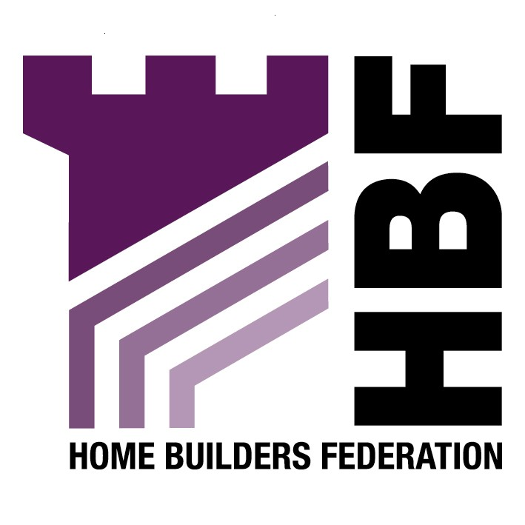

Emailed to ldf@leeds.gov.uk

Planning and Economic Policy
Leeds City Council
The Leonardo Building
2 Rossington Street
Leeds
LS2 8HD

4 December 2007

Dear Sir or Madam

Core Strategy: Issues and Alternative Options

Thank you for giving the Home Builders Federation (HBF) the opportunity to comment on your Draft Supplementary Planning Document for Developer Contributions. The HBF have considered the proposed document and have made the following observations:

4i) The Environment
2 Climate Change

c) No. In accordance with Circular 05/05 the Council can only require developer contributions which are directly related to the proposed development. Therefore, it would not be appropriate to require developers to “retro fit” existing stock when this has nothing to do with new housing developments.

d) and e) The HBF believes that both of these policies are inappropriate and there should not be a separate requirement for renewable energy in the Core Strategy. The HBF believes that any requirement for renewable energy provision upon new development should be delivered through the higher stages of the Code for Sustainable Homes. As this is a framework and timescale to which the industry is committed to delivering. The HBF consider that the application of locally based energy performance standards would be unhelpful in facilitating the broader delivery of higher energy performance and consumption standards from new housing. The industry is serious about reducing the carbon footprint of housing and is supportive of the Code for Sustainable Homes as well as being a signatory to the 2016 Commitment. Housebuilders are working to improve the energy efficiency of new housing and finding ways of incorporating energy efficient technologies (where relevant) in the design process. However, the industry believes that the best way to improve the energy efficiency of new housing stock and to promote renewable energy is through innovations in materials and technology development and the economies of scale available to house builders to incorporate the best of these new technologies in the construction process, not by setting arbitrary targets that are impossible to measurable. We feel that the prescription of minimum percentages for the incorporation of certain types of micro-renewable energy is neither constructive nor beneficial in helping to tackle the long-term challenges of climate change. Such an approach could fragment efforts to achieve economies of scale and prevent a concerted focus from the supply chain in developing the most promising new products efficiently.
The generation of energy via micro-renewables will do little to help reduce carbon emissions (for many reasons, but not least because of the energy consumed by domestic appliances inside the home). The reduction of CO₂ is best tackled through the design and construction of homes, improvements to the existing stock, changes in consumer preferences and individual behaviour and, at the macro-scale, through investment in cleaner power generation by Central Government. A plethora of micro-renewables spread across the UK’s 26 million existing homes, needing regular cleaning, routine servicing (by people in vans) and eventual replacement after a couple of decades, strikes us as an inefficient use of resources.

Moreover, many of these renewable technologies are in their infancy and are relatively untested. Only solar collectors are anything like a viable on-site option at the moment – all the other options currently available are expensive, inefficient and offer no security of supply in the longer term. This may adversely affect the saleability of housing schemes if people are wary of these untested technologies and the implication of break-down in the form of rising service charges or maintenance costs. These technologies will also add to the medium and long-term management costs of the socially rented sector.

f) No. The HBF believes that any targets for reducing carbon emissions/ environmental standards should be delivered through the Code for Sustainable Homes as this is a national framework to which the industry is committed to delivering. A nationally agreed framework is the best way of ensuring all new homes are carbon zero by 2016. Staged national delivery of improved levels of the code for sustainable homes will ensure pioneering technologies are robust, meet customer expectations and are backed by proper warranties.

g) No. See above objection.

4. Greenspace

b) Yes. Equal consideration should be given to both Greenfield and brownfield and the merits of each should be taken into consideration i.e. certainty of delivery, sustainability. In many cases greenspace may be more appropriate for quality housing development than other areas.

iii) Future Development

Housing in Leeds

10. a) Disagree

b) Agree

Leeds’ Strategic Housing Market Assessment published in May 2007 shows a clear stakeholder preference for suburban family housing, instead of increasing densities further.
11. The HBF disagrees with options a and b. In seeking to determine what is an appropriate policy approach to securing affordable housing provision, consideration has to be given to the effects on overall housing supply. Particularly the viability of development sites which is a key theme of PPS3. Setting a higher percentage target or lower site size threshold is wholly counter productive if that target / threshold impacts on development viability and so prevents sites coming forward. Or, if achieving that target means compromising so heavily on other policy objectives and planning obligation requirements that the overall quality of development is adversely affected. Should more affordable housing be required, the selling price of the market housing will theoretically need to be increased in order to cover the costs of providing more as the developer gets the least returns from this affordable housing products. However, as you will be aware the sales price of new housing must also echo/reflect the second hand market price. Thus the only alternative is for a developer to try and reduce the land price (ie "the residual land price) which requires a landowner to accept a lower land price. Past experience shows that this will reduce the supply of suitable land onto the market (as evidenced when Development Land Tax was imposed) and hence reduce housing supply. This will ultimately widen the affordability gap. Therefore, it is essential that an appropriate balance be struck in order to balance needs.

13. a) No. It is appreciated that the planning system’s involvement in the housing mix is becoming of increasing importance. However, HBF members believe that the public sector should not dictate housing sizes, mix or specification on private sector sites. Private individuals buying a home make choices about price, location, dwelling type and size; plot size etc. according to their income and personal requirements. The state has no place restricting the availability of certain types of housing, which in practice amounts to telling certain households what they should or should not buy. Also, by imposing size standards or housing mix on private housing sites, local authorities reduce the supply of housing, exclude some households from decent housing and worsen the affordability crisis. What history has demonstrated is that the more flexible housing is the more likely it is to last. Over- designing houses today must not limit the flexibility of houses to meet tomorrow’s needs.
14. PPS3 paragraph 47 states ‘LPA’s may wish to set out a range of densities across the plan area rather than one broad density range although 30 dwellings per hectare net should be used as a national indicative minimum to guide policy development and decision-making, until local density policies are in place’. The HBF supports the approach to allow LPA’s to set density standards for their own area based on a number of criteria involving character assessment and accessibility to services. There should not be either a minimum or maximum amount of housing per square hectare. The housing mix should determine density based on topography, net developable area, space about dwelling standards/ stand off distances, buffer zones, landscaping tress, etc. The Core Strategy should recognise that in some cases it is appropriate for densities below the minimum of 30 dwellings per hectare where justified. This view is supported by paragraph 47 of PPS3.

Thank you again for giving the HBF the opportunity to comment. We trust you will take our comments into account and look forward to receiving further information regarding the progress of the document.

Yours faithfully,

Laura Edwards

Laura Edwards (maternity cover for Gina Bourne)
Regional Planner – Northern Region

Home Builders Federation

