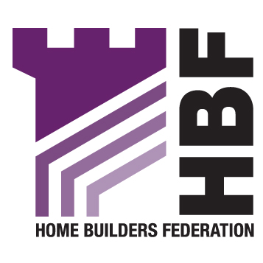

Planning Policy and Environment
London Borough of Greenwich
Peggy Middleton Hosue
50 Woolwich New Road
Woolwich
London
SE18 6HQ 22nd November 2007

BY EMAIL ONLY

Dear Sir/Madam

LONDON BOROUGH OF GREENWICH: STATEMENT OF COMMUNITY INVOLVEMENT

Thank you for consulting with the Home Builders Federation (HBF) on Greenwich’s Statement of Community Involvement. Please could you note my details as the new Regional Planner for London, and update your records accordingly.

General matters

The Council will be aware of the published document from the Planning Inspectorate entitled A framework for assessing soundness and focussing representations on Statements of Community Involvement. It will no doubt now need to satisfy itself that it is in full compliance with the content of this document, and also Creating Local Development Frameworks – A Companion Guide to PPS12. The Statement of Community Involvement also needs to be in accordance with Community Involvement in Planning: The Government’s Objectives (ODPM, 2004).

Specific matters

In relation to the specific content of the Draft Statement of Community Involvement document itself, the HBF would also like to make the following points:

Stakeholders

With regard to the Council’s list of stakeholders and interested parties to be involved throughout the LDF process, we feel it is an omission not to have made specific reference to developers or land agents anywhere in this section. The HBF would like its details to be included on the Local Development Framework Database, as well as those of key developers and land owners with interests in the borough, in order that we and they can be properly involved at all relevant opportunities in the planning process.

E-Alerts/ Letters

The HBF welcomes the Council’s commitment to communicating by letter and e-mail with regard to the production of either draft or adopted DPD and SPD documents. Such an approach would benefit all those that have commercial or site interests in the district, but who may not be physically based within it. While clear and detailed information on the Council’s website will be welcomed, it will be of little benefit unless it is specifically drawn to the attention of all interested parties (e.g. by letters and/or e-mails).

Hopefully landowners, planning agents and developers (including locally active house builders) will be directly consulted in relation to new documents and where appropriate, invited to be involved perhaps in Developers Workshops or Focus Groups. The HBF believes that the development industry has an important role to play in the planning process, particularly with regard to all matters related to the actual implementation of policies and proposals. The HBF further hopes that the Council will seek to consult directly with local house builders and other interested parties, rather than rely on other organisations passing the information down to their memberships. We therefore request that they are added to the Council’s consultation database.

4.5: Supplementary Planning Documents

The Council does not identify the precise nature of the Supplementary Planning Documents (SPDs) being produced as part of the LDF process.

The HBF strongly believes that any matters of importance which impact upon development costs, such as affordable housing, planning obligations and developer contributions, need to be clearly set out in a Development Plan Document (DPD), rather than being delegated down to a SPD. Given that they could potentially have a significant impact on development viability, they must instead be dealt with in DPDs and subject to the appropriate degree of public scrutiny bestowed upon these.

Section 5: Community involvement in planning and other related applications

We feel that this section needs to make some reference to the need for community and developer involvement in ensuring housing delivery in Greenwich, in order to comply with government guidance in PPS3 on the need to involve stakeholders in conducting Strategic Housing Market Assessments and Strategic Land Availability Assessments. The Council will need to instigate this work (possibly also in association with neighbouring local authorities) and this will need to directly involve the development industry.

Equally there will be a need for appropriate evidence gathering by the Council in order to provide a sound basis for its new DPD planning documents. This ought to be acknowledged somewhere in the text, either in this section or possibly at the beginning of sections 2 or 3.

5.7: Developer consultation statements

It is unclear what consultation standards need to be followed by applicants of major schemes. I was unable to locate these standards, despite the draft referring to these as having been ‘set out’ in the document.

Consultation

I hope that you will find these comments helpful and that they will wherever possible be taken on board in the final version of the SCI, and I await the opportunity to be further involved in all aspects of the LDF generally as it evolves. We therefore look forward to being consulted in relation to all relevant planning policy documents at appropriate times during their evolution.

I would appreciate before informed in writing by the Council whenever any Development Plan Document (DPD) is either being submitted to the Secretary of State, or being adopted.

I look forward to the acknowledgment of these comments in due course.

Yours faithfully

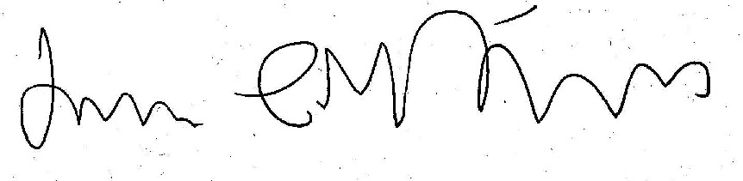
James Stevens
Regional Planner for London

