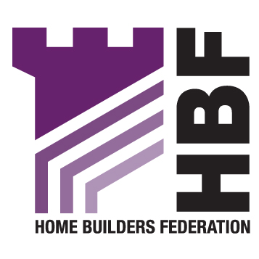

Kidbrooke Project Team
Greenwich Council
29 Carnbrook Road
London
SE3 8AD 4th December 2007

Dear Sir/Madam

DRAFT KIDBROOKE DEVELOPMENT SPD

Thank you for consulting with the Home Builders Federation on Greenwich’s Draft Supplementary Planning Document for the Kidbrooke Development Area. We would like to make the following comments:

General comments

While we acknowledge that while large development sites such as the redevelopment of Kidbrooke play an extremely important role in helping Greenwich meet its housing requirement – for existing and future residents – Greenwich should not ignore the importance of smaller and medium sized sites. The Council cannot rely solely on major schemes in order to meet its substantial housing target. As a desirable borough in which to live, and one supported by good services and schools, Greenwich must ensure that other sites for housing are allocated for development, particularly in the Blackheath area which has good transport links into central London, the City and Canary Wharf.

We would also remind Greenwich that PPS3 requires Greenwich to identify specific sites as well as broad locations to enable the delivery of housing for the next 15 years, and “sufficient specific deliverable sites” to deliver housing in the first five years. We believe that areas, such as currently or recently designated Metropolitan Open Land – areas which may be suitable for residential development – should be reviewed regularly to ensure that Greenwich is able to continue to meet this requirement.

Density

Paragraph 3.8

We are unconvinced that densities must , necessarily, respond to local context. Why the areas adjacent to the Blackheath conservation area, or indeed the conservation area itself, cannot accommodate some intensification, should be challenged and needs to be better explained in the document.

Affordable Housing

Paragraph 4.6

We believe that the Council is attempting to apply far too many different design standards here (UDP standards; the Housing Corporation Scheme Development Standards; Secure By Design Standards; English Partnership Standards; Code for Sustainable Homes; Parker Morris!). This strongly suggests that council planning staff are themselves insufficiently familiar with the content of these different standards, and how they differ, and that it hopes that by simply insisting on compliance with all, a good scheme will result. This is unlikely. Too many conflicting standards will breed confusion and misunderstanding between council staff and the developer. We strongly recommend that the Council adhere to one, or at the most two, sets of standards. We recommend urging compliance with the Code for Sustainable Homes, even though this is not obligatory.

Parker Morris is defunct. It was repealed by Act in 1980 and reference to it should be removed from the draft.

Yours faithfully

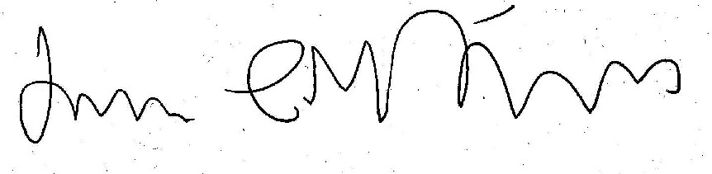

James Stevens
Regional Planner for London

