

BY EMAIL ONLY

Carly Dockerill

Planning Strategy & Projects

Room 407-410

Hove Town Hall

Hove

BN3 3ZZ
12th December 2007
Dear Mrs Dockerill,

STRATEGIC HOUSING LAND AVAILABILITY ASSESSMENT (SHLAA)

Thank you for affording the Home Builders Federation (HBF) the opportunity of commenting on your council’s draft SHLAA methodology. HBF has a number of comments to make as set out below.

Firstly we welcome the fact that the approach is broadly in accordance with the requirements set out in the Annex to PPS3 and the accompanying Practice Guidance. We also welcome the commitment given to on-going engagement with stakeholders throughout the process of preparation of the SHLAA. Turning to a couple of concerns, however these relate to the type of sites to be identified during the assessment process and the treatment of windfalls which we feel do not accurately reflect the requirements of the Practice Guidance.

Firstly on the issue of sources of supply, whilst acknowledging the tightly defined urban settlement boundaries of Brighton & Hove and the constraints of the AONB and the sea, it should not automatically be assumed that no greenfield site could be considered for development. There are non-urban areas of the district which are not covered by these designations, adjacent to the main settlement boundaries (i.e. areas of countryside) which could and should be considered for development. They may be ruled out during the process, but they should be identified in the assessment as the purpose of that assessment is to identify all potential sources of site for development. While the council may consider that such sites will neither be suitable or needed for development, others may take a different view (not least in view of the approach to windfalls dealt with below) and the important point is that the basis for addressing discussions over the suitability or otherwise of greenfield sites for development through the LDF process which will follow on from this study is clear, transparent and accountable. Incorporating greenfield sites adjacent to settlement boundaries in this assessment will assist in this later deliberation.

Secondly, turning to the thorny issue of windfalls, as the methodology notes in reference, to PPS3, these should not normally be included in assessments of supply. As the Practice Guidance notes, just because a district has a history of small site windfall development is not a justification on its own for continuing with such an allowance. Rather it suggests a need to look to identify smaller sites for development. So, where the methodology refers at paragraph 5.28 to past trends suggesting it is appropriate to include a windfall allowance, this is the wrong test. Past trends is not the “exceptional circumstance” which allows the inclusion of a windfall allowance. The exceptional circumstance, as identified in the practice guidance and PPS3, is robust evidence of genuine local circumstances that prevent sites being identified. The council must provide this evidence through the SHLAA process if it is to justify maintaining any windfall allowance.

Furthermore, while HBF accepts the impracticality of going to a threshold much lower than 6 dwellings, there can certainly not be any justification for incorporating windfall allowances for sites of larger than 6 dwellings as these should be identified through the SHLAA process.

Thirdly, and finally, turning to the ‘achievability’ factors and given the serious concerns expressed in our recent correspondence on your council’s sustainable construction SPD, an additional factor to be incorporated in to the assessment of achievability in terms of cost factors is the council’s own policy requirements be they for very high (and so expensive to implement) levels of the Code for Sustainable Homes, very high affordable housing requirements and/or the overall planning obligation requirement imposed by the council on new development. The costs of delivering these planning obligation requirements, in association with all the other market and site specific factors and constraints identified in the methodology, must be factored in to assessments of whether or not sites are likely to be viable and so come forward for development.

I trust these comments are helpful and I hope they can be incorporated into the methodology before work on the assessment commences. Either way I would be pleased to be kept informed of future stages in the SHLAA process and look forward to further opportunities for engagement as the work progresses.

Yours faithfully,
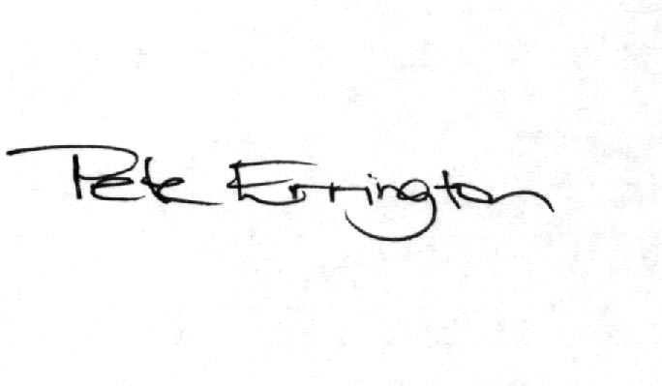

Pete Errington
Home Builders Federation
Regional Policy Manager (South, East & London)

