

BY EMAIL ONLY

Louise Evans

Project Leader – Policy & Plans

New Forest District Council

Appletree Court

Lyndhurst

Hants SO43 7PA

10th December 2007

Dear Louise,

NEW FOREST CORE STRATEGY – PREFERRED OPTIONS

I hope you are keeping well.

Thank you for consulting the Home Builders Federation (HBF) on your council’s core strategy preferred options document.

HBF has a number of comments to make on the document and they are set out on the attached sheets in the order in which they appear in the document. I hope these will be taken on board prior to the document being submitted for examination.

Yours sincerely,
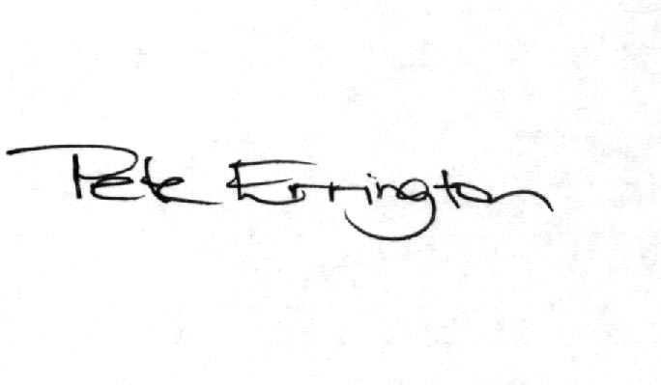

Pete Errington
Home Builders Federation
Regional Policy Manager (South, East & London)

Paragraph 6.5 / Figure 12

HBF is concerned to note that the council is relying on an urban potential study when Government policy is clear that housing policy should now be founded on a robust and credible evidence base in the form of Strategic Housing Market and Strategic Housing Land Availability Assessments.

It will not be appropriate for the strategy to move to the submission stage until the council has undertaken these exercises in accordance with the Government’s PPS3 practice guidance and with the full co-operation and involvement of key stakeholders including house builders, developers, landowners and estate agents.

In the case of the SHLAA, this should look to identify sites which can be allocated for development in subsequent DPDs rather than rely on such a large windfall allowance (approaching 50% of total supply) which is contrary to Government policy and so renders the council’s approach to housing delivery unsound when considered in the context of the tests of soundness set out at paragraph 4.24 of PPS12.
Spatial Options

Given the many and varied land interests of our members, HBF has no preference of which of the four options our pursued. However, the one comment we wish to make on this is that, of the 4 options, option 3 should not be pursued as it would not meet either the strategic housing requirement nor the needs of local communities.

Whichever spatial option is finally chosen, the council should demonstrate through robust and credible supporting evidence and policies in the strategy that the target will be met and should include sufficient flexibility and contingency to allow for future changes in circumstance. In that regard a Plan Monitor Manage (PMM) policy should be included in the strategy which sets out what monitoring will be undertaken and what management will be implemented by whom and when in the monitoring process to ensure that any necessary action is taken to ensure continuity and sufficiency of housing supply.
Housing Preferred Spatial Option / Policy CS4

As stated above, HBF is concerned that the council’s housing supply case is very heavily dependent on unidentified windfall allowances. As is made clear in Government’s practice guidance on carrying out SHLAAs, just because areas are able to demonstrate that high levels of windfall development came forward on small sites in the past, this is not an automatic justification for a continued small site windfall allowance (3rd bullet point under para 25 of the SHLAA guidance). Rather, it points to a need to identify smaller sites for development than may otherwise have been the case.

This situation applies to New Forest district. The council must seek to remove some of the uncertainty surrounding future housing supply by actually identifying sufficient land and sites for development in accordance with the principles advocated in PPS3. Not to do so runs a very serious risk that the strategy will be declared unsound upon submission for examination as has been the case with a number of core strategies recently.

Green Belt & Gaps

HBF does not object to the thrust of the council’s rationale regarding the future treatment of Green Belt. However, if there is a possibility of future amendments to Green Belt boundary through the preparation of the Allocations DPD then this possibility must be reflected in the detailed wording of the over-arching Green Belt policy as it appears in the core strategy.

That is what is proposed in the policy outline CS8. However, HBF reserves the right to submit further representations on this upon sight of the actual proposed wording in the submission document.

It is also highly likely that the core strategy will have to give a clearer steer to areas where Green Belt boundary review may be likely as this will obviously be a matter for discussion at the core strategy EIP when considering the adequacy or otherwise of the council’s policy provision for new housing. HBF would suggest that this matter cannot be left in its entirety to the Allocations DPD.

Turning to the issue of Gaps, HBF objects to the council’s preferred approach as it does not include a review of Gap boundaries as was required by the South East Plan Panel Report. The Panel was very critical of the Gap concept and the way in which it has been applied in Hampshire in particular and so recommended the need to undertake a re-assessment of strategic gaps and consider boundary reviews. The council, in its submission strategy, will need to demonstrate that it has taken on board this recommendation of the Panel and provide proper justification for the inclusion of a Gap policy in the core strategy and for the detailed boundaries when it comes to the Allocations DPD.

Policy CS11 – Energy & Resource Use

HBF objects to criterion a) of the preferred option in that it seeks to accelerate the timescale for achieving the Government’s Code Level 3 set out in the Code for Sustainable Homes.

The Code for Sustainable Homes is, until April 2008 at least, a voluntary Code. Even when it becomes mandatory next year it sets out a very clear and logical timeline for the achievement of ever increasing levels of energy and water efficiency in new development. Code level 3 does not become a requirement until 2010. The implication in the preferred wording is that Code level 3 is being required immediately.

HBF, and the house building industry generally, are signed up to the delivery of the Code and we are similarly signatories to the 2016 Commitment. However, our support for these policy aspirations is conditional upon there being recognition that the Code timescale and requirements will be very challenging to meet for a variety of reasons set out below and on the condition that the Code is applied as a single, consistent national policy requirement and not applied willy-nilly by local authorities seeking to ‘out-green’ each other.

Unfortunately, despite the industry doing its part, many local authorities are not abiding by the code and are, instead, with no proper technical or policy-based justification, seeking to apply selective aspects of the Code to suit their own ends and are seeking to accelerate the already challenging timescales set out in the Code.

This is both unhelpful and unnecessary and could actually be counter productive as it could prevent development coming forward at a time when, in New Forest in particular, there is a desperate need for new housing. Such an approach therefore, despite being touted on the back of the sustainable agenda will, in itself, be unsustainable if it brings all new development to a stop. Sustainable development is about meeting the needs of today’s generations in a way which will not prevent future generations from meeting their own needs. The key point is that it is about meeting identified needs; meeting them in as sustainable, efficient and effective way possible, but meeting them nonetheless. Not meeting clearly identified needs and so exacerbating the housing problems which exist (and remembering that the need for shelter is a basic human necessity) is inherently unsustainable.

The point of a national Code is that it is applied consistently, nationally and so will not have the ‘diversion’ effect as everyone will be playing by the same rules and required to meet the same levels and targets.

Affordable Housing

Whilst HBF does not object to the application of affordable housing policy to developments of any size (i.e. removing the minimum site size threshold) we are concerned at the blanket 50% requirement over the majority of the district and even the 40% target in the Totton & Waterside area. Such a high percentage target on such small sites will be extremely challenging in terms of development viability. The very fact that the Totton and Waterside area is identified as a ‘low value area’ and so subject to a target of ‘only’ 40% suggest that this area actually performs a role as an area which is more affordable than much of Hampshire and so should be set a much lower target than 40%.

HBF will be looking for more evidence, particularly in terms of the impact on development viability and so overall housing delivery, in support of this approach in due course. In the meantime we suggest that the council employs a more sophisticated ‘cascade’ approach which sets different targets for different parts of the district and include further variation for type and size of site. In other words, a much lower target is set for a very small brownfield site in a low value area compared to a medium sized site in a higher value area.

A number of other authorities in Hampshire are seeking to introduce more flexible policies such as this and New Forest should investigate the possibility of doing likewise.

In terms of housing size and type, PPS3, the regional assembly and even the recent panel’s report into the draft South East Plan all make it clear that it is not acceptable or helpful for local authorities to seek to dictate the size and type of housing provided by the private sector.

They may seek to influence it through negotiation. They may seek to prescribe the mix of affordable housing where this is fully supported by robust and credible evidence. But they must not restrict the ability of developers to respond to the market.

