

BY EMAIL ONLY

EERA
Flempton House
Bury St Edmunds
Suffolk
IP28 6EG

7th December 2007

Dear Sir / Madam,

REVISED INTEGRATED REGIONAL STRATEGY FOR THE EAST OF ENGLAND

Thank you for affording the Home Builders Federation (HBF) the opportunity of commenting on the above revised draft integrated regional strategy. HBF has only one comment to make on the document. It is a simple but very important point which relates to the issue of new housing provision.

According to the draft strategy at section 2.2, the number one ‘crucial regional issue’ is housing supply, growth and sustainability. While the draft strategy deals with the latter of these aspects to the n’th degree, there is no further mention anywhere in the draft strategy of the need to achieve the step-change in housing supply referred to under this heading. Nor recognition of the growth agenda, particularly in so far as new housing provision is concerned. This absence from the remainder of the document is both surprising and alarming in view of the acknowledged regional importance of the issue and leaves a glaring hole in the fabric underpinning the whole strategy.

The nearest we get in the draft strategy is Objective 8 which deals with the issue of providing decent and affordable homes for all. However, even here, it deals mainly with affordable housing and does not really address the growth agenda nor does it acknowledge the need for a step change in overall housing delivery.

In view of the acknowledged regional importance of increased housing delivery therefore, it is HBF’s view that this importance should be recognised by increased housing delivery being identified in the draft strategy as a specific Objective in its own right.

The strategy should, therefore, set out that a step change in housing delivery is an Objective in its own right and it should identify the benefits that will bring in the context of the other 18 Objectives. It should also explain how it is envisaged the Objective will be delivered and how that delivery will be monitored and managed in the same was as with the 18 existing Objectives.

If it is not recognised as an Objective in its own right the strategy as a whole can only fail as it will not adequately address this crucial regional issue. This will obviously have knock-on effects on the achievement of most of the other Objectives given the importance of new housing development as provider of funding for most of what the strategy aims to achieve; not least, affordable housing, and the provision of infrastructure in its widest sense incorporating health, education and social infrastructure provision as well as environmental improvement and improving the quality of life of the region’s residents, present and future.

I hope that this matter can be addressed by way of a further revision to the strategy and I look forward to further involvement in the preparation of the strategy in due course.

Yours faithfully,
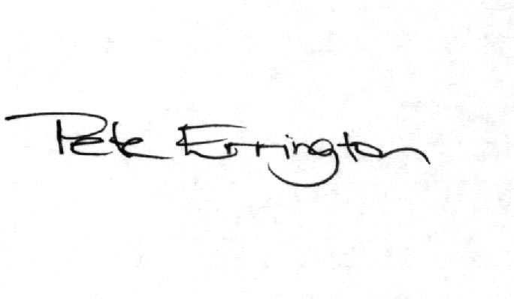

Pete Errington
Home Builders Federation
Regional Policy Manager (South, East & London)

