

BY EMAIL ONLY

East of England Development Agency

The Business Centre

Station Road

Histon

CB24 9LQ

26th November 2007

Dear Sir / Madam,

REGIONAL ECONOMIC STRATEGY FOR THE EAST OF ENGLAND

DRAFT STRATEGY FOR CONSULTATION - SEPTEMBER 2007

INTRODUCTION

The Home Builders Federation (HBF) is the voice of the house building industry. Together our Members build approximately 80% of all new housing units in England and Wales in any given year. Our Members range from multi-national corporations down to small local builders and their representatives.

HBF Members will be key to delivering much of the supporting infrastructure and housing necessary to enable many of the strategy’s objectives and aspirations to be met. We set out below our comments on a few of the questions raised in the draft strategy.

QUESTION 1 – THE THEMES

HBF welcomes the five themes. However, in our view the themes need to elucidate a stronger recognition of the fact that the goals will not be achieved if there is not the delivery of the necessary supporting infrastructure and housing.

In summarising these goals in the executive summary there is a recognition of the need for more housing in support of growth but this is caveated with references to improving the existing stock and to the fact that the household forecasts do not automatically equate to new houses. Whilst that is true to a point there is no escaping the fundamental underlying problem which is that, in order for the economic and household growth forecasts to be met, we need both more land for housing identified and allocated and more new housing built. The strategy should more explicitly acknowledge this fundamental relationship.

Turning to climate change, this important matter will not be addressed solely or even primarily through the growth agenda. Clearly it is right that new development is built to higher environmental standards than what has gone before. However, it will only be by addressing the existing stock of built development and changing individual’s patterns of travel and behaviour that any real gains will be made to this end. The strategy needs to recognise these non-growth aspects of addressing climate change.

QUESTION 2 – THE VISION

It is curious that a strategy sets a vision based on the position in the future. That is not a strategy vision; it is a vision of a static position in the future.

This vision does not, as is claimed, imply or indicate a direction of travel. But that is what it should do. The vision for the strategy should set out how that future vision should be realised. It should explain how the transition, from where we are now to where we want to be in the future, will be made. It is not unreasonable for a strategy to have a vision for the future. But this must very much be secondary to the vision for the strategy itself.

That vision must be of a dynamic strategy implying growth, change and movement towards a goal. It may be fairly non-contentious to describe a vision for the future but the vision for the strategy which takes us there is likely to be much more difficult on which to achieve consensus. But it is vital that this is addressed if there is to be any proper context for the policies and objectives set out in the strategy.

QUESTION 3 - SCENARIOS

Clearly no single scenario will form the basis of the final strategy. Rather it will be a compromise between the various different indicators. However, the bottom line is that the existing level of housing provision set out in the Secretary of State’s proposed changes to the East of England Plan will be insufficient to deliver a growth strategy of any kind. Whichever strategy is finally selected (whether P1, P2 or P3 or even the baseline) will require a significant increase in housing provision over and above the levels set out in the Government’s proposed changes to the RSS. Not least since, as is recognised elsewhere in the strategy, the population of the Eastern region is growing faster than that of any other UK region with the exception of the South-West.

QUESTION 4 – SUSTAINABLE DEVELOPMENT

Sustainable development is about meeting today’s needs in a way which does not compromise future generations’ abilities to meet their own needs. The fundamental point is that it is about meeting needs. It is about meeting needs in as sustainable way possible but it is about meeting needs nonetheless. Not meeting clearly identified needs is not a sustainable way forward.

There is too much emphasis given to the dis-benefits of growth in sustainability terms and not enough to the fact that growth has to occur, that it brings significant benefits in its own right and that it meets identified needs. Clearly new development and ‘growth’ in its widest sense must keep its environmental impacts to the minimum but the environmental aspect of sustainable development should not be given undue weight against the social and economic aspects. There needs to be a more reasonable balance in the strategy between these three facets of sustainability.

QUESTION 5 – ECONOMIC PERFORMANCE / DRIVERS

The provision of sufficient new housing of the right price and type, in the right place and at the right time is, in itself, a driver for growth. Put another way, if insufficient housing is delivered then this will act as a barrier to achieving the growth targets or could even put the brake on growth which is already occurring or will ensure that growth is unsustainable if it merely encourages more and longer commuting.

Clearly there is something of a chicken-and-egg situation in terms of the relationship between new housing and new economic development in terms of which comes first or which should follow the other. But there is no escaping the fact that sufficient housing provision to accommodate those who will deliver and service new growth is an important economic driver in its own right.

QUESTION 13 – CLIMATE CHANGE

HBF and many of our Members are signatories to the 2016 commitment and we have actively supported the government’s proposals in the Code for Sustainable Homes. The aim to achieve zero-carbon development by 2016 is a significant challenge for the industry given the very short timescale involved and the uncertainties over emerging technologies and the mass reproduction of these on a substantial scale. On that basis we clearly do not object to this aspiration of the regional economic strategy. However, we would like to see reference to the Code for Sustainable Homes included in the strategy as one of the means by which progress towards this aspiration will be delivered and monitored.

The one thing guaranteed to stand in the way of the achievement of these Code targets and the carbon reduction aspiration generally is if each local or regional authority seeks to outdo each other in terms of their desire to be seen as greener than their neighbour and imposes untested, unjustified, undeliverable and ever-changing targets on the industry. This will not only affect house building per se but will create uncertainty and confusion which will have knock-on effects for the business community generally in the region. There must be a consistent, co-ordinated and realistic timescale for the delivery of climate change objectives whether for residential or any other form of development and this should be reflected in this strategy.

The other aspect to be considered is the economic aspect of incorporating such ‘green’ technologies in new development. Not only will this have cost implications for house builders and developers but these costs will be passed on, in part at least, to the consumer at a time when house prices are already extremely high and when more general construction, land and materials costs are rising at rates significantly above inflation. Ultimately they will be factored in to land acquisitions and costs will be reduced as technologies advance. However, if these requirements are introduced too quickly or at excessive levels then it will adversely impact on the delivery of the infrastructure and housing necessary to support growth and so constrain growth itself.

Finally, while the eastern region often claims to suffer unique difficulties, particularly in terms of water resources and flooding, it is, in reality, no different to major growth being proposed in other coastal and fluvial flooding areas such as the Thames Gateway and South Hampshire. On that basis there is no real justification for any bespoke approach in the eastern region to address the global phenomenon of climate change above and beyond the already challenging policy targets set nationally.

I trust these comments will be taken on board and I look forward to continued involvement in the preparation of the strategy as it evolves in due course.

Yours faithfully,

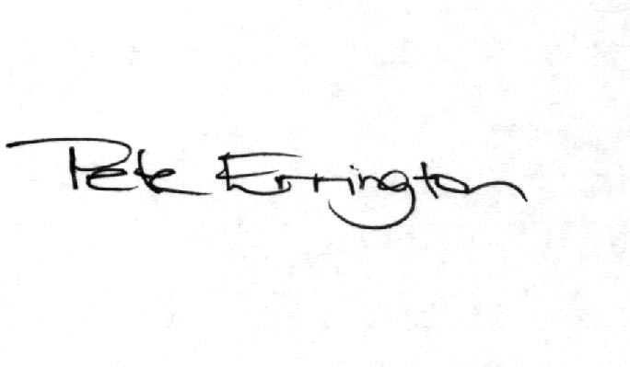

Pete Errington
Home Builders Federation
Regional Policy Manager (South, East & London)

