

BY EMAIL ONLY

Paul Newdick
Head of Planning Policy
Tandridge District Council
c/o East Surrey SHMA Partnership

1st November 2007

Dear Paul,

EAST SURREY STRATEGIC HOUSING MARKET ASSESSMENT

Thank you for allowing the Home Builders Federation (HBF) the opportunity to comment on the draft report.

Unfortunately I have not had time to consider the report in detail due to its size and the amount of time available for comments. However, those parts of the report I have read, I have to say I found very disappointing.

The purpose of carrying out a Strategic Housing Market Assessment (SHMA) is to provide and robust and credible evidence base on the demand and need for new housing to inform policy preparation. One of the 8 core outputs identified in the SHMA practice guidance is an estimate of future households requiring market housing. The aim of such an output is, amongst other things, to inform the setting of housing targets in RSS and LDFs. In this case we have a forecast demand for housing of 49,000 households yet a supply, taken as the housing requirement set out in the submitted South East Plan of less than half this amount at 21,600. A key finding and recommendation of the SHMA must, therefore, be that there is a substantial mis-match between the supply of, and demand for, new housing. Common sense would suggest that the main conclusion of the assessment should be that existing housing requirements are not high enough in the context of the evidence identified in the SHMA.

Regardless of whatever one thinks of the theory under-pinning Kate Barker’s arguments about the impact of additional supply on the price of housing, the fact is that such a massive under-provision in the light of identified demand certainly isn’t going to do anything to improve affordability.
Messing about tweaking the affordable housing percentages here and site size thresholds there, similarly, will do nothing to alter address the affordability problem. It is akin to the analogy of re-arranging the deckchairs on the titanic. Indeed, it is more like re-arranging the deckchairs on the titanic and charging people to sit on them in that, if supply remains constrained by existing targets, increasing the target percentage for affordable housing and/or lowering site size thresholds actually exacerbates the under-provision of market housing. The only way the housing problems in Surrey can begin to be addressed, quite simply, is by building more houses to meet both need and demand.

It does not matter how politically unpalatable such a conclusion may be; that must be the ultimate conclusion of this study. Yet it is not even mentioned. In that regard this SHMA is little different from an old style housing needs survey in terms of its implications for policy formulation in that all it addresses is the affordable housing “need” element. It does nothing to address “demand”. Saying that future policy must address the mis-match in type size and tenure is by far and away secondary to the mis-match between overall supply and demand. It is frankly, ridiculous for this ‘elephant in the room’ to be ignored.

It may well be that the policy measures to address this latter mis-match are somewhat limited for the time being. But that is a policy decision. Yet, the SHMA is primarily a technical evidence based report. It must present that evidence in a transparent, fair and balanced way in order that those formulating policy in the future can draw on the totality of its findings rather than them being presented with only half the picture.

I hope these comments can taken on board and the conclusions modified accordingly. I would also be pleased to be kept informed of progress on the final stages of this study.

Yours sincerely,

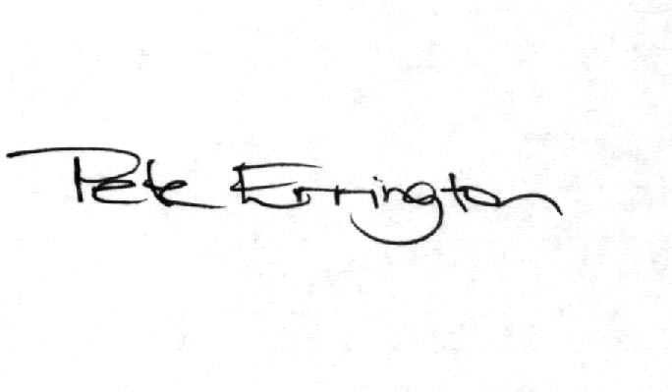

Pete Errington
Home Builders Federation
Regional Policy Manager (South, East & London)

