

BY EMAIL ONLY

Nicola Chappell
DTZ
Greyfriars Gate
5 Greyfriars Rd
Reading
Berkshire RG1 1NU

5th November 2007

Dear Ms Chappell,

HOUSING MARKET ASSESSMENT OF LEWES

Introduction

Thank you for allowing the Home Builders Federation (HBF) the opportunity to comment on this draft report.

As you will be aware from previous correspondence with your office, HBF has a number of concerns regarding this report. These relate both to the detailed findings of the report and the process by which the study has been carried out. We consider these failings, particularly the latter, to be so serious that the study cannot be said to comprise the ‘robust and credible’ evidence base required by Government policy meaning, in turn, that any policy derived from this research can only be declared unsound.

This is particularly disappointing to HBF since DTZ not only wrote the Government practice guidance document on carrying out strategic housing market assessments (SHMAs) but has also undertaken a number of previous studies where these sorts of concerns have not arisen.

Put simply, undertaking a SHMA with no stakeholder involvement (other than this consultation at final draft report stage) is contrary to Government policy, is the antithesis of the new planning policy making process and means that, according to the Government’s practice guidance, the assessment itself cannot be considered robust and credible (page 9 of the guidance).

Housing Market Area

Turing to more detailed comments the first point to make is that planning policy is required to be informed by strategic housing market assessments. Not district housing market assessments but strategic assessments. This is in recognition of the fact that district boundaries do not reflect housing markets and are drawn for purely administrative purposes. To consider the housing market of Lewes in isolation from its neighbouring authorities is, to say the least, less than helpful. Neither Lewes district nor Lewes town act as individual housing markets. They are part of a broader Brighton market; something the study itself acknowledges. To assess need and demand in Lewes alone separate from the factor which generates much of that need and demand (Brighton) immediately renders the findings of limited value. It is quite ironic that, in earlier drafts of the practice guidance prepared by DTZ, it was specifically recommended that studies were not prepared on the basis of arbitrarily drawn individual administrative boundaries. Yet here we are now in that exact position.

Stakeholder Engagement

Government’s practice guidance, as you are no doubt well aware, is absolutely clear both that stakeholder engagement must form a fundamental part of the preparation of a SHMA and that this engagement must occur throughout the process of its preparation. It is recommended that housing market partnerships be established to both lead and inform the process and that these include house builders, estate agents and others with housing market knowledge and expertise (figure 2.1 of the guidance). HBF was somewhat alarmed to be informed about the production of this report as the publication of the report was the first we knew of the study. We contacted our Members with known interests in Lewes district and they confirmed that they also had not been made previously aware of any HMA work being undertaken in Lewes.

We sought to express that concern with your colleagues but were advised that this was not the final stage but simply an initial stage in the process. This was despite the document being entitled “Housing Market Assessment of Lewes Draft Final Report v3.0 August 2007” and it looking to all intents and purposes as its title would suggest. Our concern was heightened to receive a written invitation from DTZ dated 5th September to a consultation event which stated “The study has now been completed and the event on the 8th October will entail a presentation of the key findings and the implications for policy….” Having now read the report more fully, it is blatantly obvious that the research work has been undertaken and the report completed.

Consultation on the final results of a study, even in draft form, does not constitute stakeholder engagement in the way it is expressed throughout the practice guidance, nor the way it is envisaged in Government policy in PPS3 and PPS12.

It is obvious from the invitation letter that stakeholders have no opportunity to influence the findings of the research; only the implications for policy. If we consider the findings of the research itself to be wrong or flawed in any way, for example due to something having been taken on board which should not have been or something having been omitted or interpreted incorrectly, this will obviously affect the policy outcomes but would not be something we could influence. Unfortunately, as is evident below, HBF is concerned that there have been very serious and substantial flaws in the methodology which undermines the credibility and value of the whole study. These could possibly have been avoided if the methodology had allowed for proper stakeholder engagement as outlined above.

Detailed Comments

There is little point HBF commenting on much of the detail of the methodology as nothing can overcome the fundamental flaws in the process by which this study has been undertaken.

Household Forecasts

However, there is one major issue of concern which has to be raised; namely, the issue of attempting to quantify housing demand. SHMAs are supposed to investigate both the demand and need for housing. In terms of the former the study is seriously flawed as it has not properly addressed the demand for housing. The study uses, as a proxy for future demand, SEERA’s policy-based household projection which is constrained by future housing supply to the levels set out in the draft South East Plan. Such a projection does not provide any estimate of the likely future demand for housing. It merely establishes how many households could be accommodated if the amount of housing proposed in the South East Plan was to be delivered in Lewes district in the period to 2026. One of the main functions of a SHMA is to inform future housing levels in both RSS and LDFs. Adopting a policy constrained approach forecasting approach to inform future policy formulation is a more or less useless as the outcome is constrained by the very policy it is supposed to be informing. It is certainly not a proxy for market demand.

The reason the council would support the use of such an approach is obvious but HBF would have expected a more objective and impartial approach from what is supposed to be a merely technical and evidence-based assessment.

The study relies on a level of household growth of 4,250 households between 2006 and 2026 (which ties in very closely with the current housing requirements of 220 dwellings per year [220 x 20 = 4,400]). Compare this to the government’s most recent household 2004-based household forecasts published in March this which gives a household growth figure for Lewes district for the same 20 year period 2006 to 2026 of approximately 10,000 households.
This shows the scale of the underestimate of the policy constrained projection. The Government’s household forecast puts likely future demand for housing at a level more than twice that of the SEERA policy constrained projection used as the basis for this study.

The study then goes on to consider housing supply but, again, that is constrained at the current housing requirement of 220 dwellings per year and does not reflect the level of supply needed to meet forecast demand for housing which is another major failing. SHMAs cannot be constrained by policy or by existing housing requirements, supply or targets. They must properly try to assess and understand likely future demand. If they do not do this they can only ever be of very limited value in policy formulation.

HBF is extremely concerned, therefore, that this further limits the value, robustness and credibility of the study. Anyone relying on this study for as a basis for policy formulation is burying their head in the sand in so far as the true scale of future housing demand in Lewes. It makes a nonsense of the recommendations which follow on future affordable housing policy for the study to assume under-provision of market housing on such a scale as this can only significantly exacerbate the affordability problem in Lewes. The study should be re-cast using the Government’s most recent household forecasts in place of the SEERA projections in order to properly assess the likely future demand for housing.

Development Economics

The final comment relates to the draft policy recommendations outlined in the report. One such recommendation relates to possible future policy targets and site thresholds. Not only do the above considerations in themselves significantly impact on future affordability issues in the district. But also, government policy on affordable housing delivery is absolutely clear that part of the technical justification for affordable housing policy must incorporate site specific viability and housing delivery considerations. For the study to make recommendations on future affordable housing policy targets and site thresholds while at the same time admitting there has been no assessment of viability or impacts on overall housing delivery (paragraph 8.77 of the report) is totally unacceptable and these unjustified recommendations should be removed from the report.

Summary / Conclusion

Overall therefore HBF is concerned that, unlike Ronseal, quick drying woodstain, this assessment does not do exactly what it says on the tin. Put simply it is not a strategic housing market assessment for three fundamental and very important reasons.

Firstly it is not strategic; it only looks at Lewes district.

Secondly it does not properly assess the future market demand for housing as it uses a policy constrained household projection. It completely fails to address the enormous discrepancy between the politically driven policy constrained projections produced by SEERA and Government’s official household forecast which is more than twice as high.

Thirdly, it provides no proper technical or evidence based justification for the recommendations it makes on future affordable housing policy.

Unless these failings are addressed, the study is can only be of very limited value and is certainly not sufficiently robust to form the basis of future housing policy in Lewes district.

I hope these comments will be taken on board. Either way, I would be pleased to be kept informed of progress on this study in due course.

Yours sincerely,

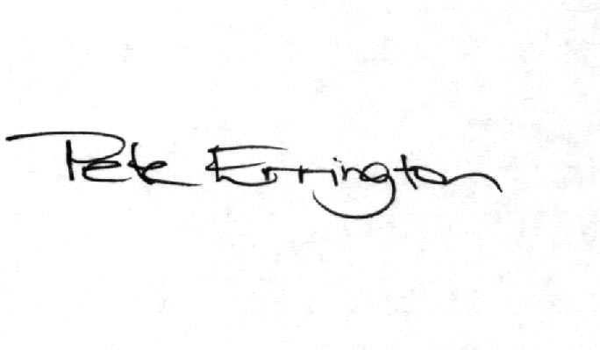

Pete Errington
Home Builders Federation
Regional Policy Manager (South, East & London)

