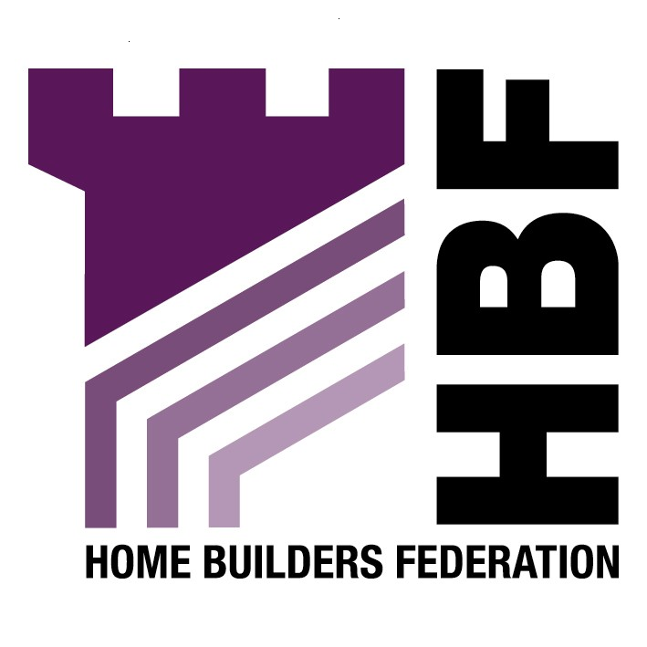

Emailed to ldfconsultation@bolton.gov.uk

Bolton Council
Spatial Planning Team
Development and Regeneration
5th Floor
Town Hall
Bolton
BL1 1RU

28 September 2007

Dear Sir or Madam

Core Strategy: Issues and Options

Thank you for giving the Home Builders Federation (HBF) the opportunity to comment on the above document. The HBF have considered the proposed document and have made the following observations:

Question 4: Overall Spatial Option

The HBF considers that any option should allow for a flexible consideration of Greenfield land in the Council’s housing land supply. Although there is no actual acknowledgement that Greenfield development is both necessary and, in many circumstances, appropriate, PPS3 paragraph 65 suggests that, if performance of housing provision fails to meet trajectories or assumptions, planning authorities might have to update the quantity and mix of different categories of land within their housing land supply. Equal consideration should be given to both Greenfield and brownfield and the merits of each should be taken into consideration i.e. certainty of delivery, sustainability.

Question 5: Built Environment

The HBF believes that any policies on the built environment should not be too prescriptive. In terms of policy BE4 “Sustainable Design and Construction” any requirements should be covered by the Code for Sustainable Homes as this is a single national standard that the house building industry is working towards. The development industry has signed up to the target of all new homes being built to an agreed zero carbon standard by 2016. In order to achieve this, the industry should be able to rely on a clear national framework and timetable for the necessary changes in building regulations. This approach will enable industry to work with greater confidence and efficiency to find the best means of delivering homes to the new standard in the volumes needed.

Question 6: Built Environment

Supports Option BE 1(a).

Question 7: Sustainable Design and considerate Construction

BE4 (i) Sustainable design and considerate construction

The HBF believes that the reference to Eco Homes in this policy should be removed, as in accordance with current guidance this has been replaced by the Code for Sustainable Homes.

BE4 (v) Carbon and Renewable Energy

The HBF objects to the inclusion of the 10% Merton rule in this policy. This fails to take into account the fact that many sustainable design matters will very soon be covered by the Code for Sustainable Homes, and that in order to reduce CO2 emissions, 10% renewables provision on site might not be the most appropriate means of achieving this overall reduction, either technically or financially. The HBF believes that any requirement for renewable energy provision upon new development should be delivered through the higher stages of the Code for Sustainable Homes. As this is a framework and timescale to which the industry is committed to delivering. The HBF consider that the application of locally based energy performance standards would be unhelpful in facilitating the broader delivery of higher energy performance and consumption standards from new housing.

Question 8: Conservation

Supports BE5 A

Question 9: Thresholds

Another Option

The HBF believes that planning contributions should be determined on a site by site basis. The determination of the contributions should be based on the impact the development will have on the local area, to be in accordance with Circular 05/05. With regards affordable housing this should be based on an up to date Strategic Housing Market Assessment carried out with the full cooperation of the house building industry. Therefore, setting arbitrary thresholds is unhelpful. The impact on the viability of residential schemes of S106 Affordable Housing demands should be assessed in the context of other S106 demands and other abnormal costs outside S106 agreements. For example, a growing number of local authorities are requiring a proportion of energy used on developments to be met from renewable sources. Some are also requiring new dwellings to meet higher levels of the Code for Sustainable Homes. Like S106 demands, all of these requirements add to development costs, have an impact on land values and scheme viability and reduce the scope for meeting S106 and Affordable Housing demands.

Question 10: Types of Infrastructure

Support Option PC2 A

The Council should not require contributions which are unrelated to the proposed development. The HBF draws attention to the Circular 05/2005, paragraph B5, which sets out five tests which must be met by all local planning authorities in seeking planning obligations:

“A planning obligation must be:
- relevant to planning;
- necessary to make the proposed development acceptable in planning terms;
- directly related to the proposed development;
- fairly and reasonably related in scale and kind to the proposed development; and
- reasonable in all other respects.”

Any obligation must meet these tests. Therefore, in accordance with the comment in response to Question 9 the HBF would like to emphasise that the Council must be realistic.

Question 13: Parking Standards

Support Option TA1 A

The HBF believes that the Council should develop the targets to be in accordance with the Regional Spatial Strategy. Imposing more restrictive targets is unhelpful particularly as latest government policy seems to be shifting away from the application of blanket restrictive parking standards, towards a more flexible approach taking greater account of local characteristics. The HBF supports a more flexible approach given that every site and locality is different. Whilst some can operate with very little parking provision, others cannot. If a lack of sufficient parking provision arises, the end result is often nearby approach roads being clogged up with parked vehicles. Which apart from being unsightly and inconvenient can also pose access problems.

Thank you again for giving the HBF the opportunity to comment. We trust you will take our comments into account and look forward to receiving further information regarding the progress of the document.

Yours faithfully,

Laura Edwards

Laura Edwards (maternity cover for Gina Bourne)
Regional Planner – Northern Region

Home Builders Federation

