

BY EMAIL ONLY

Peter Griffiths
Housing Research Development and Enabling Manager
Housing Services
Isle of Wight Council
7 High Street
Newport
Isle of Wight
PO30 1SS

31st October 2007

Dear Mr Griffiths,

ISLE OF WIGHT AFFORDABLE HOUSING CONTRIBUTION ASSESSMENT

Thank you for allowing the Home Builders Federation (HBF) the opportunity to comment on this draft methodology.

In general terms the approach set out accords with that recently recommended in HBF's own affordable housing policy group report whereby all development should be required to contribute in some way towards improving the delivery of affordable housing. I attach a copy of our report for your information. However, while the council's proposed approach seeks to apply the requirements mainly to smaller housing developments, HBF would suggest that consideration be given to securing some form of contribution from all forms of development, not just housing. In particular those forms of development which actually generate a need for affordable housing (e.g. employment development).

I guess it could be argued that the approach is somewhat complex, probably over-complex and that in itself could hinder delivery if it necessitates protracted negotiations over the s106. However it is for the council to demonstrate that this is not the case and to make the approach as simple and easy to understand and implement on the ground as possible.

A cascade or tiered approach taking into account viability considerations, and so overall housing delivery, is also welcomed. HBF would suggest that this is the key consideration as any policy approach which was so onerous and adversely affected development viability to such a degree that it was no longer viable for a developer to proceed with the development, would be counter productive in terms of affordable housing delivery in the long run.

In that way, affordable housing delivery is inseparable from the delivery of market housing and the oft-quoted statement that 50% of nothing is nothing, still holds true.

The only other comment we wish to make is also on viability in that, when considering the viability of affordable housing requirements, these should not be viewed in isolation. They must be costed, assessed and factored into the decision making process alongside the council’s other s106 planning obligations requirements. It is no good merely considering the cost of delivering affordable housing are suggesting it will not impact on viability if that is only part of the story. The viability of delivering development in accordance with council policy in the round is what must be assessed. Otherwise the assessment itself will be of limited value.

I hope these comments and the attached report are helpful and will be taken on board. I would be pleased to be kept informed of progress on this policy approach as it evolves.

Yours sincerely,

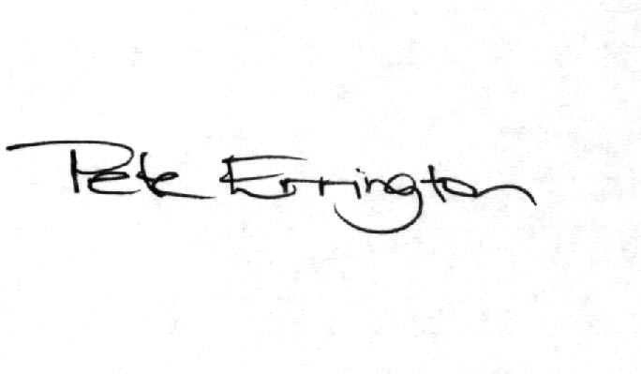

Pete Errington
Home Builders Federation
Regional Policy Manager (South, East & London)

