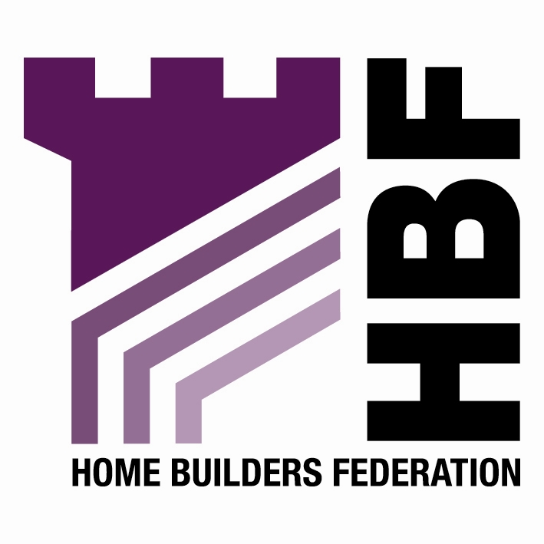

BY EMAIL ONLY

Sheryl French

Quality of Life Programme Manager

Cambridgeshire Horizons

Endurance House,
Vision Park,
Histon,
Cambridge,
CB4 9ZR

26th October 2007

Dear Sheryl,

A QUALITY CHARTER FOR GROWTH IN CAMBRIDGESHIRE; CONSULTATION DRAFT

Introduction

As you know from the discussion at our regional planning meeting which you kindly attended, the main concern of the housebuilding industry surrounding the Charter is not so much the detailed requirements of the Charter, but rather, the status of the document and the way it is intended to be used in the decision making process.

We are concerned that, rather than simplifying the process as is claimed, the Charter actually adds another layer of confusion and bureaucracy which is less than helpful.

Process

There is a statutory land use planning system in place with very clear guidance as to how the decision making process regarding new development should operate. This Charter does not form part of the statutory process and is, therefore, of limited value and even less weight as a material planning consideration. The suggestion, made a number of times now by Cambridgeshire Horizons officers that, if developers sign up to the Charter they will be given an easier ride through the planning process (and the obvious implication that those who do not will be given a tougher time) is wholly unacceptable and somewhat underhand to say the least.

Justification

Despite the suggestions in the document to the contrary, there is nothing particularly unique about either the growth planned in the Cambridge sub-region or the sub-region itself compared to other growth areas in the wider south east.

There are obviously economic and physical differences between the areas but they are all seeking to achieve the same objective of creating sustainable, mixed and balanced new communities. There is a plethora of guidance, policy, advice and information already in the public domain produced by a wide variety of public and other bodies to assist decision makers in achieving these objectives. We would question whether there is a need for anything more. Particularly given the confusion this document creates around its status, how it will be applied and the area to which it will be applied.

Cambridgeshire Horizons has a remit to facilitate the delivery of growth in the Cambridge sub-region yet this claims to be a Charter for the whole of Cambridgeshire. Who will deliver the provisions of the Charter in those areas outside the Cambridge sub-region. ? What powers are available to local authorities to impose these requirements ? How will it be adopted or endorsed by the local authorities ? How will anyone know who has or hasn’t signed up to the Charter ? I’m afraid that the Charter raises more questions than it answers.

Principles

Clearly the house building industry is not against the principles of good design, place making and sustainability set out in the Charter in general terms. Most of them are common sense, are required by the statutory land use planning system and other regulatory mechanisms and many are undertaken and addressed by developers already. This Charter does little to add to the stock of public knowledge, guidance and policy requirements which already exist and does nothing to speed up the delivery of new communities in the sub-region. Indeed, it is viewed by many in the industry as yet another obstacle being placed in the way of delivery. Particularly in view of the requirements in Section C which seek to require the attainment of standards over and above those statutorily required. It is unlikely that many in the industry would wish to sign up to the Charter for that reason alone.

Mixed and Balanced Communities

In terms of the information provided by developers in support of their planning applications, the planning system already requires the provision of design and access statements. The new requirements for the validation of planning applications which will come in to force in April next year will ensure that local authorities receive all of the information set out in the Charter in support of applications (where they follow due process to require this) to ensure they make decisions which will ensure the creation of successful places and sustainable communities. Planning policy is required to be supported by Strategic Housing Market Assessments and Land Availability Assessments which will look at what type, size, mix and tenure of development is required and what sites are available to deliver them.

Design

Similarly, in terms of design, given current powers available to local authorities to address design concerns, if poor quality developments are still being built then local authorities have only themselves to blame.

Climate Change

In terms of Climate Change the industry is already signed up to deliver zero carbon development through successive tightening of building regulations advocated in the Code for Sustainable Homes. There is no justification or need for any acceleration of the Code timescales or targets. Every development in the country cannot be an exemplar or push the boundaries of currently available technologies. Yet that is what not only this document but similar statements by other Government bodies and local authorities are saying in other regions. The current Code targets are going to be a significant challenge for the not only house builders but also the suppliers of these new technologies to meet. Accelerating these targets can only be counter-productive if it results in large scale technology failures. Are local authorities or Cambridgeshire Horizons going to underwrite the risk of future technology failure of the technologies it will require ?

It is quite interesting to note that, while HBF and many individual house building companies have signed up to the Government’s 2016 commitment on zero carbon, neither Cambridgeshire Horizons, nor a single local authority in Cambridgeshire has done likewise. We will, quite simply, not get anywhere in terms of delivering lower carbon development unless we move together in partnership rather than local authorities and government quangos seeking to impose unrealistic, unjustified and unnecessary burdens on the house building industry.

Summary / Conclusion

In conclusion, therefore, before the development industry is willing to sign up to this Charter we would like to see a reciprocal arrangement with Cambridgeshire Horizons and the local authorities in the sub-region whereby they sign up to a Charter to deliver the housing numbers with penalties in place if the targets are not met ! As has been mentioned by Horizons officers, a fifth “C” is co-operation and we would like to see a genuinely co-operative approach rather than being pressured into signing up to a non-statutory Charter in return for an easier ride through the planning system.

As is clear from the current state of absolute disarray and chaos which is the current LDF system, there is no such thing as an easy ride through the planning system and it is not in the gift of Cambridgeshire Horizons or any other body to make such a promise / threat.

HBF requests that this Charter be withdrawn and that, instead, the principles it advocates are introduced properly through the statutory LDF process through development plan documents, action area plans and masterplans prepared in co-operation with the industry rather than imposing the requirements on us by unfair, unsound and inappropriate means. At the very least, if the document is to be published, it should contain a very clear statement in the introduction which makes its status (or lack of) absolutely clear and explains more fully how it is anticipated it will be used in the decision making process.

Yours sincerely,

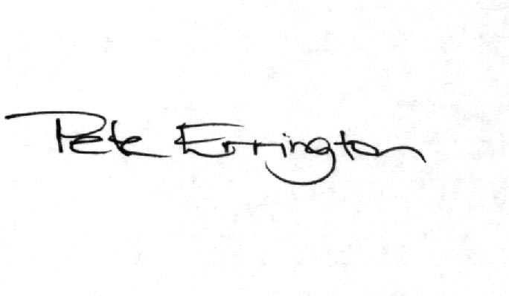

Pete Errington
Home Builders Federation
Regional Policy Manager (South, East & London)

