

BY EMAIL ONLY

Forward Plans Group
AVDC
66 High Street
Aylesbury
Bucks HP20 1ZA

12th October 2007

Dear Sir/Madam,

CONSULTATION ON DRAFT SUPPLEMENTARY PLANNING DOCUMENT ON AFFORDABLE HOUSING

Introduction

Thank you for consulting the Home Builders Federation (HBF) on your council’s draft supplementary planning document. As you might expect given that it will impact severely on the housebuilders who operate in the district, HBF has a number of significant concerns on the content of the document and the process by which these policy requirements are being introduced. Such are the nature and extent of these concerns that we request that the SPD be withdrawn as there is, quite simply, no proper policy basis or evidence base to justify what is proposed. It is fundamentally flawed and completely unsound (tests iv, vi & vii, paragraph 4.24 PPS12).

Process

Firstly in terms of process, PPS12 is clear that:

“Supplementary planning documents may contain policies which expands or supplements the policies in development plan documents. However, policies which should be included in a development plan document and subjected to proper independent scrutiny in accordance with the statutory procedures should not be set out in supplementary planning documents” (PPS12 paragraph 2.44)

HBF is concerned that this draft SPD does far more than simply expand or supplement the existing adopted policy. Rather, that it introduces a raft of onerous and prescriptive policy requirements on the house building industry which should more properly be included in a DPD in order that their implications can be tested through the process of independent examination.

Policy

Policy GP.2 of the adopted (saved) local plan, which this SPD purports to merely supplement, states that:

“The council will negotiate for the provision as affordable dwellings of a minimum of 20% and up to 30% of the total number of dwellings on developments of 25 or more dwellings……”

This SPD goes way beyond the adopted local plan policy and supporting text in that it establishes very different and much more onerous and costly set of policy requirements. Namely, that it changes the 25 dwelling threshold to 15 dwellings and the minimum 20% target to a minimum of 40%. This is a substantial and radical change in policy approach. It is totally unacceptable and unreasonable and an outrageous and blatant mis-use of the planning policy process to introduce such a substantial policy change via the SPD route.

Justification

The council refers to national and regional guidance in justification for its policy change. However, there is no scope for local authorities to produce SPD against national or regional guidance. SPD can only be produced against policies in the adopted local plan or development plan document. PPS3 is clear that it is in DPDs (not SPD) where local authorities should set out their affordable housing policy (and any changes to that policy) and that they should factor in assessments of economic viability of the thresholds and targets and the impacts of these on overall housing delivery. Any policy must be based on robust and credible evidence; in this case a housing market assessment carried out in accordance with the practice guidance and with the full co-operation of key stakeholders including the house building industry. Here, there is no such evidence.

I am feeling a sense of déjà vu here in that the council did exactly the same thing in 2004 with its affordable housing SPG. Obviously, therefore, the council is more than aware of the procedural failings of this document and the approach it advocates. On that basis it is highly unlikely that these comments will not be taken on board. Nonetheless, the council would have been better advised using its time and resources compiling a robust evidence base in support of its policies so that they could be taken through the proper procedures and subject to independent testing rather than wasting time producing this SPD. It should also be borne in mind that, should the council proceed with this SPD the document will have very little, if any, weight as a material consideration in the determination of planning applications as it is so obviously contrary to many aspects of Government policy so rendering the document completely unsound.

Carrying out a sustainability appraisal of a document which is so obviously and fundamentally flawed does not add to the credibility or weight to be afforded the document.

Summary

There is little point HBF commenting on the detail of the document as the process by which it has been prepared is so fundamentally flawed and unsound. These policy requirements will have a substantial impact on development economics with knock-on effects on site viability and the delivery of housing sites. This is wholly incompatible with the role of Aylesbury in assisting delivery of the Government’s growth agenda set out in the sustainable communities plan and more recently the south east plan panel’s report and the housing green paper.

The document should be withdrawn and the council should concentrate on advancing its LDF in order that these matters can be addressed through the proper procedures. In the meantime, saved policy GP.2, as supplemented by more recent Government guidance in PPS3, should continue to apply.

Yours faithfully,

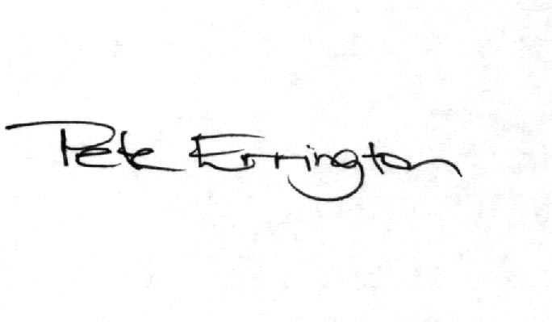

Pete Errington
Home Builders Federation
Regional Policy Manager (South, East & London)

